**PRI User Manual**

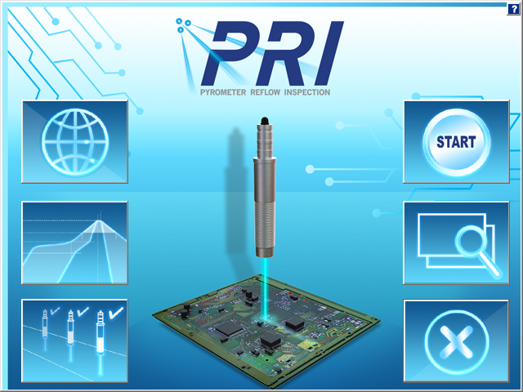

Version 1.0

Publication Number SFT-324400-000



**PRI User Manual**

Copyright © 2023 KIC. All rights reserved. Patents pending.

16120 West Bernardo Drive

San Diego, CA 92127

Phone: +1 858 673 6050 Fax: +1 858 673 0085

A Division of Embedded Designs Inc.

This document contains information that is proprietary to KIC. Said information, is copyrighted as is all associated software and hardware. All rights are reserved. Patents are pending.

This document and the information contained in it may not be sold, duplicated, used, or disclosed, in whole or in part, except as specifically authorized in writing by KIC. The information contained in this document and associated software is subject to change without notice.

There are no warranties with respect to the information contained in this document, express or implied, except as provided by written contract between KIC and the customer.

All KIC product names and logos are trademarks of Embedded Designs, Inc. All other trademarks used herein are the property of their respective owners.

**Software Licensing Agreement and Product Warranty**

The KIC software is subject to the following license terms and conditions.

1. **KIC SOFTWARE LICENSE**
   1. This is a software license granted by *KIC*, mailing address 16120 West Bernardo Drive San Diego, CA 92127.
   2. The KIC software is licensed to you as the end user and is not sold.
   3. The KIC software is copyrighted material.
   4. The KIC software is licensed for use with one or more pieces of associated hardware that together constitute a thermal process management system. This license allows you to use the software with the purchased system. You must purchase additional copies of the software if used with additional system hardware.
   5. You may not change, modify, decompile, disassemble, or otherwise reverse engineer the licensed software or any associated hardware.
2. **LIMITED WARRANTY**
   1. KIC warrants that the system hardware and software are free from defects in material and workmanship under normal use. KIC warrants that the system as a whole will perform substantially in accordance with the specifications set forth in the documentation provided with it.
   2. Warranty regarding rated temperature: Components of the system hardware are rated by KIC for proper performance up to a specified maximum temperature. Any component that KIC determines to have been exposed to temperatures higher than the rated temperature is not covered under this warranty.
   3. Start of the Warranty period. The warranty period begins the day the KIC product is delivered to you as the first customer.
   4. Obligations of KIC during the warranty period:
      1. Return for complete refund: If, within the first thirty (30) days after the start of the warranty, the customer returns, for any reason whatsoever, any of the purchased hardware or software in its original condition, KIC will refund the associated money paid and accept the return as payment for any money owed.
      2. Replacement: Within the first year of the start of the warranty, KIC will replace, on an exchange basis and without additional charge, any product proven defective in materials or workmanship.
      3. Correction of software: KIC will either replace or repair, without additional charge, any software that does not perform in substantial compliance with its documented specifications. In the foregoing circumstances, KIC will deliver either corrective code or a corrected copy of the software.
      4. Final Remedy: If KIC is unable to replace defective media or provide a corrected copy of the software within a reasonable amount of time, KIC will either replace the software with a functionally similar program or refund the license fees paid for use of the software.
   5. **Exclusion of Other Warranties**
      1. KIC does not warrant that the functions contained in the software will meet your requirements or that the operation of the software will be uninterrupted or error free. The Warranty does not cover any copy of the software that has been altered or changed in any way by you or others. KIC is not responsible for problems caused by changes in the operating characteristics of the computer hardware or operating system which are made after delivery of the software.
      2. **EXCEPT WHERE LIMITED BY LOCAL JURISDICTIONS, KIC SHALL NOT IN ANY CASE BE LIABLE FOR SPECIAL, INCIDENTAL, CONSEQUENTIAL, INDIRECT OR OTHER SIMILAR DAMAGES ARISING FROM ANY BREACH OF THESE WARRANTIES EVEN If KIC OR ITS AGENT HAS BEEN ADVISED OF THE POSSIBILITY OF SUCH DAMAGES.**
   6. **Other Conditions**
      1. **The warranties set forth above are in lieu of all other warranties, whether oral, WRITTEN, or implied, INCLUDING BUT NOT LIMITED TO ANY IMPLIED WARRANTIES OF MERCHANTABILITY OR FITNESS FOR ANY PARTICULAR USE. the remedies set forth above are the customer’s sole and exclusive remedies**. Only an authorized officer of KIC may make modifications to this warranty, or additional warranties binding on KIC. Accordingly, additional statements such as advertising, collateral, or presentations, whether oral or written, do not constitute warranties by KIC and should not be relied upon as such. This warranty gives you specific legal rights, and you may have other rights, which vary by state and/or country.
3. **LIMITATION OF LIABILITY**
   1. In no case shall KIC's liability exceed the license fees paid for the right to use the licensed software or One Hundred Dollars ($100.00), whichever is greater.

Contents

Introducing the PRI System 1

The Hardware 2

Hardware Diagram 4

Install The Software 5

Start the Software 6

The Main Screen 7

Global Preferences 8

Global Tab 8

Auto-Focus Tab 10

Control Limits Tab 11

Disable Alarm Tab 13

Barcode Tab 14

Outputs Tab 15

Process Window Setup 18

Solder Paste Menu 19

Edit Specs 20

Change Specs Name 22

Save - Process Window 23

Import Legacy Process Windows 24

Hardware Status 25

Run A Thermocouple Profile 26

Run a Profile Screens 27

Auto-Focus, Product Dimensions 28

Oven Characteristics 31

Specify An Oven Recipe 32

Attach Thermocouples 33

Attach Thermocouples To Semiconductor Wafers 34

Selecting Thermocouples 35

Start the Profile 36

Live Profile Graph 38

Profile Retransmission 39

View the Profile and Statistics 40

Description Tab 46

Profile Optimization with Navigator 47

Manual Profile Prediction 47

Different Top and Bottom Setpoint Temperatures 49

Profile Explorer 52

Find PP Production Run Data by Lot ID Code 53

Browse for Historical Data 54

View Historical Data Over A Network (History Mode) 54

Profile Explorer Buttons 55

Profile Explorer – Pyrometer Profiling 56

History Data Files 58

Insert Data Files from an Outside Source 58

Rename Profiles 58

Pyrometer Profiling (PP) 59

Establish A Valid Baseline Profile 59

Create/Load a Pyrometer Profile 60

Monitor Production in PP Live Mode 61

How to Avoid the Grey Crystal Ball 61

PP Live Mode - General Tab 62

PP Live Mode - Description Tab 65

PP Live Mode - Charts Tab 66

PP Live Mode- Troubleshooting Tabs 68

PP Live Mode –Troubleshooting Empty Oven Tab 69

PP Live Mode – Conveyor Speed Tab 69

PP Live Mode – Pyro Tabs (Pyrometer Tabs) 70

PP Live Mode Buttons 71

Verify the Pyrometer Profile 72

Historical Mode 74

Historical Mode - Description Tab 76

Historical Mode - Chart Tab 77

Historical Mode - Troubleshooting Tab 79

Barcode Functions 80

Barcode Types 81

Configuration Overview 81

Pyrometer Profiling and Barcodes 84

View Barcode Traceability Information Historical Data 88

Live Data Output And Barcodes 89

Live Data Output 90

LDO Formats 91

Details of Output Files 91

Configure LDO 92

Delete Accumulated LDO Files 93

Dual Lane Systems and Functionality 94

Dual Lane Dual Systems 94

Configure Dual Lane Systems 95

Use Sweet Spot Target (Optional) 97

O2 Live (Optional) 98

Configuration 98

Operation 100

PP Idle Mode (Optional) 102

Configuration 102

Units Per Hour 103

Auto- PP 104

Profile Printing 105

Portrait Mode 105

Landscape Mode 106

Write Data to and View PRI Data Over a Network 107

Write Data To A Network Drive 107

View Historical Data 110

Communicate with Oven Controllers 111

Confirm Oven Communications 112

Configure Software For Oven Communication 113

Use a Base Oven Recipe with Oven Communication 113

Run A Profile Using Oven Communication 114

Start a Pyrometer Profile with Oven Communication 116

Base Oven Recipe Automatic Verification 117

Status Messages and Alarms 118

Acknowledge Alarms 118

Messages During Profiling and Baseline Profiling 119

System Message and Alarms 119

Light Tower 137

Standard Light Tower 137

3 Color USB Light Tower 137

Appendix A: The Process Window Index 138

The Problem 138

Define the Process Window Index 138

Calculate the PWI 139

Benefits of Ranking Thermal Profile Performance 140

Conclusion 140

Appendix B: Recalculating Zone Delta Limits from Navigator/Auto-Focus Predictions 141

For Stand-alone Software Installations (Not Communicating with Oven) 141

For Oven Controller Software Installations 143

Appendix C: Configuration Program 145

User Settings Tab 145

Decimal Tab 147

Hardware Tab 147

Auto-PP Tab 148

Message Config Tab 148

Password Control – Multi User 149

AR Matrix Settings Tab 159

Barcode Tab 161

Contact KIC 164

# Introducing the PRI System

**Pyrometer Reflow Inspection (PRI)** is the first ever reflow inspection system to utilize pyrometers installed throughout the oven process tunnel. These pyrometers measure the real-time temperature of production boards directly, without making contact, sensing their infrared energy as they go through the oven.

The Pyrometer Reflow Inspection system is a comprehensive suite of thermal process management tools designed to give you the ultimate in PCB soldering quality control. KIC PRI can monitor the entire thermal process, giving advanced warning before a product drifts out of specification. Its barcode control features can prevent costly product/recipe mismatches, and its power management features enable efficient operation at the lowest energy cost.

PRI combines software and hardware components into an integrated system, supplementing its thermal profile analysis core with special tools for performance optimization, changed variable prediction, and data file management.

## The Hardware

The major hardware components to a PRI system are:

* Data Acquisition Unit (DAU)
* Pyrometer sensors
* Purge Blocks
* Conveyor speed encoder
* Product sensor
* Alarm Relay/Light Tower
* Profiler

### DAU

The DAU is the main control unit for the system, to which all installed sensors connect through. It interfaces with the computer using an Ethernet cross-over cable that connects from the UpLink port on the DAU directly to a USB to Ethernet adapter (or to an installed Network Interface Card (NIC)). Please follow manufacturers’ instructions to install the USB adapter or NIC.

The computer used with the PRI system can be a machine that is dedicated to only supporting PRI or it can also serve as the oven controller PC. PRI can interface directly with the oven controller on selected models from many oven manufacturers. When installed on an oven that is capable of communication with the PRI software, it will allow information (zone setpoints, conveyor setpoints, etc.) to be exchanged between the PRI software and the oven controller software.

The DAU must be plugged into an AC power source. The DAU utilizes a universal A/C transformer power supply. The DAU ships from the factory with multiple AC connectors to accommodate any connector/voltage requirement.

### Pyrometers

The pyrometers are installed in the oven process tunnel. They are mounted on the fixed rail, or in a manner that allows clear visibility of the printed circuit boards without interfering with the product flow by oven manufacturer approved brackets. The pyrometers are connected to an adapter box, which adapts the inputs to the DAU. Typically half the pyrometers enter from the oven entrance and half enter from the oven exit. Pyrometers 1-6 are connected into one adapter box that will be plugged into the A labeled input of the DAU and pyrometers 7-12 are connected into the other adapter box and plugged into the DAU input labeled B.

### Nitrogen or Compressed Air Purge Block

Dual Purge Blocks supply a regulated flow of gas or air to each of the pyrometer sensors.

### Conveyor Speed Encoder

The conveyor speed encoder is a sensor mounted to sense the teeth of a gear that turns while the conveyor is moving. The conveyor speed encoder connects to channel #1 of the DAU Sensor ports.

### Product Sensor

The product sensor is typically mounted near the entrance of the oven, on the fixed conveyor rail. The sensor is connected to channel #2 of the DAU Sensor ports. The first pyrometer acts as the main board sensing device, but the product sensor at the entrance of the oven is used to display the boards as they travel from the oven entrance to the first pyrometer (middle of zone 1).

### Alarm Relay/Light Tower

The Alarm Relay connects to the Alarm/Barcode port of the DAU and provides a method for external notification to the user when an alarm condition occurs. It allows for a KIC supplied audible light tower to be powered and triggered; it can include SMEMA interface connections; it also allows a user to hardwire in an external device of their choosing. The Alarm Relay is required to have an external AC power source.

There are two audible light towers available – one model connects directly to the Alarm Relay device; the other model connects directly to the USB port of the PC. See the *Light Tower section**.*

### Profiler

The profiler is a separately offered data acquisition component that is required to use the PRI system. It provides the on-board, through-the-process temperature data, what we call the “Thermocouple Profile”.

#### Profiler Models

The following profiler models are compatible with the PRI system software:

1. SPS Smart Profiler
2. X5
3. K2

The SPS profilers are available in two different configurations —datalogger and datalog/wireless*.* In standard datalogger mode, the profiler records temperature data as it moves through the thermal process. A download cable is then connected to download the data to the PC running the PRI software. In wireless mode, the profiler transmits data by Wi-Fi via a Smart Dock connected to the PC. The PRI software displays the accumulating data in real-time.

For specific information regarding your profiler, consult one of the following KIC publications:

* SPS Smart Profiler Hardware Guide, (Publication Number PTG-330310-000)
* X5 Profiler Hardware Guide, (Publication Number EXP-337310-000)
* K2 Profiler Hardware Guide, (Publication Number EXP-331310-000)

### Additional Components

#### Barcode Reader

A user-supplied barcode reader can connect to the DAU Alarm/Barcode port (when using a DB-9 serial connection), to one of the DAU USB ports (when using a USB barcode scanner), or to a PC Com or USB port. When used in conjunction with the Alarm Relay, the serial barcode reader hardware can connect to the DAU via the Alarm Relay Y- cable. The barcode reader is mounted on the entrance side of the oven, on the in-feed conveyor. For additional information about using barcode scanners, see *Appendix C – Barcode Tab.*

## Hardware Diagram

The interconnection of the hardware components is illustrated in the hardware diagram below:

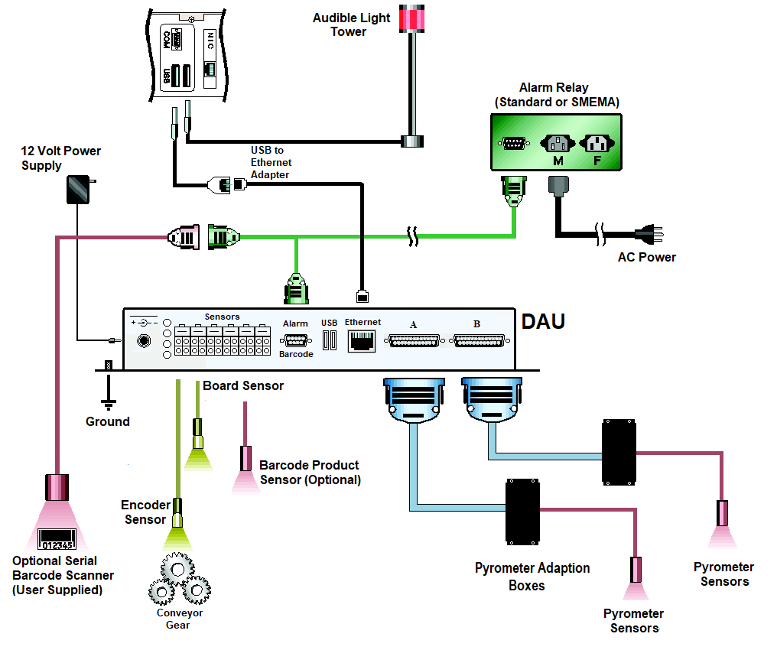

Figure 1: Hardware Configuration Diagram

It is critical that all PRI hardware is properly installed and configured. If one of the system components is setup incorrectly or is malfunctioning, the PRI system will not allow you to run *Pyrometer Profiling* or provide accurate data. If you have any questions or are unsure about any of the following, contact KIC Technical Support for assistance at [tech@kicmail.com](mailto:tech@kicmail.com)

## Install The Software

### Minimum PC System Requirements

* 3 GHz Dual Core processor
* 4GB RAM
* SSD is recommended
* Video 1024 x 768 / 16-bit color
* 1 available USB port for data download
* 1 available USB port (for software protection dongle key)
* 1 available Ethernet port or 1 available USB port with Ethernet-to-USB adapter

**Note**: Additional powered USB ports may be needed for additional accessories.

#### Notes Before Installation

* Shut down all other applications as a precaution against software conflicts.
* If you are installing the PRI software on an oven that is capable of communication with the software**, DO NOT place the PRI icon in the Windows Startup folder.** If the PRI software loads before the oven controller software, it can cause the oven controller software to malfunction.

|  |  |
| --- | --- |
|  |  |
|  |  |
|  |  |

### Install

1. Insert the USB flash drive into a USB port on your computer.
2. Depending upon your computer setup, a dialog box may appear. If it does, select **Open folder** to view **files**. If a dialog box does not appear, use Windows Explorer to browse to the USB flash drive directory.
3. Double-click the installation file in the root directory to begin the installation.
4. Follow the instructions for the installation program as the screens appear.

*When installing the software over an existing PRI directory, the installation will automatically create a backup folder of the existing directory. A warning message will be displayed when selecting an existing directory, and a checkbox can be de-selected if you do not wish to create a backup.

The name of the backup directory created will be C:\ PRI _Old_MM-DD-YYYY

**Note**: If you have questions regarding your hardware or software configuration contact KIC Tech Support.

## Start the Software

**Note**: The installation automatically adds a **KIC** folder to the main Windows Start Menu.

|  |  |
| --- | --- |
| 1. Click on the **Windows Start** button to locate the PRI icon.   **Note**: The icon will appear in the Start button’s list of frequently used applications or you can click the **All Programs** command to find it in the **KIC folder** that appears among the displayed folder/icon list. |  |

* 1. Alternately, you can browse to the *C:\PRI* directory and double click the KICHost.exe file to start the application. 

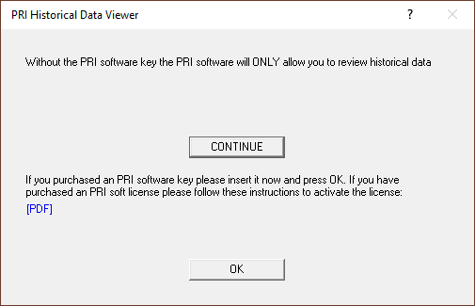

1. A specifically programmed USB dongle key is required to run the PRI software. When starting, if you see the above message, insert the dongle key and click **OK**.

# The Main Screen

The main PRI screen has six buttons. The buttons on the left are for setup and status; the buttons on the right are for running and viewing profiles and exiting the software. Placing the mouse pointer over each button will display a description for each button.



**Setup**

**Exit**

**Search**

**START**

**Status**

Figure 2:PRI Main Screen

|  |  |  |
| --- | --- | --- |
| **Global Preferences**  Set units of measure, Profiler configuration, Basic Password control, Cpk and Optional equipment setup  **Define/Edit Process Window**  Create or edit Process Window files for solder paste and profile specifications  **Hardware Status**  Shows the status of the oven controller (if applicable), DAU Inputs, the profiler status, and operating software components |  | **Run a Profile**  Begins the step-by-step procedure for running a product profile  **Profile Explorer**  Filing system used to manage and view all profiles and Pyrometer Profile data  **Exit**  Exits the PRI software |

# 

# Global Preferences



## Global Tab

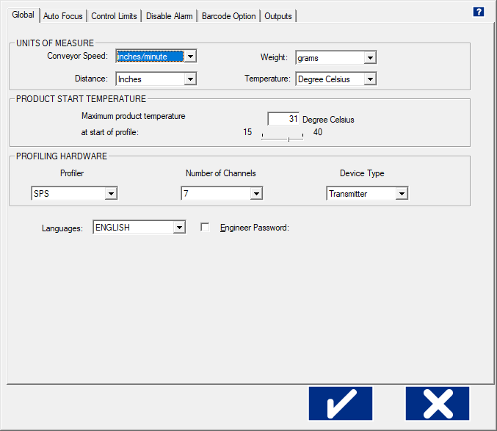

Figure 3: Preferences – Global Tab

* **Units of Measure** – There are four drop down menus to choose units for ***Conveyor Speed****,* ***Distance****,* ***Weight****,,* and***Temperature****.*  The ***Weight*** menu is only used for the ***Auto Focus***functionality.
* **Product Start Temperature** – The software cannot create a profile while a board is too hot. Before a profile can begin, the temperature of all thermocouples connected between the product and the profiler must be below the value you specify here with the slider bar.
* **Profiling Hardware** – Specify the model of your profiler, the number of channels (7, 9, or 12), and, if using the SPS Smart Profiler or X5, specifiy the Device Type - data transmission mode (Datalogger or Transmitter).
  + **Languages –** The *PRI* software is currently available in English language.
  + **Engineer Password** – By checking this and entering a password you can control access to certain menus in the software. See the next section for additional details.

Throughout the software, clicking the  button will ***Save*** the changes made, and clicking the  button will ***Exit*** the screen without saving.

### Password Protection

To enable the basic password functionality, select the ***Engineer Passwor*d** check box, and enter the desired password.

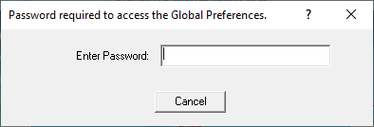

Figure 4: Password Protection

Only a single password is used to restrict access. Items that are password protected:

* Global Preferences button on the main screen
* In the Process Window Screen – Saving or deleting Process Windows or changes to Process Windows
* In the Run a Profile first screen – Remove Oven
* In the Profile Explorer – Delete a profile, or other events
* In the Profile display – Access to the Optimization tab; disabling TCs

As an alternative to this single password functionality, you can configure the software to be protected by user level groups and define specific access allowed for each user group. For more information on this type of password protection feature, see *Appendix C: Password Control – Multi User*.

## Auto-Focus Tab

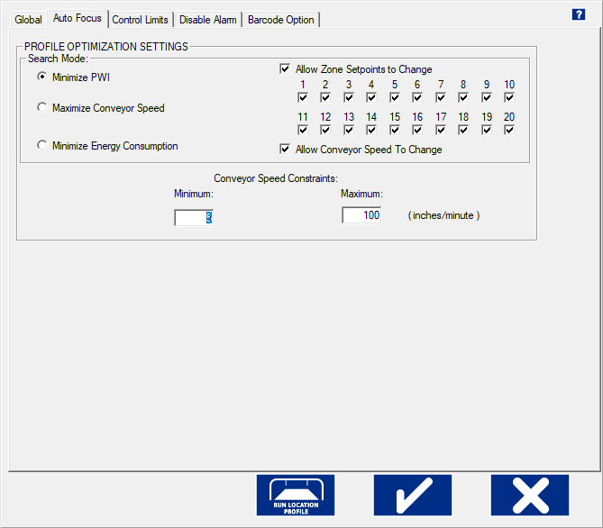

Figure 5: Preferences – Auto Focus Tab

### Profile Optimization Settings—Search Mode

* **Minimize PWI** – Search for the combination of setpoint temperatures and conveyor speed that will minimize the Process Window Index (PWI).
* **Maximize Conveyor Speed** – Search for the setpoint temperatures that will maximize conveyor speed.
* **Minimize Energy Consumption** –Using the Power feature; the software will search for the oven settings that will minimize the power consumption of the oven by finding setpoint solutions with slower conveyor speeds and lower temperature settings.
  + **Allow Zone Setpoints to Change –** This option determines if Auto*-*Focus will include zone setpoint changes when predicting new solutions. It also allows you to exclude individual zones from suggested changes.
  + **Allow Conveyor Speed to Change -** Choose whether to allow Auto-Focus to vary the conveyor speed. If you choose Allow to Vary you can set a desired minimum and maximum.

**Conveyor Speed Constraints**

* **Minimum** – Select the slowest conveyor speed you would allow Auto-Focus to recommend for profiling new products.
* **Maximum** – Select the fastest conveyor speed you would Auto-Focus to recommend for profiling new products.

## Control Limits Tab

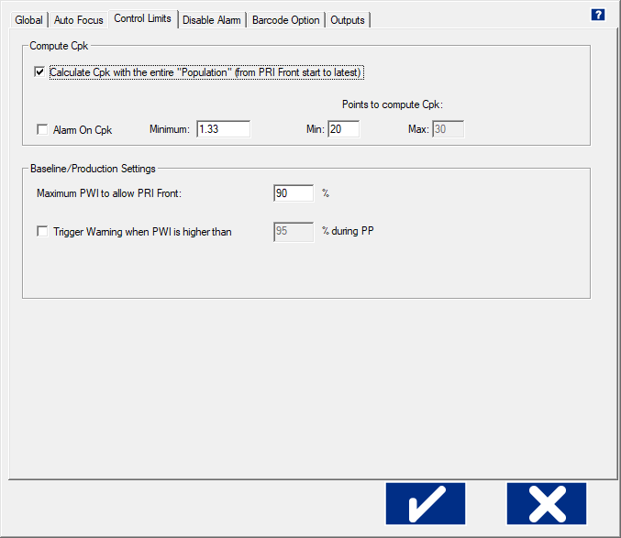

Figure 6: Preferences – Control Limits Tab

**Statistical Process Control** (SPC) for the thermal process is critical for any manufacturing program that involves continuous quality monitoring and improvement. SPC provides the ability to understand the predictability of the process and to know in real-time when a process may be changing and affect product quality.

**Process Capability Index** (Cpk) gives a continuous indication of how current production is keeping within specifications and will indicate if the process is drifting towards a condition where defective product may be produced. It is a measure of where the process spread falls within the Process Window. By monitoring this and alarming when it becomes too low, you can proactively address issues in the process before a single defect occurs.

**Note**: Cpk is only calculated and displayed when Pyrometer Profiling is running.

### Compute CPK

* **Calculate Cpk with the entire “Population” (from PRI** **start to latest) –** When selected, the software will calculate Cpk across an entire production batch once the specified minimum points to compute Cpk has been exceeded.
* **Alarm on Cpk –** Enable or disable the Cpk alarm. If the Cpk drops below the defined Minimum value, the software can activate an onscreen or hardware alarm.
  + **Minimum –** When *Alarm on Cpk* is enabled, this value determines the threshold for the Cpk alarm. If the Cpk value drops below this minimum, the alarm condition is activated. (Default = 1.33.)
* **Points to compute Cpk**
  + **Minimum –** The minimum number of data points needed for the software to begin calculating Cpk.
  + **Maximum –** *(Active when Population is unchecked)* The maximum number of data points to calculate Cpk. The Cpk value is calculated over a rolling window of data, only using up to the maximum data points at any given time.

### Baseline / Production Settings

* **Maximum PWI to allow PRI front –** This value determines the maximum PWI for any given profile to qualify as a Pyrometer Profile baseline. If the PWI for a profile is lower than this value, the profile can be used as a baseline. Profiles that exceed this value cannot be used as a baseline.
* **Trigger Warning when PWI is higher than** – Enabling this feature allows you to display a Warning dialog box on the screen when the PWI exceeds the user defined PWI percentage.

### How the Software Calculates Cpk

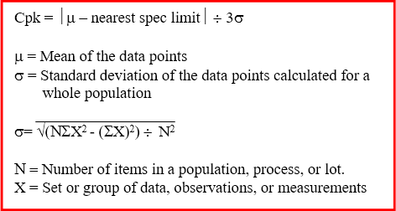

Figure 7: How PRI calculates Cpk

Values used for the spec limits and the data are translated in terms of the Process Window Index.

Here is a simple example. Let us set the Points to Compute Cpk to 5, and the five PWI values are as follows: 68%, 88%, 70%, 64%, and 65%.

Mean = (68 + 88 + 70 + 64 + 65) ¸ 5

= 71

StdDev = √ ((5 • (682 + 882 + 702 + 642 + 652)) – (68 + 88 + 70 + 64 + 65)2) ¸ 52

= √ (127945 – 126025) ¸ 25

= √ 76.8

= 8.76

By definition, the overall PWI is always positive, and the limit is always 100%.

Oven CharacteristicsCpk = ½71 – 100½ ¸ (3 • 8.76)

= 29 ¸ 26.29

= 1.10

So, while the worst PWI is 88%, the Cpk is 1.10 which is below the typical target minimum of 1.33. This tells us that the chance that the process drift out of spec is too high and this process should be improved.

Here is five more sample PWIs: 91%, 91%, 92%, 89%, and 90%.

Mean = 90.6.

StdDev = √ (205235 – 205209) ¸ 52

= 1.02

Cpk = ½90.6 – 100½¸ (3 • 1.02)

= 3.07

Even though every PWI in the second list is considerable higher/worse than the worst PWI in the first list, the Cpk is a very good 3.07. Such a high Cpk indicates that there is very little chance this process will drift out of spec. The reason the second process is better than the first is because the second process has very little variation in it.

## Disable Alarm Tab

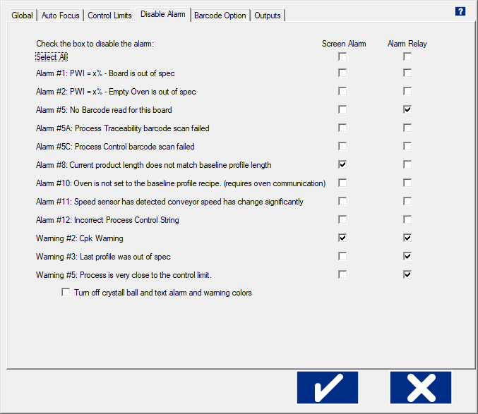

Figure 8: Preferences – Disable Alarm Tab

By default, the PRI software provides many on-screen notifications and alarm relay signals to help keep your process within spec and your production flowing. Selecting the *Disable Alarm* tab displays a matrix of options to let you *selectively disable* any alarm, warning, or relay signal *that does not suit your workflow*.

**Screen Alarm –** This column of features lets you specify if the alarms and warnings appear on your monitor.

**Alarm Relay -** This second Column lets you specify the conditions under which a DAU signal energizes the alarm relay to let it power an audible or light indicator or to stop an infeed conveyor.

**Note:** For some alarms, if you disable a *Screen Alarm* selection, but leave the corresponding *Alarm Relay* selection active, you will have no way of acknowledging the alarm condition. This type of configuration is NOT recommended.

**Select All -**This checkbox selects or deselects all of the options in the column below. Toggling *Select All* resets the options to let you more easily choose individual items.

|  |  |
| --- | --- |
| **Turn off crystal ball and text alarm and warning colors** – This check box (boxed in red) lets you turn off the crystal ball graphic that provides a color-coded status during Pyrometer Profiling. |  |

## Barcode Tab

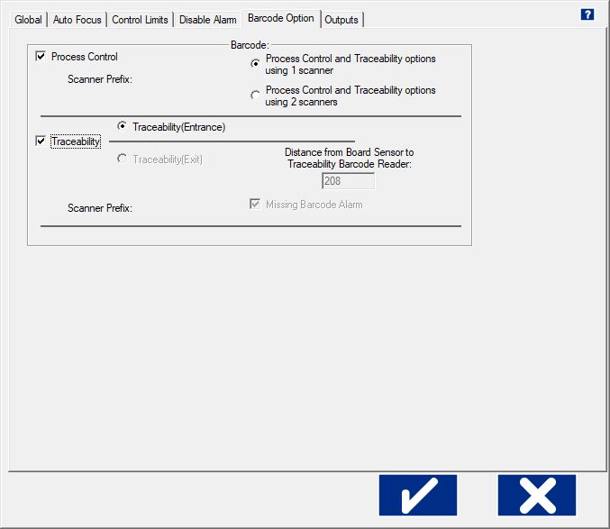

Figure 9: Preferences – Barcode Option Tab

**Process Control –** The feature allows control of the process by comparing the barcode string of a product to the corresponding process currently running. It ensures that the product matches the process.

**Traceability –**  This feature links each product’s unique barcode string to its production profile data.

**Note:** When both ***Process Control*** and ***Traceability*** are selected, radio buttons appear that let you specify using *one or two* scanners, together with fields for entering identifying prefixes for the scanners.

**Scanner Prefix** – Enter the predefined prefix number to identify each barcode scanner when using two scanners. The software uses this prefix to determine which scan goes to which feature—***Process Control*** or ***Traceability***. The prefix is programmed using the barcode manufactures software program. Contact the barcode scanner manufacture for more information.

**Note:** The ***Traceability (Exit)*** configuration, and its associated settings and fuctionality are NOT supported.

See the *Barcode section* for more detailed information about configuration and operation.

## Outputs Tab

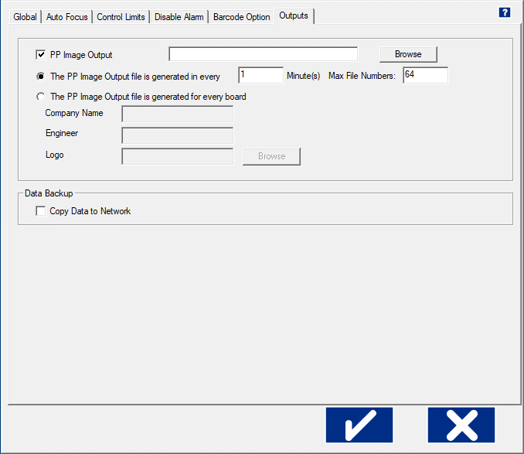

Figure 10: Global Preferences – Outputs Tab

### Pyrometer Profile Image Output

The *Pyrometer Profile Image Output* generates an image file of the product profile data while Pyrometer Profiling is running live. The image file is output in the form of a .JPEG file type. The output file can be generated at user selected time intervals, or for each board processed and optionally in a pre-configured network location (pg. 17).

To enable this feature select the check box and browse to a network location to store the *Pyrometer Profile* image files.

* + **The PP Image Output file generated every X minute(s) –** Selecting this option will generate the images based on time interval. Enter the time in minutes (1 – 60) at which it generates each image.
    - **Max File Numbers -** Enter the maximum number of files (64 – 512) to be stored in the destination folder. PRI automatically limits the number of files in this folder during live Pyrometer Profiling situations. When the maximum number of files is exceeded, new files automatically replace the oldest files.
  + **The PP Image file generated for every board –** Selecting this option will generate an image for each board.

**Note:** When this selection is in use, the *Run a Verification Profile* and *View/Edit Process Window* buttons are unavailable. Additionally, when using this selection you can specify additional information that will appear on the image:

* + - **Company Name**
    - **Engineer**
    - **Logo (.**BMP file type**)**

#### Examples of Image Output

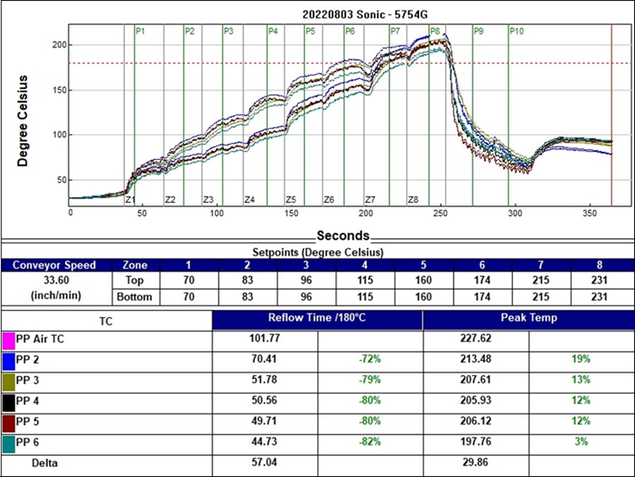

Figure 11: Image Output

### Copy Data to the Network

The *Copy to Network* tool lets you store all PRI files and data to a network location for backup or archival purposes. When you click the check box, the tool software launches, and an icon appears in the system tray area. Right click, and then choose *Settings* to configure the *CopyToNetwork* settings.

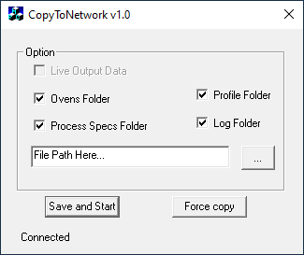

Figure 12: CopyToNetwork Software Tool Screen

Select the folders and/or data to be copied and then enter or browse to the network location. You must enter a valid network path. Click the Save and Start button to begin copying the selected files and folders to selected network location.

The software will prompt you to either, copy all the data now or save the settings without copying the data.

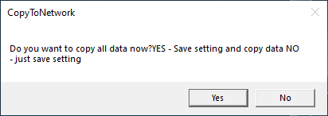

Figure 13: CopyToNetwork Message

**Yes** – The selected data is copied to the selected network location and the settings are saved.

**No** – The settings are saved, but no data is copied.

**Note:** If the network location is not available, is an invalid path, or the network is disconnected, PRI temporarily writes the selected data to the *C:\PRI\_Data_Backup_* folder until the network path or connection has been reestablished.

1. The CopyToNetwork tool launches automatically as long as the Copy to Network option is checked in the Global Preferences-Global tab.
2. Whenever any selected folder is updated with new/modified information, the new information is automatically backed up to the network location without any further user interaction.

# Process Window Setup

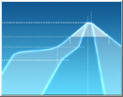

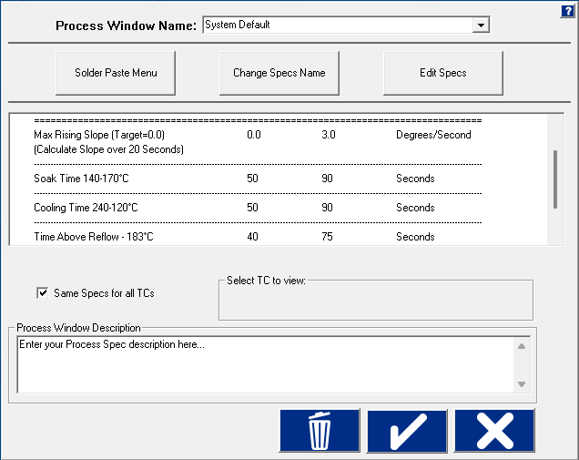

Deselect this check box to assign separate specs for each thermocouple used. See details below.

Read Only Text Box

Figure 14: Process Window Setup

**Process Window Name** – Name of the Process Window file that includes the statistics chosen and limits for those statistics, along with whatever text appears in the Description field.

**Solder Paste Menu** – A ‘read only’ library list of numerous solder pastes along with the statistics and limits suggested by the paste manufacturer; also included is a user-defined option in the list which allows you to create a specification of your own. (See below for additional details)

**Change Specs Name** – Opens an external application allowing you to customize the name of any individual statistic. (See below for additional details)

**Edit Specs** – Screen allowing you to edit or choose statistics and limits for a chosen solder paste or define your own specs.

**Read Only Text Box** – For the given Process Window chosen it states the paste name, statistic’s used, and their cooresponding limits.To edit select the *Edit Specs* button.

**Same specs for all TCs** – By deselecting this checkbox, you can assign separate specifications for each individual thermocouple you are using. This option would be used if you had component specific specifications that differ from the general solder paste specs. Another use for this would be if you wanted to monitor the actual board temperature as well as component temps. You would then only select the statistics for that TC that are relevant. If you wish to use the same specifications for all thermocouples, put a check mark in the box.

**Select TC to view –** This dialog box will appear only if the Same Specs for all TCs checkbox is deselected. By clicking on the dropdown menu, you can view the specifications that have been defined for that number thermocouple. If a description was included, it appears next to Label.

**Process Window Description** – Field allowing for freehand notes for a particular Process Window.

## Solder Paste Menu

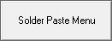

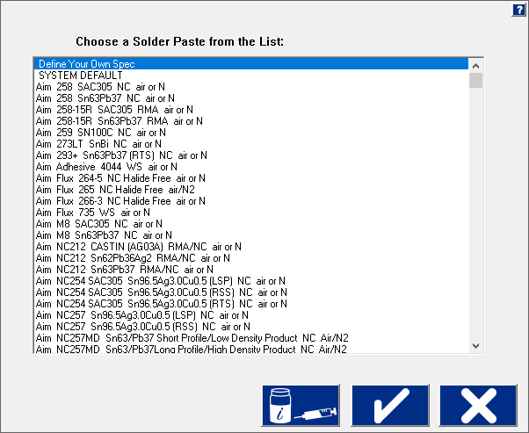

Figure 15: Solder Paste Menu

**Solder Paste Menu** - Once you have clicked on *the Solder Paste Menu* you will have a list of pastes to choose from. Use the scroll bar on the right to find your paste, and then click on the paste in the list.

* Clicking the **paste jar and tube** button will give you technical support information for the solder paste manufacturer that is currently highlighted in the list.
* Clicking the **checkmark** button will accept that paste and load its reflow specifications.
* Clicking the **X** will cancel your selection and return you to the Process Window screen without making any changes.

## Edit Specs

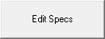

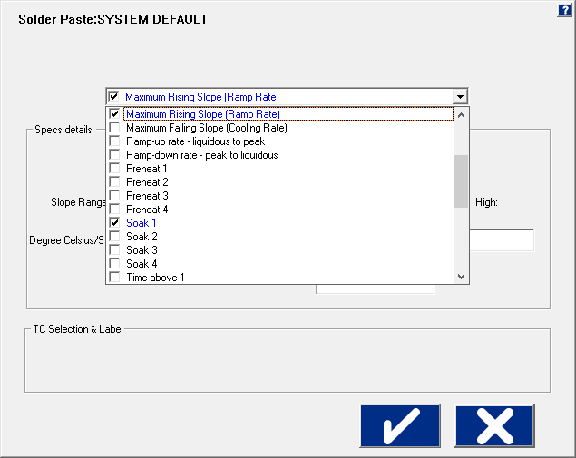

Figure 16: Process Window Edit Specs

The name of the solder paste selected from the *Solder Paste Menu* appears at the top of the screen.

There is a single drop-down list at the top that contains all of the available specifications that can be applied to your Process Window. These specifications are specific limits or a group of limits that define the overall Process Window for your product. These specifications include Slope, Preheat, Soak, Peak temperatures, and Time above temperatures.

**Spec Details** – The Spec Details coincide with the selected Specification check boxed in blue. For each Specification selected, enter the Temperature, and Time limits. These limits are usually dictated by the solder paste used. The limits are used to measure the profile PWI.

***CAUTION****:* Changes made within this screen will have a direct effect on the profile PWI value.

Once you have completed all spec modifications you can click on the **check** (Save and Exit) button and your changes are applied. Clicking on the **X** button will cancel your changes and exit.

### Specify Different Specs for Individual TCs

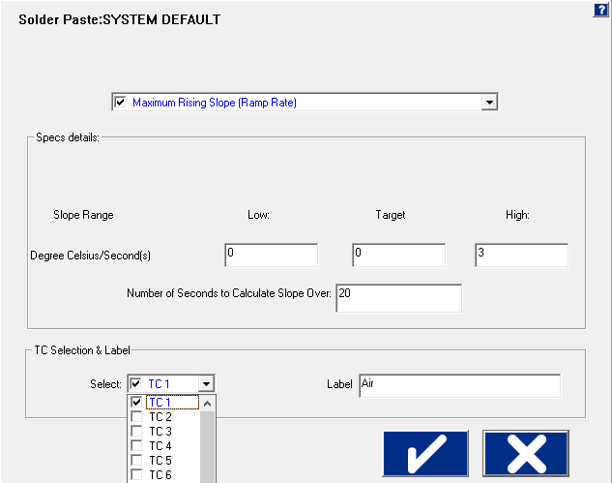

This Section is specific for *Separate Specs* for each TC

Figure 17: Edit Specs screen with TC Selection & Label panel displayed

**TC Selection & Label**

If you have deselected the Same Specs for all TCs option on the Process Window Setup screen, when the Edit Specs screen appears, it will display an additional TC Selection & Label.

* **Select** – Use the Select drop-down menu to select the TC whose specifications you wish to view/edit. The Spec Details for the selected TC appear.
* **Label –** This area lets you type in a description or label to identify that particular TC. If left blank, the TCs will simply be identified as TC2, TC3, etc.

**Note:** When using separate specs, the Edit Specs screen is the only place where you can select or deselect which TCs are used for a profile.

Once you have completed all edits of the specs you can click on the **check** button and your changes are applied. Clicking on the **X** (Cancel) button will cancel your changes and exit.

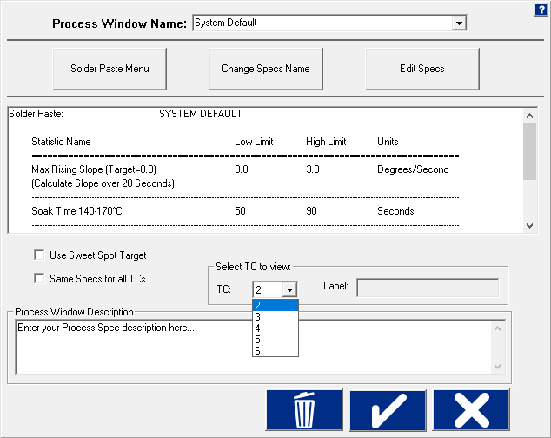

Figure 18: Process Window Select TC to View

**Select TC to View** – Drop-down menu containing the TCs that have already been defined. (Previous step).

## Change Specs Name

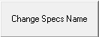

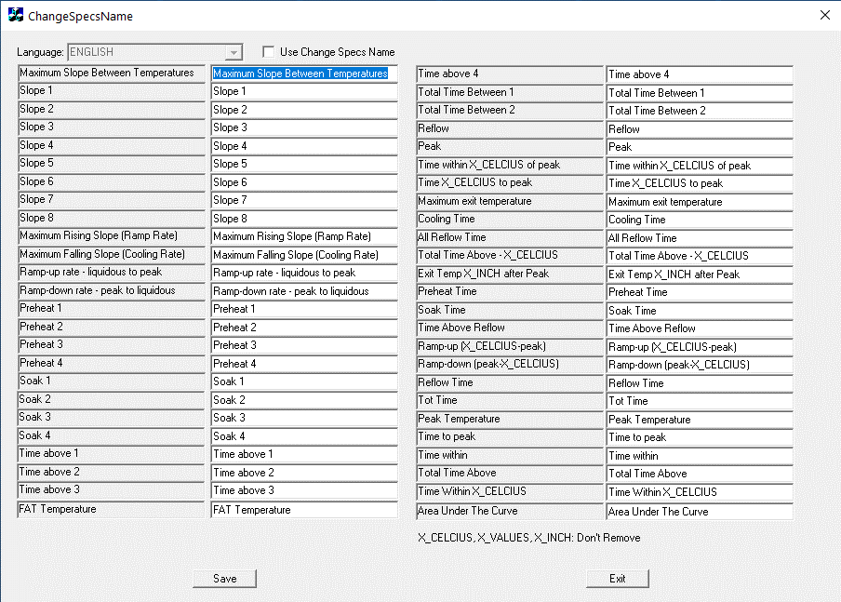

Figure 19: Save Process Window

If you wish to rename the label for a particular statistic, start by clicking on the *Change Specs Name* button, which opens a separate window. Select the check mark adjacent to ‘Use Change Specs Name’ at the top of the screen to enable this change function. Next, locate the desired specification in the greyed out columns, and type in the new name in the corresponding editable column. Click **Save**, then **Exit** to close the window and return to the Process Window screen.

## Save - Process Window

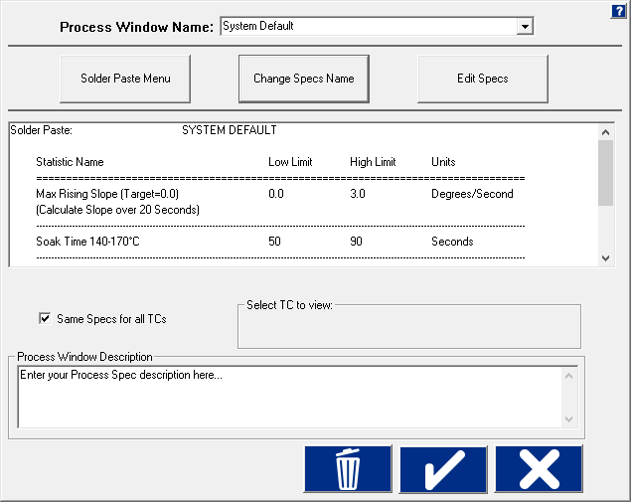

Figure 20: Save Process Window

To create a Process Window, follow these steps:

1. *Choose a solder paste* from the **Solder Paste Menu**.
2. *Edit the specs* if necessary.
3. *Name the Process Window*
4. *Save* the Process Window by clicking the **check** (save and exit) button

A dialog box appears asking if you want to add this Process Window to your current list of Process Windows.

1. Click **Yes** will save it and exit to the main screen.

You can click **No** and then click the **X** (cancel) button to exit without accepting or saving any changes.

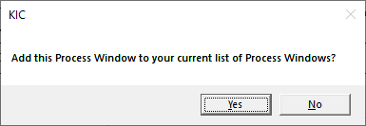

Figure 21: Add Process Window Prompt

## Import Legacy Process Windows

You can import process windows that you have created in *RPI* or other KIC software into *PRI* and use them in your current production.

1. Open the RPI main product folder.

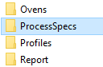

1. Open the RPI **Process Specs** folder:

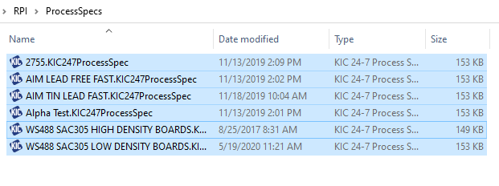

1. Copy the files that you want to run in PRI.

1. Open the PRI main product folder and then open the PRI **Process Specs** folder.



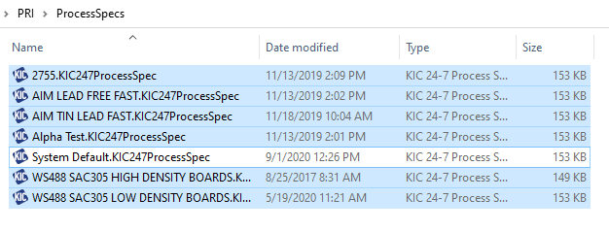

1. Paste the copied files into the folder.

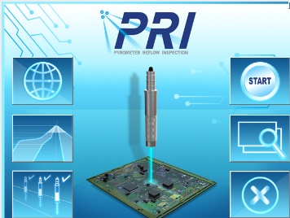

1. Run the PRI software.

1. On the PRI Main screen, click the **Define Edit/Process Window** button.

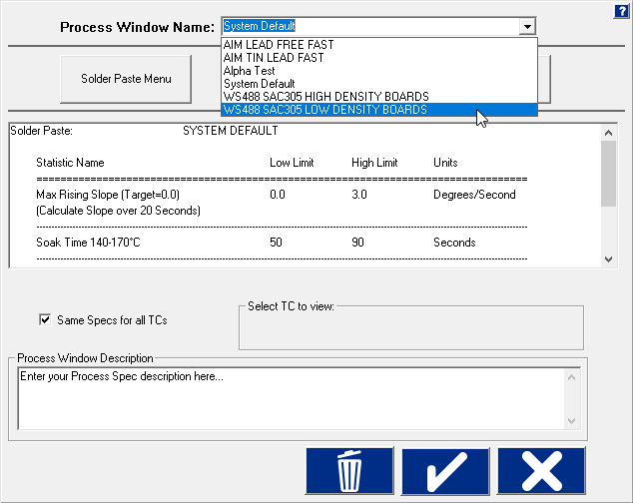

1. The Process Window Name screen appears, showing the copied files available for selection in the drop-down menu.

# Hardware Status

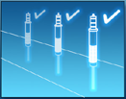

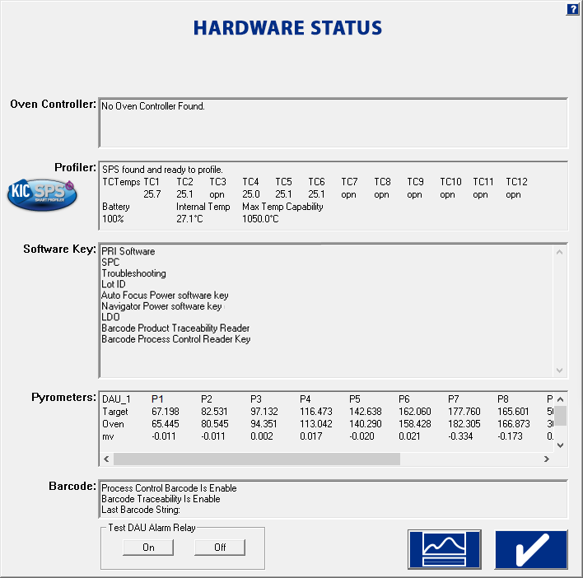

Figure 22: Hardware Status Screen

**Oven Controller –** When connected to an oven that can communicate with the PRI software, the software will display oven status and display the oven control software name.

**Profiler –** Shows the status of the profiler. This box displays the following information:

* Profiler communication status
* TC Temps– for all connected thermocouples
* Battery – percentage of battery life
* Internal Temperature – currrent temperature inside the profiler
* Maximum Temperature Capability – the maximum temperature the profiler can read

**Software key –** Displays all the features currently programmed on the USB Dongle key.

**Pyrometers –** The current live temperatures for the pyrometers are displayed. If you do not see any data displayed in this field, the PRI software is not communicating properly with the DAU hardware.

**Note:** If you are using the barcode capabilities, the last barcode read by a scanner appears.

# Run A Thermocouple Profile



The **Run a Profile** button will guide you through a series of screens. Use the **Back** and **Next** arrow buttons at the bottom to move through the screens in the process, which will end with a completed and graphed profile. The **Cancel** button returns you to the main menu.

**Note:** If you have already profiled your product using the PRI software, you can save time and go directly to the Profile Explorer, start a Pyrometer Profile, or load the most recent profile for your product, then use the PRI prediction capabilities to improve the profile PWI and generate new oven setti

## Run a Profile Screens

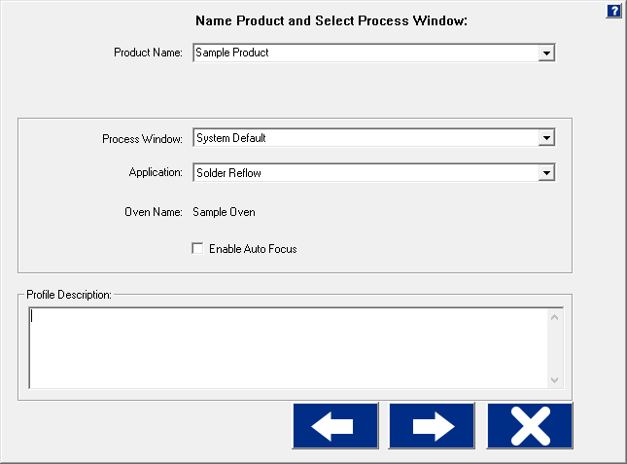

**Back**

**Next**

**Cancel**

Figure 23: Run a Profile Screen #1

**Product Name** – Enter a unique product name (long file names are acceptable) or choose an existing product name from the drop-down list.

**Process Window** – Choose a *Process Window* from the drop-down list. These Process Windows are created in the Define/Edit Process Window screen that is accessed from the main screen.

**Application** – Select your application type from the list. The software will function depending on the selected application type. Some variables that might change depending on the selected Application type are: *data-sample rate and specific artwork*.

**Oven Name –** The oven file has information about the number of zones saved with it as well as other zone information. These details, as well as the oven name, are entered in the *ConfigurationProgram.exe* application.

***CAUTION:*** The oven and system configuration settings are entered when the system is installed, and typically do not need to be changed. Contact Technical Support before making any changes to these values.

**Profile Description** – Allows for freehand typing of any notes you may want to include with this profile.

1. Click the **Next** button.

## Auto-Focus, Product Dimensions

If you enable the Auto-Focus software and check the box, the following screen appears:

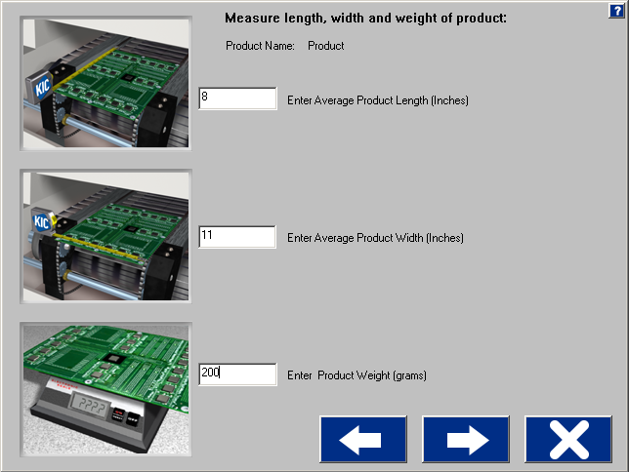

Figure 24: Run a Profile – Auto Focus screen #1

Use the fields to enter the length, width, and weight of your product. (Make sure to measure using the correct units of measurement)

1. Click the **Next** button.

This product is included in the Auto-Focus library from this point forward.

### Auto-Focus, Confirm

|  |  |
| --- | --- |
| The ***Confirm*** screen appears so that you may confirm the product measurements you entered.  You have two choices:   1. **Use current Oven Recipe** – use the most recent oven recipe setting for this product.   The next screen will display the most recent setpoints and conveyor speed for this product.   1. **Use Auto-Focus to find an in-spec Oven Recipe** – This will initiate the Auto-Focus software for this product. | Graphical user interface, application  Description automatically generated  Figure 25: Run a Profile – Auto Focus screen #2 |

|  |  |
| --- | --- |
| If the Use Auto-Focus… button is selected and no matching product is found, this dialog will appear. Click the **OK** button.  You are returned to the Confirm screen. Select the **Use Current Oven Recipe** button and enter the oven setpoints and conveyor speed you want to start with. | Graphical user interface, text, application, email  Description automatically generated  Figure 26 |
| If the Use Auto-Focus*…* button is selected, but there are not enough products in the database to confidently give an expected PWI, this *Auto-Focus* dialog appears.  **Yes:** the next dialog box shows the Auto-Focus–First Guess recipe in order for you to confirm.  **No:** you are returned to the Confirm screen. Select the ***Use Current Oven Recipe*** button and enter the oven setpoints and conveyor speed you want to start with. | Graphical user interface, text, application  Description automatically generated  Figure 27 |

|  |  |
| --- | --- |
| If the Use Auto-Focus… button is selected and there are a enough boards in the database, this *Auto-Focus* dialog appears.  **Yes:** the next dialog box shows the Auto-Focus –First Guess recipe for you to confirm.  **No:** you are returned to the Confirm screen. Select the ***Use Current Oven Recipe*** button and enter the oven setpoints and conveyor speed you want to start with. | Figure 28 |

If you select **YES**, the following screen appears, prompting you to confirm the first guess recipe.

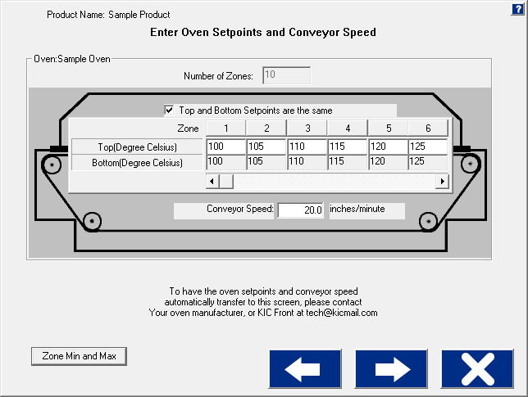

Figure 29: Run a Profile – Oven Recipe

1. Click the **Next** button.

If there is no communication with the oven controller, the following dialog box appears. You must manually enter the recipe information on the oven.

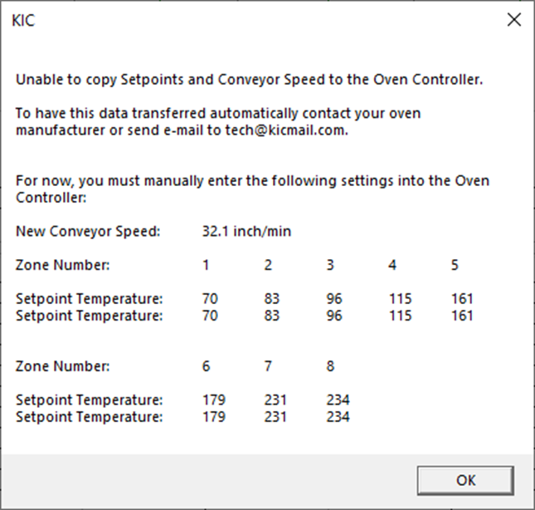

Figure 30: Run a Profile – No Oven controller communication

If there is communication with the oven, then the recipe is copied directly to the oven.

## Oven Characteristics

To ensure accurate profile data, you may need to enter specific information into the software about the oven(s) you intend to use--information that changes the default values used by the software’spredictive algorithms. These default values are stored in an oven *initialization* file that the software creates when you first enter the name of a new oven. The software adds the extension. kiccfg to the name you entered and stores the file in this location:

*C:\PRI\Ovens*

Unless you specify otherwise, the software works with the following initialization file default assumptions:

* The zones are uniform and consecutive with no large gaps between them.
* The minimum temperature for all zones is 70° C.
* The maximum temperature for all zones is 315° C
* Default setpoint values start at 100° C and increases at 5° intervals at each zone.

These values are entered in the *ConfigurationProgram.exe* application under the ***Oven Settings*** tab. You may need to set some values, such as min/max temperature limits only once - when you first set up the oven. Others, such as temperature setpoints and conveyor speed values that make up an oven *recipe*, you may change frequently to match to new products.

***Important:*** The oven and system configuration settings are entered when the system is installed, and typically do not need to be changed. Contact Technical Support before making any changes to these values.

## Specify An Oven Recipe

|  |  |
| --- | --- |
| 1. In the ***Enter Oven Setpoints and Conveyor Speed*** screen, type in new temperature values for the top of the oven zones.   **Note***:* This screen does not appear when thePRI softwareis communicating with an oven controller. | Figure 31: Run a Profile – Recipe screen |
| 1. If the bottom of the zones has different setpoint values than the top, deselect the **Top and Bottom Setpoint are the same** checkbox.   The bottom row of fields becomes editable (white). | Description: Description: C:\Users\dklueck\Desktop\New oven setup art\Top and bottom zones.png |
| 1. Enter new temperature values in the bottom row fields. 2. Type in a value in the ***Conveyor Speed*** field.   Description: Description: C:\Users\dklueck\Desktop\New oven setup art\conveyor speed field.png | |
| 1. Click the **Next** button to advance to the thermocouple attachment phase of running a profile. | |

## Attach Thermocouples

Thermocouples (TCs), attached to solder joints or other important sites on the board, directly measure the temperature at the point that the TC bead is in contact with the PCB. The TC measurements are collected by the profiler and the PRI software to create thermal profiles.

Two methods are typically used to attach TCs—*aluminum tape* and *high temperature solder*. Both methods are acceptable.

The system works with two kinds of TCs—*standard* TCs and the *Air TC*. Standard TCs record the temperature data for various sites on the board. The air TC is used solely for predictions.

### Attach The Air TC

There are *two* important considerations regarding the Air TC:

|  |  |
| --- | --- |
| 1. It must be attached at the leading edge of the board, extending approximately 1.5 inch (38 mm) in front of the leading edge of the board. 2. It MUST be plugged into channel 1 on the profiler. 3. Click the **Next** button. |  |

### Attach Standard TCs

|  |  |
| --- | --- |
| Attach the standard TCs at selected sites on the board, and plug them into the remaining connectors on the profiler. Order is not important, unless you plan on labeling where each TC is attached.  When selecting a position for the standard TCs, you want to measure points on the product that represent the mass-range of the product. Select at least one position that is a high mass (large component) area of the board and at least one position that is a low mass (small component) area of the board. If you can develop an acceptable profile for the low and high mass areas of the board, you can process the other areas of the board within the same parameters.   1. Click the **Next** button. |  |

## Attach Thermocouples To Semiconductor Wafers

|  |  |
| --- | --- |
| Attach The Air TC  1. It must be attached at the leading edge of the wafer, extending approximately 1.5 inch (38mm) in front of the leading edge of the wafer. 2. It MUST be plugged into channel 1 on the profiler. |  |
| Attach Standard TCs Attach the standard TCs at selected sites on the wafer, and plug them into the remaining connectors on the profiler. Order is not important, unless you plan on labeling where each TC is attached. |  |

## Selecting Thermocouples

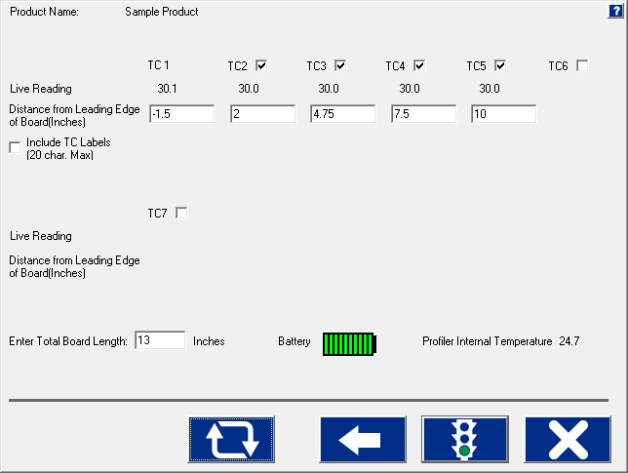

Figure 32: Run a Profile – Select TCs

**TC Check Boxes** – Place a check next to each TC channel that is going to be used for this profile. TC number 1 is always used for the AIR TC, and you must use at least one other TC.

**Live Reading** – When the KIC profiler is on and plugged directly to either the download cable for datalogging or transmitting to the Base Station/Smart Dock, you will see live temperature updates for the TCs plugged into the profiler. The TC checkbox must be selected for each TC you are using in order to view the temperature readings.

**Distance from Leading Edge of Board** – Enter the distance from the leading edge of your product back to each TC location.

**Note:** TC1 should *ALWAYS* be at -1.5” (-38mm).

**Include Thermocouple (TC) Labels (20 char. Max)** – Checking this will display a field below each TC that is selected. Up to 20 characters can be used to describe the placement or description of the TC.

**Board Length** – Enter the length of the board to be profiled. When using Auto-Focus, this value will automatically be filled in based on previous Board Length entry.

**Battery** – Displays the current profiler battery power. The software will recognize if your battery voltage is too low and will not allow you to start a profile until the battery has enough voltage to complete the profile.

**Profiler Internal Temperature** – Displays the internal temperature of the profiler. If the temperature is too high to complete the profile and stay under the maximum rating for the unit, it will not allow you to start the profile until fully cooled to operating temperatures. The software will let you know what temperature you will have to cool below.

***Important:*** All profilers have a maximum internal operating temperature that, to avoid damage, *should never be exceeded.* See the product datasheet for additional temperature tolerance information:

|  |  |
| --- | --- |
| Profiler model | Maximum internal operating temperature |
| X5 | 85°C/185°F |
| K2 | 85°C/185°F |
| SPS Smart Profiler | 85°C/185°F |

## Start the Profile



Select this button to start a profile.

Figure 33: Run a Profile - Start

1. Once the oven has stabilized and you are ready to load the profiler and profile board, click the **start profile** button (green traffic light).The software will ask if all the oven control thermocouples are within 2 degrees of the setpoint temperature values.

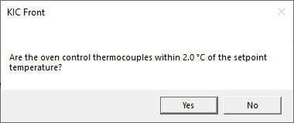

If the control thermocouples are NOT within 2 degrees of the

setpoints, click **No**, then reference Appendix B.

**Note:** This dialog box will not appear if the PRI software is communicating with the oven controller. The oven controller will send the oven control thermocouple data directly to the PRI software.

Figure 34

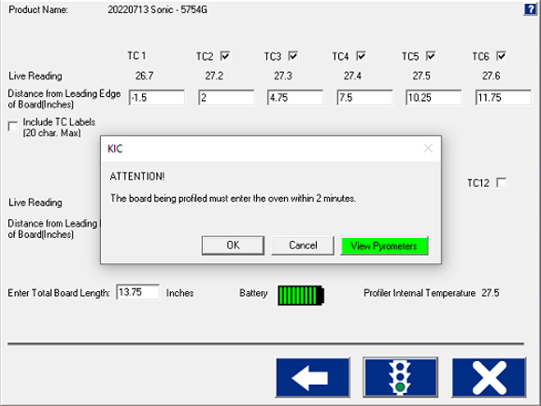If you select **Yes**, the PRI software will display a prompt informing you that the profiling board must enter the oven within 2 minutes. Click **OK** to continue.

Figure 35

If the oven temperatures are stable, the View Pyrometers button will display in green. If the oven is not stable, it will display in red. Clicking the **View Pyrometers** button allows you to view a display of the current pyrometer readings.

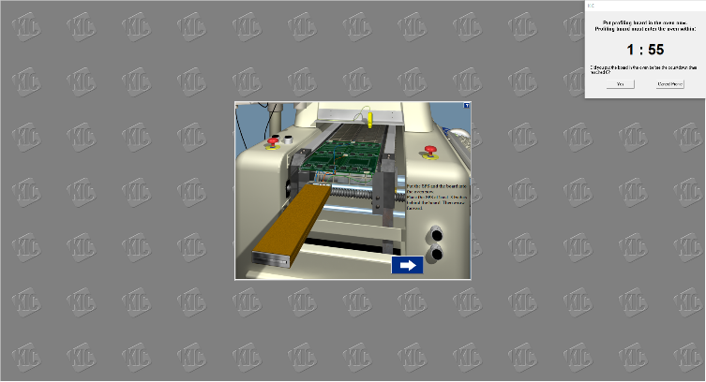

Next, the software will prompt you to put the profiler and profile board into the oven. Then choose the **forward arrow** button.

**Note:** For the pyrometer sensor to properly calculate the length of the profile board, make sure the KIC profiler is at least 8” behind the profile board. For product profiling and Verification profiling (while Pyrometer Profiling is going), the software will ignore any boards including the KIC profiler that fall within 24” of the trailing edge of the profile board.

Figure 36: Insert Profiler/Product

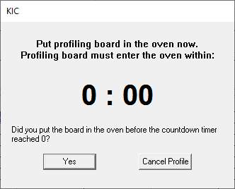If the board was placed into the oven before the countdown timer reached 0, click **Yes.**

If the board wasn’t placed into the oven or before the timer reached 0, click **Cancel Profile**.

Figure 37

## Live Profile Graph

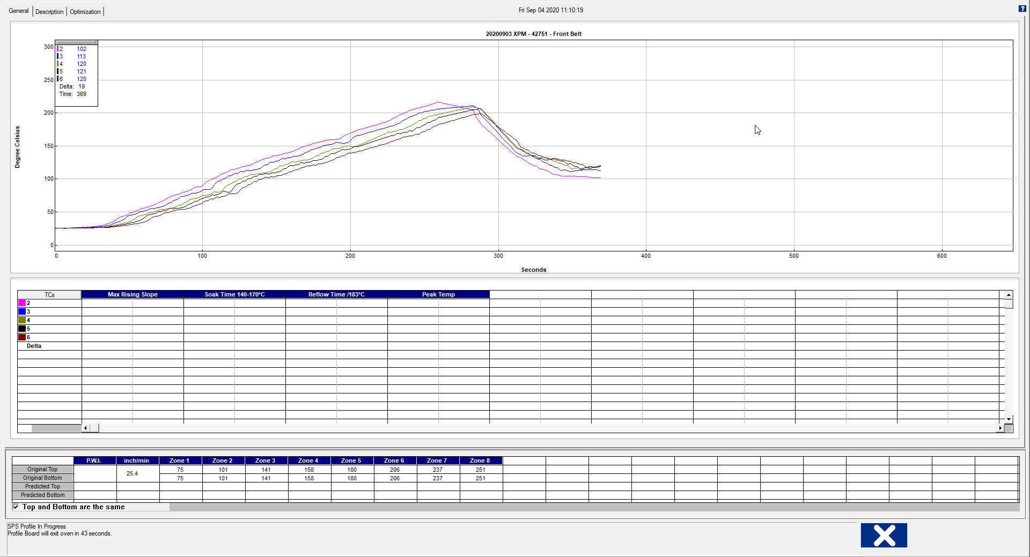

Live profile status

Oven temperature settings and conveyor speed.

Temperature plots

Live temperature readings and Delta

Figure 38: Live Profile Graph Display

**Note:** This will only appear live when using wireless profiler models.

The live profile graph screen shows the real-time plot of the product as it travels through the oven. The bottom area of the screen displays the live status of the profile. During the live profile, all the tabs on the screen are deactivated and are inaccessible to you. The only action that you can take at this point (besides waiting for the profile to complete) is to cancel the profile by clicking on the **X** button. This will bring you back to the main menu.

**During the live profile:**

(Wireless models only.)

* The live profile is plotted on the graph.
* The current temperatures for each thermocouple and the Delta between them are displayed in a small window in the upper-Left hand corner of the profile graph. The elapsed time is also displayed.
* The current oven temperature setpoints and conveyor speed for this profile is displayed beneath the Statistics table.

## Profile Retransmission

**Note***:* For users of profilers with wireless capability.

While the profiler transmits the live profile data to the computer running the PRI software, it simultaneously stores the profile data in its onboard memory.

Once the profiler reaches the end of the oven, the profile recording will stop and it will begin retransmitting the profile data. When retransmission begins, the KIC profiler will send the profile in data packets. The retransmission status appears at the bottom of the screen.

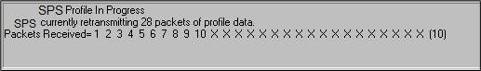

Figure 39: Wireless models profile retransmission

If you have a Data logger version, you must remove the KIC profiler from the oven and thermal shield and then connect the download cable to the KIC profiler. The profile data will automatically begin downloading to the PRI software.

***CAUTION****:* The profiler and your product may be HOT when exiting the oven. Always use gloves when handling.

When all the data packets have been received, the software will display a message asking you to turn the profiler off, choose **OK**. Failing to turn the profiler OFF will drain the battery**.**

After the KIC profiler has completed its retransmission, the next message will ask if the thermocouples are still firmly attached to the board. Click **OK** and you are brought to the Graph screen, with the profile and statistics displayed for the current profile run. If any of the thermocouples used became unattached or has developed a loose connection to the board, select **NO**. If you choose **NO**, the profile CANNOT be used as a baseline profile for Pyrometer Profiling.

## View the Profile and Statistics

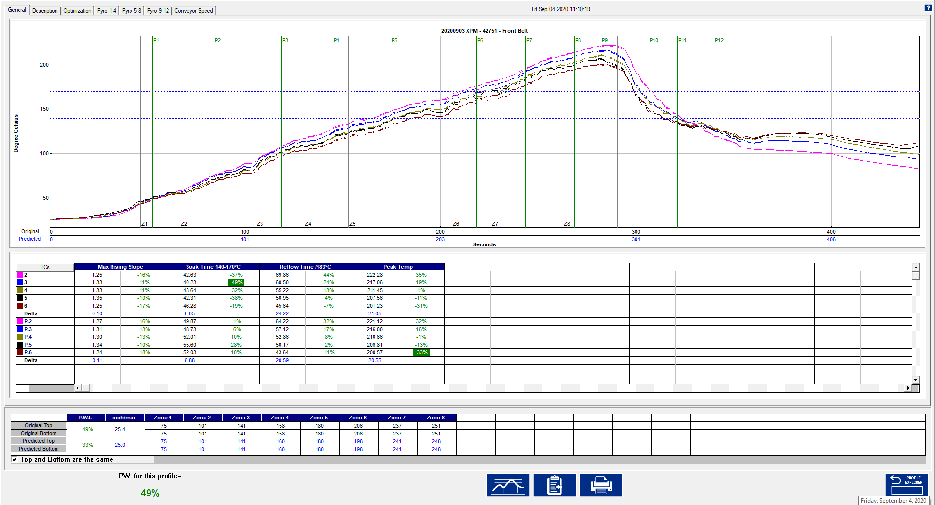

Figure 40: Profile General Tab – Shows graph, statistics, and recipe

### General Tab

The General tab shows the profile graph, profile statistics, and current predicted recipes. To enlarge the graph portion of the General Tab, simply double click on the graph. To enlarge the statistics portion of this screen, double click on the statistics.

**Note**: If you have run a profile that meets the Pyrometer Profile criteria, then a ***Start Pyrometer Profiling*** button will appear once the profile has completed. Click the button to start Pyrometer Profiling for this product.

### 

### Profile Graph Display



***Predicted*** profile plot (dotted lines)

***Original*** profile plot (solid lines)

Figure 41: Graph Display

The PWI for the profile appears in the bottom-Left corner of this screen. If the measured PWI is below 100%, the value appears in a green font. If the measured PWI is 100% or higher, the value appears with a red font. This enables you to easily identify whether the profile is in or out of spec.

 

A PWI under 100% is acceptable.

A PWI above 100% is unacceptable.

Figure 42: PWI

### The Graph Controller

|  |  |
| --- | --- |
| The ***Graph Controller*** settings allow you to modify the view of the PRI-profile graph. To open the Graph Controller, left-click on the TC column header in the Statistics table.  **Auto scale –** The Auto Scale feature will automatically adjust the X and Y-axis scales to fit all of the data in the profile graph. When the Auto Scale feature is disabled, you must manually input the minimum and maximum scale settings for the X and Y-axis scales of the profile graph.  **TCs –** The TCs section is a list of the thermocouples used for the profile. If you wish to view the profile without a particular thermocouple, you can deselect it, or deselect the “All” check box, and choose only the thermocouples you wish to view. The software recalculates the PWI and updates the profile statistics based on the remaining thermocouples selected. You must select at least one product thermocouple.  **TC’s Line Thickness –** – The pull-down menu lets you select five different thicknesses for the TC lines drawn on the graph.  **Board Length –** Displays the board length defined when the profile was run. | Table  Description automatically generated  Graphical user interface, application, Word  Description automatically generated  Figure 43 |

**Grid –** Enables/disables the view of the X and Y-Axis scales.

**Reference lines –** Enables the view of Reference Lines displayed on the profile graph. These lines represent any temperatures referenced in the selected Process Window.

**Zone lines –** Enables the view for the oven zone lines on the profile graph.

**Predicted TCs only** - Removes the original profile plot from view, displaying only the prediction profile plot on the graph.

**Original TCs only** - Removes the predicted profile plot from view, displaying only the original profile plot on the graph.

**Zero decimal** – When viewing the Examine tool, this setting enables or disables the decimal display. When unchecked, the software will display one decimal point.

**Internal temp** – Enables the view of the profiler’s internal temperature profile plot on the graph.

**Display Detailed PWI** – With this unchecked, you will only see the “overall” PWI for the profile. It will not display the individual TC PWI values.

**Extra Cooling Slope** – Enabling this feature displays multiple Cooling Slope measurements which are customizable by the user.

**Floating O2 PPM display** – When the *O2 Live* option is purchased, you can enable/disable a window on the graph that shows the O2 measurement during production.

### Graph Option Menu

To view the graph option menu, right-click anywhere within the profile graph area. This menu gives you a host of options to edit your profile graph listed below.

Figure 44

#### Graphical user interface, application Description automatically generatedExamine

After selecting a pop-up display asking to ‘Turn on Examine Line Mode’, select **OK**. This displays the given temperature for the location of the cursor on the profile graph in a window in the upper left-hand corner.

Figure 45

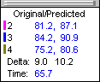Wherever the examine line is moved across the profile, the following data appears:

* The first column is the actual temperature for each TC.
* The second column is the temperature of the predicted profile data – based on setpoint or belt speed changes.
* The Delta T for both actual and predicted TC data.
* The time during the profile at which the pointer is placed

Figure 46

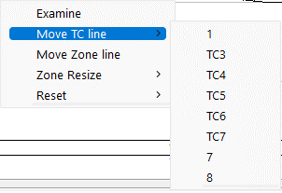

#### Move TC Line

The Move TC line feature allows you to manually move the thermocouple plot on the profile graph. Moving the plot lets you fine-tune the profile or make corrections if the measurement was entered incorrectly.

Select the thermocouple you wish to move and then click and drag the highlighted plot and move it to the desired location on the profile graph.

Figure 47



Figure 48: Move TC Line

#### Graphical user interface, text, application, table Description automatically generatedMove Zone Line

The *Move Zone line* feature lets you manually move the zone separation lines on the profile graph. You can use this feature to fine-tune the profile or make corrections in the event the software did not properly display the zones.

Figure 49

#### Zone Resize

Select to move the first line (Zone beginning) or the Last line (Zone ending) and then click and drag it to the desired location on the profile graph.

Figure 50

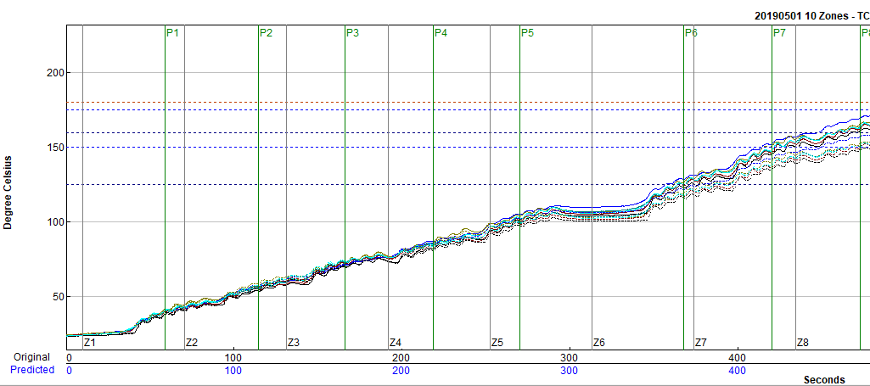

Figure 51: Zone Resize

#### Reset

The Reset feature will reset the profile and undo any changes you have made to the graph using the Graph Option Menu. Select the TC Line, or Zone Line option.

Figure 52

### Profile Screen Buttons

There are four buttons at the bottom of the profile screen:

|  |  |
| --- | --- |
|  | **View/Edit Process Window –** Choose this button to either view or edit the process specification(s) for the product used in this profile. |
|  | **Copy to Clipboard –** Choose this button to copy the profile data to the windows clipboard. You can then paste the data to a different application. |
|  | **Print –** Choose this button to print a copy of the profile that is currently on your screen. |
|  | **Check button –** When finished viewing or analyzing the profile select this button to either run another profile with this product or return to the PRI main menu. You return to the Profile Explorer if the profile was opened from there. |

### General Tab Buttons

|  |  |
| --- | --- |
|  | **Start Pyrometer Profile –** If your profile meets Pyrometer Profile criteria, this button will appear. Choose this button to start Pyrometer Profiling using the displayed profile as a baseline. |
|  | **View/Edit Process Window –** This lets you view the Process Window specifications and limits. |
|  | **Copy to Clipboard –** This button will copy the profile data to the clipboard for use with third-party software such as a spreadsheet application, or SPC software. |
|  | **Print –** This button will print the current profile. For more information about printing, see the section titled Profile Printing.  **Note**: If you wish to print a tab besides the General tab, pressing F9 on your keyboard will print the contents of any screen in the PRI software. |
|  | **Check button –** Select this button to run another profile or to exit. |

## Description Tab

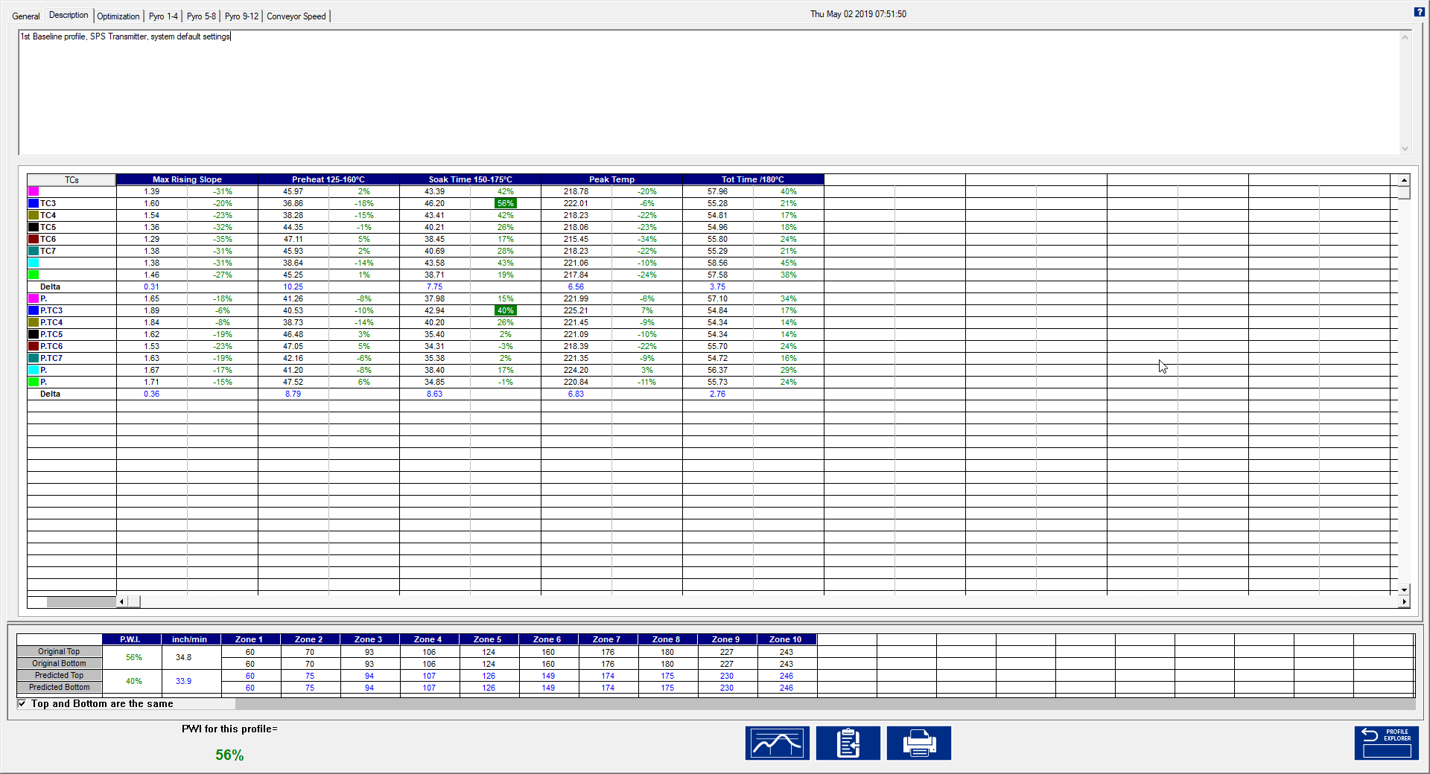

Figure 53: Profile Description Tab – Shows Description notes, statistics, and recipe

The Description tab shows the profile description notes, Profile Statistics, current and predicted recipes.

**Description Tab Buttons**

|  |  |
| --- | --- |
|  | **View/Edit Process Window –** This lets you view the Process Window specifications and limits |
|  | **Copy to Clipboard –** This button will copy the profile data to the clipboard for use with third-party software such as a spreadsheet application, or SPC software. |
|  | **Print –** This button will print the current profile. For more information about printing, see the section titled Profile Printing.  **Note**: If you wish to print a tab besides the General tab, pressing F9 on your keyboard will print the contents of any screen in the PRI software. |

## Profile Optimization with Navigator

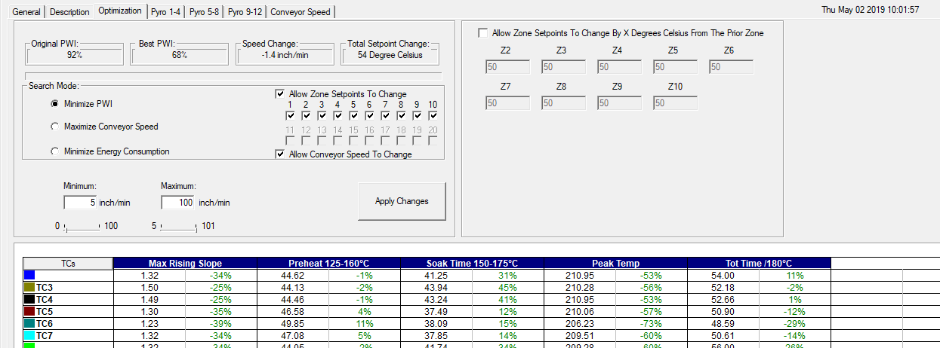

Figure 54: Profile Optimization Tab

The *Optimization* tab allows you to set the search parameters for Navigator. Thesoftware will search through millions of setpoint and conveyor speed combinations to find the optimal oven settings for each product. These optimization calculations are based on the selections you make on this tab.

**Original PWI** – The Process Window Index for the original profile

**Best PWI** – The best Process Window Index that can be found based on the oven recipe optimization constraints selected.

**Speed change** – The total change to the conveyor speed for the best oven recipe found.

**Total setpoint change** – The sum of all setpoint changes for the best oven recipe found.

### Search Mode

**Minimize PWI –** Search for the combination of setpoint temperatures and conveyor speed that will minimize the Process Window Index.

**Maximize conveyor speed** – Search for the setpoint temperatures that will maximize conveyor speed.

**Minimize energy consumption** – Used by the Power software feature. The software search for the oven settings that will minimize the power consumption of the oven by finding oven setpoint solutions with slower conveyor speeds and lower temperature settings.

**Allow zone setpoints to change** – This option will determine if Navigator will include zone setpoint changes when predicting new solutions. It also allows you to exclude individual zones from suggested changes.

**Allow conveyor speed to change** – Choose whether to allow Navigator to vary the conveyor speed. If you choose this feature, you can set the minimum and maximum speeds.

If the Allow Conveyor Speed to Change feature is selected, these options are available.

**Minimum** – Select the slowest conveyor speed Navigator can recommend

**Maximum** - Select the fastest conveyor speed Navigator can recommend

**Allow Zone Setpoints to Change by x Degrees…** - If your oven is not able to maintain large deltas from one zone to the next, enabling this checkbox allows for setting restrictions on the delta T from the previous zone to that one.

**Apply Changes** – After making changes to any of the above settings, click the ***Apply Changes*** button to force the Navigator to calculate a new predicted recipe suggestion.

## Manual Profile Prediction

The PRI software has automatic (Navigator), and manual prediction capabilities. Manual prediction gives you the flexibility to easily predict changes to the oven settings (temperature settings, conveyor speed), and view the results without having to spend the time running unnecessary profiles. This feature is very helpful to you, minimizing the time spent fine-tuning or developing a thermal profile.

### Make Changes

To predict changes to the oven settings, or modify the Navigator prediction results, click on the zone you wish to change. In the example below, zone 1 has been selected.



Figure 55: Prediction Settings

Type the new temperature setting, and then press Enter.

The Navigator prediction tool will predict the results of that change, and then automatically update the PWI, predicted Statistics, and the profile graph. The new predicted results appear on the graph in a dotted-line format. This format lets you quickly determine the difference between the original and predicted profiles.

**Note**: When separate Top and Bottom setpoints are used, the Navigator prediction will maintain the same delta between the Top and Bottom setting that was used in the original profile.

## Different Top and Bottom Setpoint Temperatures

|  |  |
| --- | --- |
| The PRI software lets you enter different top and bottom setpoint temperatures prior to running a profile by unchecking “Top and Bottom Setpoints are the same”.  Notice how the top of zone 8 is set to 267 and the bottom is set to 257. | Graphical user interface, application  Description automatically generated  Figure 56: Enter Oven Setpoints and Conveyor Speed |

Once the profile is downloaded, and the Navigator prediction is done, it will maintain the same differential in temperature between the top and bottom zone, as shown below in Zone 8:

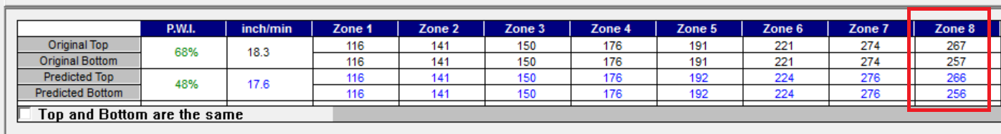

Figure 57: Same Differential in Temperature Between the Top and Bottom Zone

### Exit the Graph Screen

|  |  |
| --- | --- |
| The following message appears whenever a profile is closed: “Do you want to run a profile with this product?”  If you select **No**, you return to the PRI main screen or the Profile Explorer if the profile was originally opened from there. | Figure 58 |
| If you select **Yes**, you will need to choose from the Original, or Predicted recipe settings.  **Original –** The same recipe settings used when this profile was originally run.  **Predicted -** The recipe settings as predicted by Navigator, or a standard prediction that you manually input. | Figure 59 |

For both the original and predicted recipe settings, the software will attempt to automatically send the selected recipe information to the oven controller. If there is no communication between the PRI software and the oven controller, PRI displays a dialog box showing the recipe information. You must manually enter this recipe information in the oven control software.

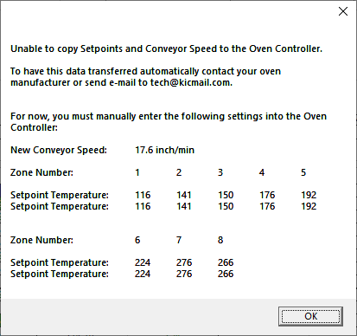

Figure 60: Oven Controller Communication Error

PRI software will automatically apply the changes to the Run a Profile –Enter Setpoints screen. You will exit to theRun a Profile–Enter Setpoints screen. If you are running on the oven controller PC, and the oven is compatible with the PRI software the oven recipe will automatically be updated.

You are sent back to the PRI main menu if you had just completed running a profile. If you opened the profile from the Profile Explorer, you are returned to the Profile Explorer.

Two other messages may appear if changes are made to the Description notes or Process Window:

**Save Changes to the Profile**

|  |  |
| --- | --- |
| Any changes to the Description Note or the Process Window can be saved with the profile. This will permanently update this profile with the changes. Changes to the Process Window saved here only save the changes with the profile.  To save the changes to Process Window file, see next dialog box. | Figure 61 |

**Save Changes to the Process Window**

|  |  |
| --- | --- |
| If you have made changes to the Process Window from the Graph screen, you can save these changes when you exit the graph screen. The Process Window is updated and utilize these changes whenever it is selected for profiling from this point forward. | Figure 62 |

If you select **Yes,** the PRI software will take you to the Edit Process Window screen to save the changes that you have made.

# Profile Explorer

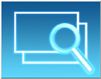

The Profile Explorer is a powerful and simple data file management tool. For each unique product name, you use when profiling, the software will create a folder with the same name. The software saves all the profiles run using that product name in that folder.

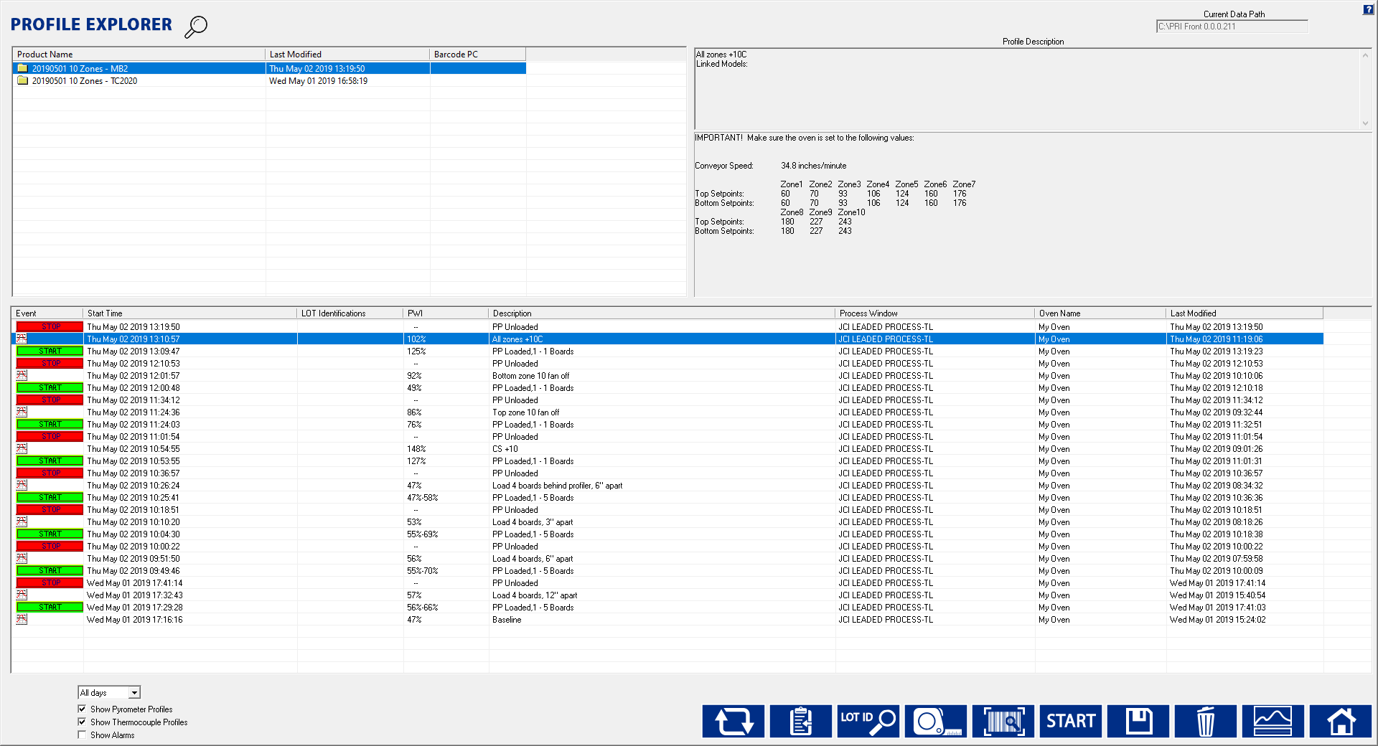

Lot Identification Column

This field is only active when running in ***History*** mode.

This button will start pyrometer profiling running in ***Production*** mode.

Lot Identification

Figure 63: Profile Explorer

The list of product folders is in the upper left of the Profile Explorer. Click on the magnification glass button at the top left to search for a product name.

* By default, the time/date listed in the *Last Modified* column will show the date/time of the last completed VP. Alternatively, you can select the time/date to be based only on baseline profiles by right-clicking on the *Last Modified* button and selecting *Most recent profile/profile modification*.
* **View a profile** - Click on a product folder to display the profiles that have previously been run for any product. Highlight the profile you wish to view and then select the Graph button at the bottom of the screen or double-click the profile to display it.

**Note:** Once the profile appears on screen, you can use the Control + Up Arrow to view the next profile, and Control + Down Arrow to display the previous profile.

* + The profile section can be sorted by clicking on any of the column headers. Single clicking on a profile will display the Profile description in the upper right corner.
  + Double-clicking the profile to display the graph and statistics for that profile. Clicking the “Display Graph…” button can also do this.

**Note**: If the profile is labeled as “Bad” or if, for any reason, the PRI software cannot display it, the profile is automatically copied to the Clipboard so that you can use a third party such as MS-Excel to view the data.

## Find PP Production Run Data by Lot ID Code

PRI software lets you search for Pyrometer Profile production runs based on the Lot ID code. If you do not know the complete code, you can use the asterisk symbol (*) as a wildcard to begin searching with a partial code.

1. On the Profile Explorer screen, click on the **Lot ID** button. 

The ***Lot ID* *Searching*** screen appears:

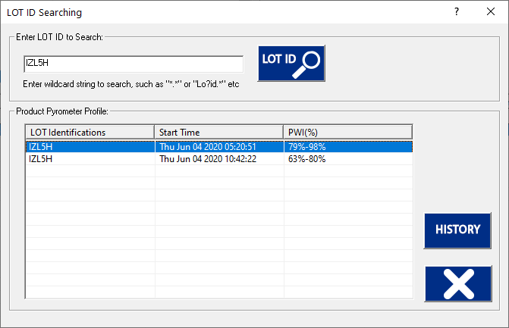

Figure 64

1. In the Lot ID search screen, type the code in the ***Enter LOT ID to Search*** field.
2. Click on the **Search** button.

Matching PP production runs appear listed in the table.

1. Mouse over the row in the table to display pertinent data from the production run in a tooltip popup window:

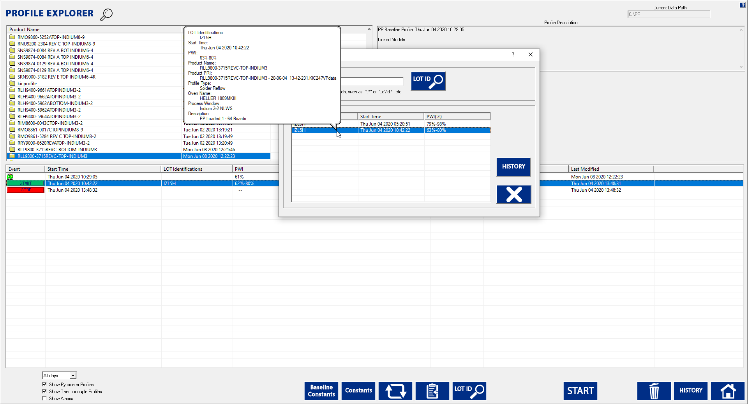

Figure 65

1. Highlight the row and click on the **History** button to display the pyrometer profile historical data.

## Browse for Historical Data

The current data path for the data viewed in the Profile Explorer appears in the upper-right corner. This is grayed out if running in production mode. It is active, if you clicked on the, I am not going to Profile or Pyrometer Profile button (enabling History mode), when first launching the PRI software.

The data path can be changed but must be done through theC:\PRI\Log\KIC2000DataPath.kiccfg file.

To view historical Pyrometer Profile data from the same PC while Pyrometer Profiling is live, you launch a separate KIC Host.exe file located: C:\PRI\AppForViewerforViewer\KICHost.exe. This will open a separate Profile Explorer that lets you browse through the history of any product including the one currently running PP. Historical data is available for any boards that have already exited the oven.

**Note**: This feature was designed to allow you to view PRI historical data stored in a different directory on the same computer or on remote PC over a network.

## View Historical Data Over A Network (History Mode)

While in *History* mode you can view all collected data over a network from any PC with PRI software loaded.

|  |  |
| --- | --- |
| **Step 1** - From your remote PC, start the PRI software, and click on the **I am not going to Profile or Pyrometer Profile** button.  **Step 2** - The software will open normally. When the main screen appears, click the **Profile Explorer** button. | Graphical user interface, text, application  Description automatically generated  Figure 66: Product Tracking Initialization |

**Step 3 -** Now, a **Browse** button is enabled in the upper right-hand corner of the Profile Explorer screen.



Figure 67: Profile Explorer – Browse Data Path

You can click the **Browse** button and point to the root directory where your profiles are stored. Keep in mind that you want to direct it to the root directory of the main “Profiles” folder.

For example: if the profiles are stored in a directory named C:\PRI\Profiles\Board A, you would direct it only to the C:\PRI\ folder.

## Profile Explorer Buttons

|  |  |
| --- | --- |
|  | **Product Dimensions –** Gives you an opportunity to enter product dimensions for products that have already been profiled. Once product dimensions have been entered, the Auto Focus library is updated. This increases the likelihood of in spec profiles and decreases the number of profile passes. |
|  | **Process Traceability Barcode –** Click on the Barcode button. A dialog box pops up with a field to enter the barcode value with a Search button next to it. Below this is a field that will list the time, date, and PWI for that barcode if it exists for the chosen product. Either double-click the listing or highlight it and click on the View Selected Profile button. |
|  | **Start** Pyrometer **Profiling –** Click this button to start Pyrometer Profiling. The PRI software will always use the latest qualifying profile as the baseline profile needed to start Pyrometer Profiling. |
|  | **Save Selected Profile –** Click this button to save an event or profile to the location of your choice, either hard disk, network drive, or floppy disk. |
|  | **Delete –** Click this button to delete an event or profile. |
|  | **Display the Graph and Statistics for this profile –** Click this button to display the graph and statistics for the selected profile. If you have an event other than a profile, the Display Graph and Statistics button will change to a Charts button. |
|  | **Lot ID history search –** Click on this button to search for a PP production run based on the Lot ID. |
|  | **Return to KIC Main Menu –** Click this button to return to the PRI main menu screen. |

### Profile Explorer Checkboxes

At the bottom-left of the Profile Explorer are checkboxes to select what information to display:

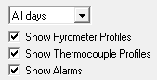

* **Show Pyrometer Profiles –** Display all PP Start and Stop events for the selected product.
* **Show Thermocouple Profiles –** Display the Profiles for the selected product.
* **Show Alarms –** Display the Alarm state changes for the selected product.

**Note:** Double click any event to view the details including alarm event history. If two alarm/alert acknowledgements appear at the same time, only one will appear in Profile Explorer.

## Profile Explorer – Pyrometer Profiling

The profile that meets Pyrometer Profiling criteria will be displayed with a green PP  overlaying the standard profile icon.

The software will always use the most recent qualifying profile as the Pyrometer Profile -Baseline profile.

### View Pyrometer Profile Data

1. Select your product folder from the upper left- corner of the Profile Explorer.

This will display the profiles and events for that product.

1. Choose a Pyrometer Profile event.

### Profile Explorer Event Icons

##### Profile Icons

 **Profile –** This icon appears for any valid profile that does not fit Pyrometer Profile criteria.

 **Pyrometer Profile Capable –** This icon appears for the most recent Pyrometer Profile capable profile.

### Pyrometer Profile Event Icons

The PRI Profile Explorer will display an event icon for any event that occurs while Pyrometer Profiling is running and only when Pyrometer Profiling is running. These events include:

 **PP Start –** This icon appears when Pyrometer profiling is enabled.

 **PP Stop –** This icon appears when Pyrometer Profiliing is disabled.

### Alarm Icons

 **In Spec. – Alarm state change –** This icon appears when the Pyrometer Profiling alarm state changes back to Ready. There are three ocassions when this icon may appear:

* Back into Spec
* Back into Control
* Process Temperatures Back to Normal

 **Warning – Alarm state change –** This icon appears when the Pyrometer Profile alarm state changes to Warning. There are three ocassions when this icon may appear:

* Cpk Warning
* Significant Process Temperature Variation
* Process Is Likely to Go Out of Spec Soon.

 **Out of Spec. – Alarm state change –** This icon appears when the Pyrometer Profile alarm state changes to Out of Spec. There are nine ocassions when this icon may appear:

* Process temperatures are Out of Spec
* Product length is different from the Pyrometer Profiling baseline profile
* Missing barcode (Process Traceability only)
* The number of barcodes that have not been read. (Process Traceability only)
* Encoder stopped, or changed signifigantly.
* Oven recipe no longer In-Spec
* DAU lost communication

 **Warning Acknowledged –** This icon appears once the operator acknowledges the Warning alarm state change.

 **Alarm Acknowledged –** This icon appears once the operator acknowledges the Out of Spec. alarm state change. Not all alarms require acknowledgement.

##### Communications Icons

 **DAU Communication Error –** This icon appears if the software loses communication with the DAU.

 **DAU Communication Restored –** This icon appears when the software re-gains communication with the DAU.

 **Process Traceability** **Barcode failure –** This icon appears if the software detects a board in the oven but does not read the barcode for that product.

## History Data Files

As the software processes Pyrometer Profiles, it logs data files that later can be analyzed, to a *Profiles/’Product Name’/History* folder. It automatically stores these *Event* and *PP data* files associated with each specific product to that directory.

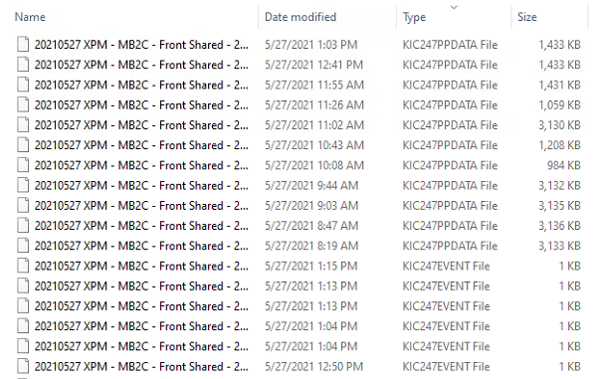

Figure 68

## Insert Data Files from an Outside Source

If you receive PRI data files you want to view, exit the PRI software and copy them into the *C:\PRI\Profiles* folder in Windows Explorer. The next time you enter the Profile Explorer screen the software will automatically create folders for those profiles based on the profile name and put the profiles in the folders.

## Rename Profiles

In situations that require it, you can edit the profile name. This can be especially useful when products are identical but have different names. Once the profile has been optimized, it can be renamed and used as a baseline profile for similar products if the need arises. This eliminates the need to re-profile very similar products unnecessarily.

1. Manually create a new folder in the *C:\PRI\Profiles* folder using the new product name.
2. Copy the desired profile into this new folder.
3. A folder with that new Product Name will appear in Profile Explorer.
4. When you open that profile, it will display in the software with the new Product Name

The new profile name will appear on all the screens (Profile Explorer, General Tab, Charts Tab, and Troubleshooting Tab). The new name will also appear in the data that is copied to the Clipboard.

None of the files on the PC are actually renamed, when viewing the profiles in Profile Explorer, they all look the same. However, profiles run after the name has been changed will use the new product name as part of their file names.

**Note:** Pyrometer Profiling is most accurate for products that have their own baseline profile.

# Pyrometer Profiling (PP)

***Pyrometer Profiling*** (PP) is a means of reliably measuring the temperature of every board directly during a production run*.*

Once the baseline is established, the PRI software allows you to start monitoring mode, recording real-time belt speed and pyrometer temperature data as a production run of similar boards passing through the oven. PRI updates and saves the PP profile data to each board as it exits the oven, creating a valuable quality assurance record of each production unit.

In monitoring mode, the software displays each board’s profile chart and a table of data based on its process window. Other screens show PWI and SPC control charts. When board temperature readings vary significantly from the baseline profile, PRI displays appropriate warnings to system operators.

**Note:** Before you start Pyrometer Profiling, ensure all the PRI system hardware is properly installed and configured.

## Establish A Valid Baseline Profile

Pyrometer Profiling makes use of a special profile, called the *baseline* profile, as the data model for its predictions. The software requires that you first establish this baseline before it enables Pyrometer Profiling. The baseline profile should represent your optimum oven recipe for your product and needs to meet the Pyrometer Profile criteria shown below:

* The PWI must be below the Maximum PWI to allow the PP value as set in Global Preferences.
* The conveyor speed measured by the encoder must be within 20% of the specified conveyor speed.
* Pyrometer temperatures must be valid; if any pyrometer thermocouple reports a range of greater than 30°C between adjacent readings (every 2.5 seconds), the PRI software will consider them invalid.

If your profile meets the above criteria, it can work as a baseline profile. The baseline profile will display differently in the Profile Explorer screen—the profile’s icon will have an overlying green PP. 

If you suspect the current baseline profile needs replacement by a newer version that more closely matches current production conditions, the software lets you create a new baseline during ongoing production. If this *verification profile* meets PP criteria, it can become the new baseline profile.

##### Empty Oven

For a baseline to work as a good predictive model, it needs to use temperature data that reflect both *board present* and *board absent* states at each pyrometer’s location. To obtain this data most efficiently, KIC recommends running the profile board with similar *boards moving ahead of it and an empty conveyor behind it.* The downstream flow of boards stabilizes the oven temperature and gives a good approximation of normal production conditions. As the profile board exits each oven zone, the pyrometers can measure the temperature when a board is not present. The software will integrate this comparative data for a more accurate predictive capability. The oven should remain empty until the profile board completely exits the process chamber.

**Note:** Be aware of the potential to put the system into a state where the software lacks enough empty oven data to make reliable PP predictions. The condition can occur during a verification profile run where you insert the profile board into an ongoing production flow. With other boards both ahead of and behind the profile board, no interval for gathering empty oven data occurs. A grey crystal ball indicates it will be unable to predict the empty oven state. See Monitor Production in Live Mode.

## Create/Load a Pyrometer Profile

There are several ways to begin Pyrometer Profiling:

1. Open the Profile Explorer. Select your product folder in the upper-left corner. This will display the profiles and events for the selected product. If you have a profile that meets Pyrometer Profiling criteria, the profile icon is overlaid with a green PP. This qualifying profile (baseline) will always be the most recent profile that meets Pyrometer Profiling criteria (only one profile can qualify as the baseline).

No need to highlight the baseline profile, simply click the Start Pyrometer Profiling button. This will start Pyrometer profiling for the selected product.

|  |  |
| --- | --- |
| 1. If you have run a profile that meets the Pyrometer Profile criteria, then the *Start Pyrometer Profiling* button will appear once the profile has completed. Click the button to begin Pyrometer Profiling for the indicated product. |  |

***CAUTION:*** Your software security key must be connected prior to enabling Pyrometer Profile mode. If the key is removed from the computer while Pyrometer Profiling mode is enabled an alarm message appears.

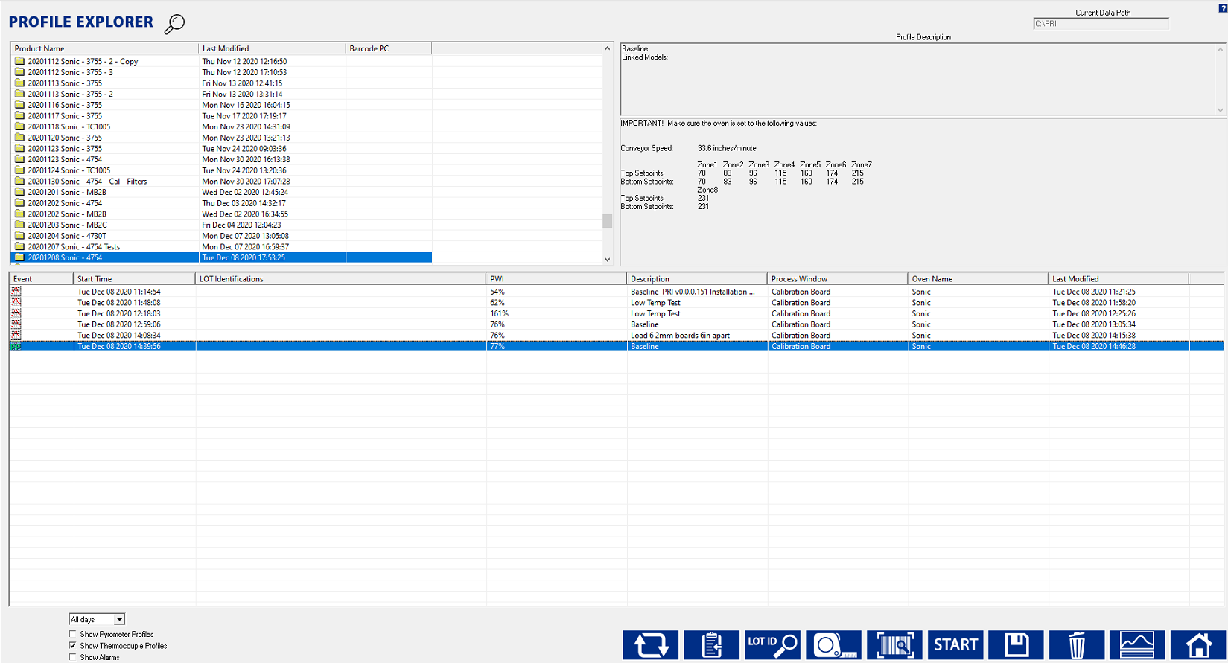

Figure 69: Profile Explorer – Start Pyrometer Profiling

**Note**: If your oven can communicate with the software, a dialog box will appear notifying you that Pyrometer Profile is starting, and the oven recipe will be changed automatically. If the oven recipe is already set correctly for that product, a confirmation message will display. If nothing happens within several seconds, check the oven control software to make sure there are no error messages or errors that will cause the system to hang.

If your software is not communicating directly with the oven controller, the software will display the settings used during the Baseline profile. Make sure the oven is set to the exact recipe settings.

# Monitor Production in PP Live Mode

In PP ***live mode***, the PRI software displays real-time data for the PP it generates for every production board processed. The software displays the data in various charts, graphs, and statistical tables.

|  |  |
| --- | --- |
| During live mode, it also displays a crystal ball indicator that shows the current Pyrometer PWI, and Cpk values for your process as measured by the software. The crystal ball indicator appears continuously while PP is enabled. You can move the crystal ball, but not close or minimize it.  The crystal ball color will indicate the current Pyrometer Profiling status:  **Green**  Ready  **Yellow**  Warning  **Red**  Alarm  **Grey**  Unable to Predict | A picture containing text, green  Description automatically generated  Figure 70: Pyrometer Profile Crystal Ball indicator |

**Note**: A PP status message appears when you place the mouse pointer over the crystal ball.

## How to Avoid the Grey Crystal Ball

While a green crystal ball reports the system as PP-capable, and yellow/red alert you to problems, the grey color indicates that the software has insufficient data to make useful PP predictions. The condition can occur during a baseline or verification profile run where you introduce the profiler into an ongoing production flow. With boards both downstream and upstream of the profiler, the system lacks necessary data obtained by sampling empty oven zones. To avoid the grey status KIC recommends running the profiler with no boards following behind. For more information, see Integrate Empty Oven Data.

## PP Live Mode - General Tab

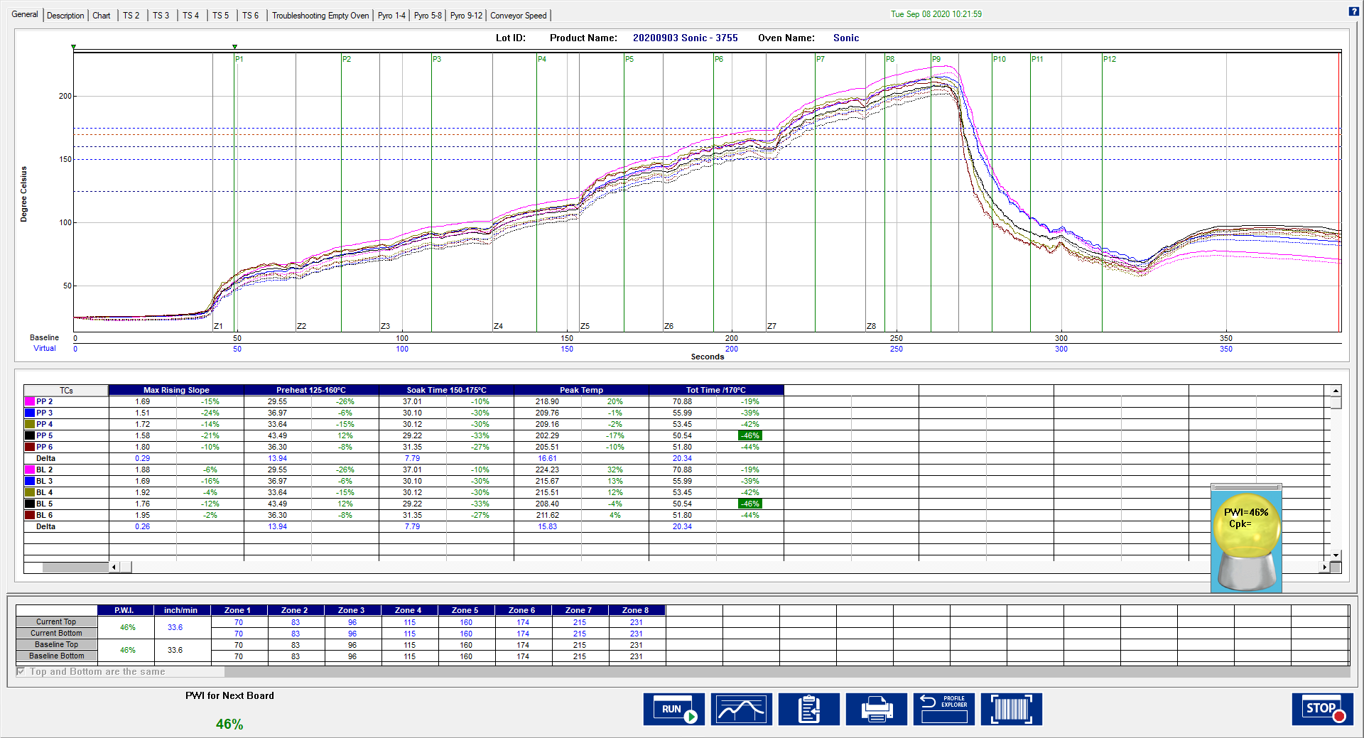

Figure 71: Pyrometer Profiling – General Tab

On the live-mode screen, the software displays both the baseline and pyrometer profile. The baseline profile appears in a solid line format, while the pyrometer profile appears in dashed lines. To enlarge the graph section, double click on the graph. To enlarge the statistics section, double click on the statistics.

### Board Sensor Indicator

|  |  |
| --- | --- |
| The software indicates the physical location of the board sensor in or near the oven entrance by a small triangle above the graph.  When the sensor first detects a board, the on-screen indicator changes color from green to red. The indicator stays red as long as the board remains beneath the sensor. | Graphical user interface  Description automatically generated with low confidence  Figure 72 |

### Pyrometer 1 Sensor Indicator

|  |  |
| --- | --- |
| The software indicates the physical location of the board sensor in zone 1 by the triangle above the graph.  When the sensor first detects a board, the on-screen indicator changes color from green to red. The indicator stays red if the board remains beneath the sensor. | Figure 73 |

### Profile Statistics

As shown, the Pyrometer Profile and baseline statistics appear in a table below the profile graph. Below the statistics, the Pyrometer Profile and baseline profile recipes appear. These recipes should match identically. The current PWI appears in the bottom-left corner. The PWI for the last board to exit the oven will not be displayed; go to the Charts tab to view this information.

### Graph Controller

|  |  |
| --- | --- |
| The Graph Controller allows you to modify the view of the PRI profile graph. To open the Graph Controller, Left-click on the TC column header in the Statistics table or Double Left-click, anywhere just outside the profile graph.  **Auto scale –** The Auto Scale feature will automatically adjust the X and Y-axis scales to fit all of the data in the profile graph. When the Auto Scale feature is disabled, you must manually input the minimum and maximum scale settings.  **TCs –** You cannot disable or rename a TC in a live Pyrometer Profile. You can only perform this function on the Baseline Profile. Those changes would then be reflected in any Pyrometer Profile data recorded from that point. | Graphical user interface, application, Word  Description automatically generated    Figure 74 |

**TC’s Line Thickness** – The pull-down menu lets you select five different thicknesses for the TC lines drawn on the graph.

**Board Length –** Displays the board length defined when the profile was run.

**Grid –** Enables/disables the view of the X and Y-Axis scales.

**Reference lines –** Enables the view of Reference Lines displayed on the profile graph. These lines represent any temperatures referenced in the selected Process Window.

**Zone lines –** Enables the view for the oven zone lines on the profile graph.

**Predicted TCs only** - Removes the original profile plot from view, displaying only the prediction profile plot on the graph.

**Original TCs only** - Removes the predicted profile plot from view, displaying only the original profile plot on the graph.

**Zero decimal** – When viewing the Examine tool, this setting enables or disables the decimal display. When unchecked, the software will display one decimal point.

**Internal temp** – Enables the view of the profiler’s internal temperature profile plot on the graph.

**Display Detailed PWI** – With this unchecked, you will only see the “overall” PWI for the profile. It will not display the individual TC PWI values.

**Extra Cooling Slope** – Enabling this feature displays multiple Cooling Slope measurements which are customizable by the user.

**Floating O2 PPM display** – When the *O2 Live* option is purchased, you can enable/disable a window on the graph that shows the O2 measurement during production.

##### Examine Tool

|  |  |
| --- | --- |
| You can also view the Delta T (∆T), or Delta Temperature, at specific points across the profile by right mouse clicking on the graph. This will bring up a pointer and a chart will appear in the upper left corner of the graph. | Figure 75: Examine Tool Display |

Wherever the pointer is moved across the profile, the following data appears:

* The first column is the actual temperature for each TC, Original.
* The second column is the temperature of the predicted profile data – based on setpoint or belt speed changes.
* The Delta T for both actual and predicted TC data.
* The time during the profile at which the pointer is placed

### Board Spacing

PRI can detect boards regardless of separation. The PRI system will accurately count and track boards through the oven even if two boards become pushed together leaving no space. The PRI system is able to detect the correct number of boards processed.

If the board length as determined by the system differs by more than 15% from the baseline-product length while Pyrometer Profiling – live, an alarm will appear after five boards.

The number of boards to trigger an alarm can be changed if needed, contact KIC Technical Support for help.

## PP Live Mode - Description Tab

|  |  |
| --- | --- |
| The Description tab displays the profile Description notes for the baseline profile.  You can edit these notes by clicking in the description area.  Below the description area, the Pyrometer Profile and Baseline Statistics, and recipes are displayed. In the bottom-left corner, the current PWI appears. Enlarging the description area and statistics are not possible while viewing this tab. | Graphical user interface, application, table, Excel  Description automatically generated  Figure 76: Pyrometer Profiling – Description Tab |

## PP Live Mode - Charts Tab

|  |  |
| --- | --- |
| The Chart tab will display a control chart for the overall profile PWI, and each individual process specification, as defined in the Process Window setup.  The alarm limits for each specification appears on each chart using red horizontal lines.  Each time a board is detected exiting the oven, the PRI software will plot a data point for each product thermocouple on each chart. The chart data will coincide with the live Pyrometer Profile data.  The PRI software will update the overall PWI for each chart and calculate the Cpk and display the results above each chart. | Diagram  Description automatically generated  Figure 77: Pyrometer Profiling– Chart Tab, all charts |

**Note**: You can enable or change the Cpk alarm values in the “Global Preferences” screen before you start Pyrometer Profiling.

Above the control charts is a bar display showing the board sensor location. Similar to the ***General*** tab, when a board is detected under the sensor, the indicator color will change from green to red as long as the sensor detects a board. This display also shows the current location and number of boards in the oven. In the bottom-left corner, the current PWI appears. If the Barcode capabilities are enabled, the barcode number for the current board appears in the lower-left-corner as well.

### View Chart Data

To view individual chart data, click inside the chart area of your choice. This will display that chart in a full screen view.

Move the mouse pointer over the chart data, a display box will appear. This display box data includes barcode number, PWI, Cpk, date, and time for each board. The date and time for the last board to exit the oven appears at the bottom of the full screen chart in Blue text.

Click in the chart area to return to the regular **Chart** tab view.

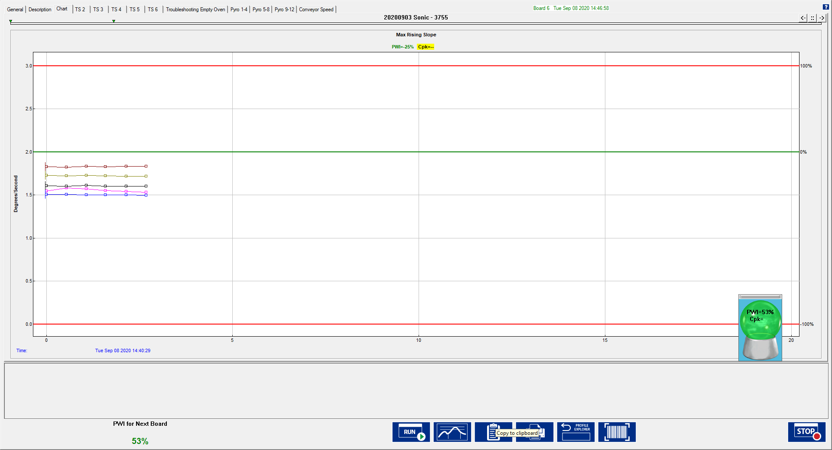

Figure 78: Pyrometer Profiling – Chart Tab, zoom chart

## PP Live Mode- Troubleshooting Tabs

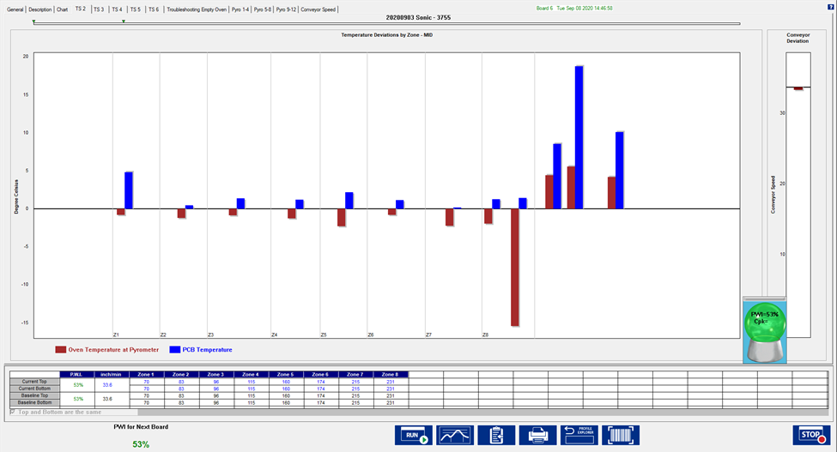

Figure 79: Pyrometer Profiling – Troubleshooting Tab

The Troubleshooting tab will display the pyrometer and conveyor speed deviation on charts. The pyrometer deviation is measured against the baseline profile – pyrometer data. This data is updated for every board, or every 25 Seconds. In the bottom-left corner, the current PWI appears.

**Note:**There is a separate tab called Conveyor Speed that provides a more in-depth view as to what the conveyor speed was at every location in the oven for the entire profile.

TS2 stands for troubleshooting thermocouple 2. TS3 stands for troubleshooting thermocouple 3…etc. The blue bar represents the deviation in board temperature between the baseline and the current production board. The red bar represents the deviation in oven temperature between the baseline and the current production board. The figure above is displaying deviation for TS2, troubleshooting thermocouple 2. You can inspect each thermocouple individually by clicking the corresponding tabs.

**Note:**  Moving the mouse pointer over the deviation chart data will enable tool tips that show the deviation value for each of the pyrometers. Moving the mouse pointer over the conveyor speed chart will show the baseline profile conveyor speed, and the conveyor speed for the last board to exit.

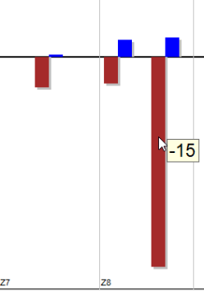

Figure 80: Pyrometer Deviation Value Display

## PP Live Mode –Troubleshooting Empty Oven Tab

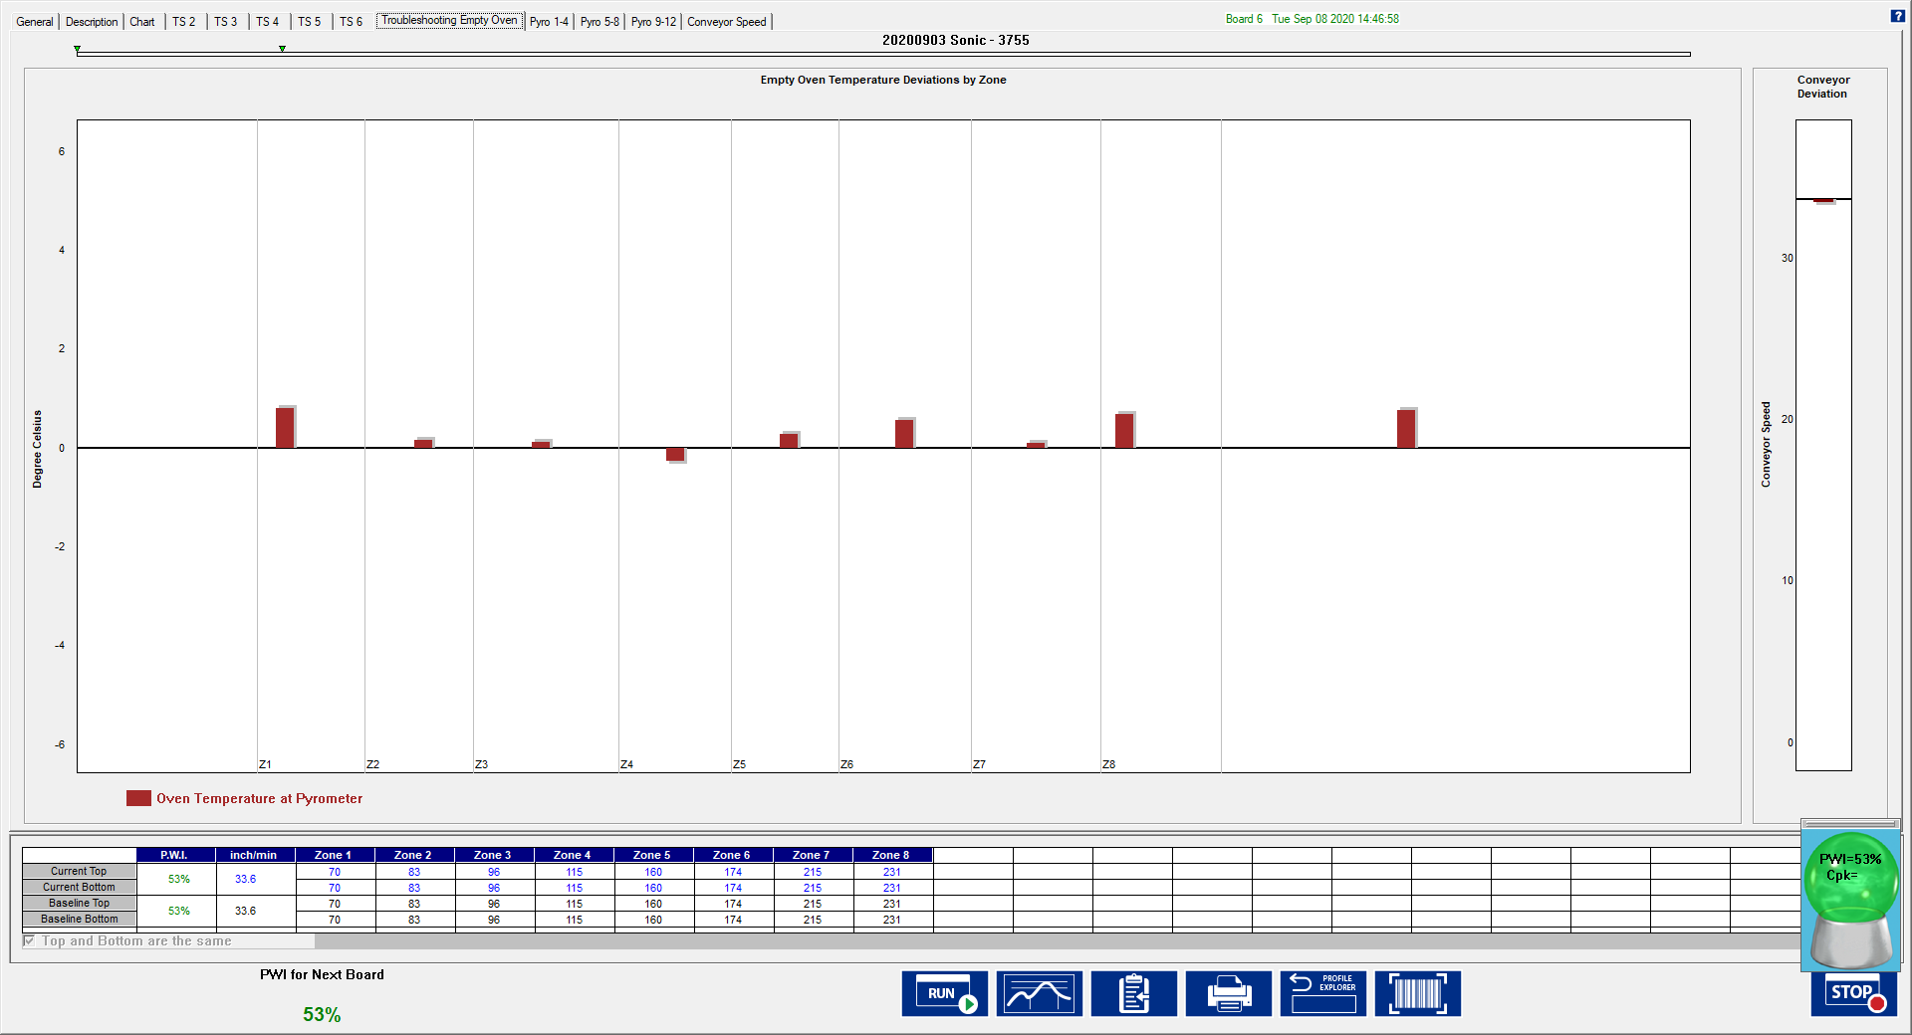

Figure 81: Pyrometer Profiling – Troubleshooting Empty Oven Tab

The Troubleshooting Empty Oven tab will display the difference in empty oven temperature readings between the baseline and the current empty oven. This data is updated every time the oven becomes empty and experiences changes.

## PP Live Mode – Conveyor Speed Tab

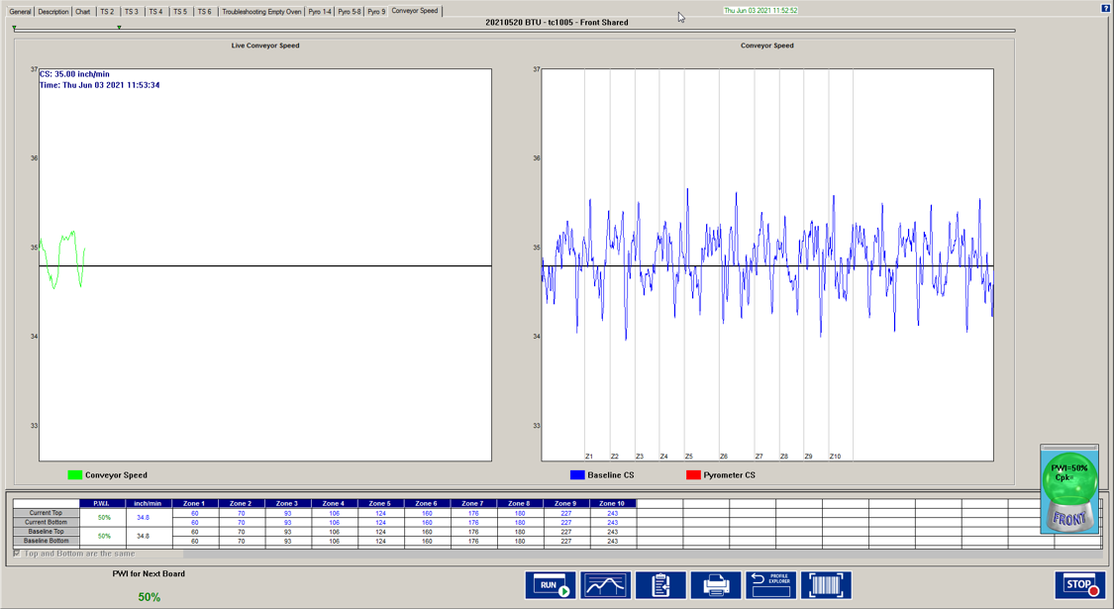

Figure 82: Pyrometer Profiling – Conveyor Speed Tab

The Conveyor Speed Tab displays conveyor speed at every location during the boards ride through oven. The straight horizontal black lines represent the conveyor speed setpoint. This oven is set for -+1” of tolerance and the oven seems to stay within the boundaries. The conveyor speed recorded during the baseline displays with the blue line in the chart to the right. The live real-time conveyor speed during production is displayed with the green line in the graph to the left.

## PP Live Mode – Pyro Tabs (Pyrometer Tabs)

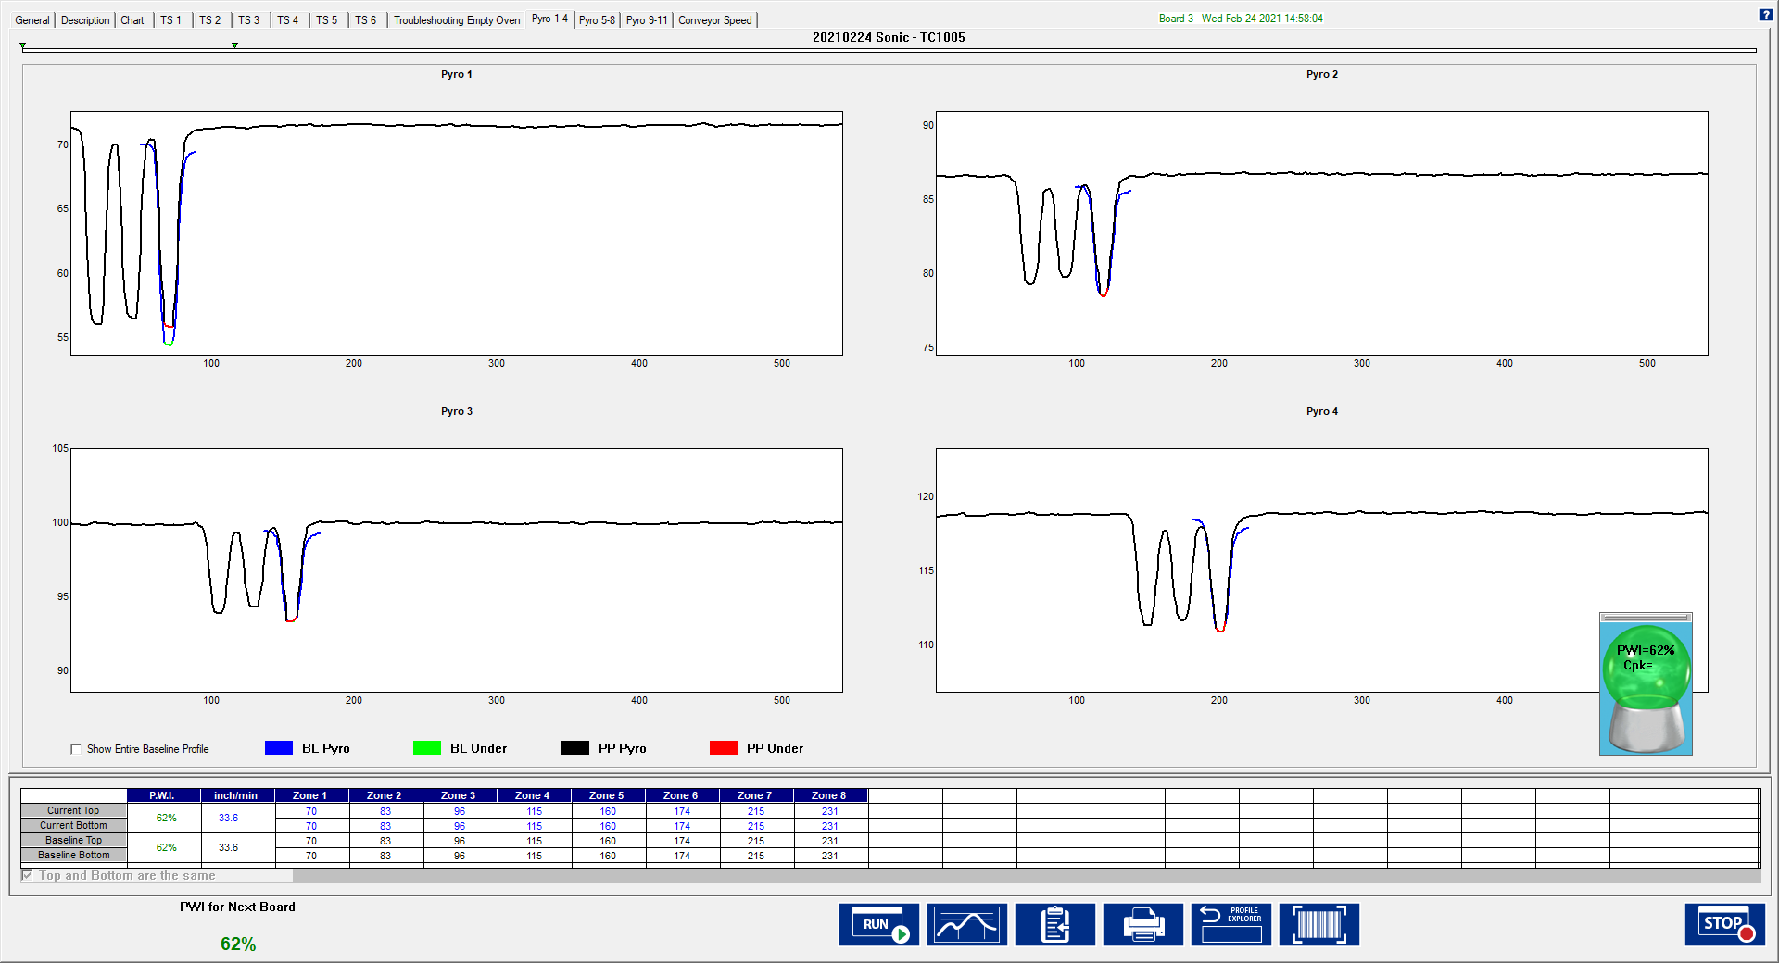

Figure 83: Pyrometer Profiling – Pyro Tabs

The Pyro tabs will display pyrometer readings for a maximum of 4 pyrometers per tab. The Y axis is temperature while the X axis is conveyor clicks. The blue line shows the pyrometer readings from the baseline. The green line indicates the expected location of the baseline board. If the green line does not appear under the blue line, then that signifies board jam/shifting. Similarly, the black line shows the pyrometer readings during production. The red line indicates the expected location of the production board. If the red line does not appear under the defined production board in black, that would signal a board jam/shift.

In the example above, it shows the baseline and production board did in fact arrive at their expected locations. There was no shifting during these profiles.

**Note:**You can enlarge a specified pyrometer by double left-clicking the chart:

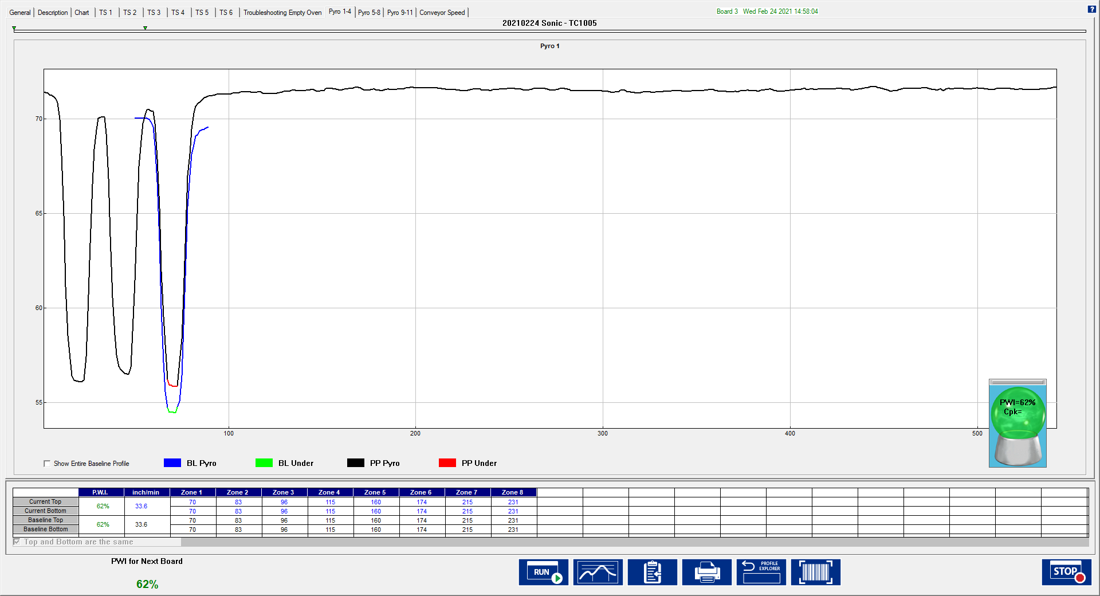

Figure 84: Pyrometer Profiling – Pyro Tabs, zoom chart

## PP Live Mode Buttons

While in Pyrometer Profiling - live mode the software displays several buttons at the bottom of the screen.

**Run Profile –** Select this button to run a Pyrometer Profile Verification profile. The software may require you to run a Verification profile if it has determined that the current PP is no longer accurate.

**View/Edit Process Window –** Select to view the Process Window specifications and limits in a read-only format.

**Copy to Clipboard –** Copies the profile and/or Pyrometer Profile data to the clipboard for use with third-party software such as a spreadsheet application, or SPC software.

**Print –** This button will print the current profile.

**Note:** If you wish to print a tab besides the General tab, pressing F9 on your keyboard will print the contents of any screen in the PRI software.

**Profiler Explorer –** This button will take you to the Profile Explorer screen. You can view profile and Pyrometer Profile event data. This feature is especially useful to ascertain which alarms have occurred and have been acknowledged during production. There is only one button at the bottom, which will return you back to Pyrometer Profiling - live mode.

**Stop Pyrometer** **Profiling –** This button will return you to the *Profile Explorer* screen.

**Barcode Queue –** Displays a text box showing the current barcodes yet to be assigned.

## Verify the Pyrometer Profile

The *verification profile* is when a thermocouple profile and pyrometer profile are generated at the same time. The verification profile is used to help determine how the oven and board may have changed from the current Baseline profile.

The verification profile updates the Baseline profile for the current Pyrometer Profile, ensuring that its prediction model yields the most accurate possible results, using the most recent profile. The software always recognizes the latest in‑spec profile as the Baseline for any Pyrometer Profile.

The software recognizes when the process temperatures change significantly as compared to the current Baseline profile, and then prompts you to run a verification profile. You can intentionally run a verification profile at any time during Pyrometer Profiling Live Mode.

**Note**: The software will only accept a verification profile as a new baseline if meets the standard PP criteria. See Get A Valid Baseline Profile.

|  |  |
| --- | --- |
| 1. Verify that PP is running in live mode 2. Select the **Run Profile** button at the bottom of the PP live screen. | Figure 85: Run Profile Button, PP Live Mode Screen |
| 1. The software displays a message asking if you want to run a verification profile:   If you choose **No**, the software will return to the previous screen.  If you choose **Yes**, the software will begin stepping through the run profile routine. | Graphical user interface, application  Description automatically generated  Figure 86: Run verification message |

1. Verify the following before profiling:

The profiler is on and ready to profile.

* + If in Transmit model – Smart Dock (SPS) or Base Station (X5) is plugged into computer.
  + If in Datalogger model – The profiler is plugged into the download cable and download cable is plugged into the computer.
  + Profiler batteries and internal temperature are at the proper levels to profile.
  + All thermocouples attached to the profiler are below the defined product start temperature.

1. To begin profiling, click the **Profile Start** button (green traffic light).

Once the verification profile is complete and the data has downloaded, it will display one of the two dialog boxes shown below.

Figure 87: In-spec Verification Profile

Alternatively, if the profile is out of spec, the dialog box shown below will appear stating that the PWI is too high.

Figure 88: Out of Spec Verification profile

If you choose to continue running Pyrometer Profiling, you will receive WARNING #2, “The last profile was out of spec”. In which case, you would need to run profiles until an in-spec profile is achieved before the software lets you continue Pyrometer Profiling.

The dialog boxes present two choices:

1. **Continue Pyrometer** **Profiling –** If the verification profile meets Pyrometer Profiling criteria, it will automatically be used as the new baseline profile. If you choose this option, the software will update the baseline and continue Pyrometer Profiling, using the verification profile as a new baseline profile.
2. **Unload Pyrometer** **Profile and go to Prediction mode** – If the verification profile does not meet Pyrometer Profiling criteria or is out of spec, it can’t be used for Pyrometer Profiling. If you choose this option, you can predict changes to the profile in order to bring the profile back within its process specification. You will have to run at least one more profile in order to produce a profile that meets Pyrometer Profiling criteria.

**Note**: For an explanation of PP criteria, see Pyrometer Profiling.

## Historical Mode

The PRI software has an historical mode feature. This feature allows you to view Pyrometer Profile data for any board processed when the PRI system has been running. Open the Profile Explorer and select any event other than a profile**.** The **Display the Graph and Statistics for this profile** buttonwill change from a single graph button display to a **HISTORY** button display, indicating there is Historical data associated with selected event.

|  |  |
| --- | --- |
| Figure 89: Profile Explorer–Display Graph and Statistics for this profile | Figure 90: Profile Explorer–Display Historical Graph and Statistics |

### View Historical Data while Running a Live Pyrometer Profile

To view historical Pyrometer Profile data from the same PC while Pyrometer Profiling - live, you launch a separate KICHost.exe file located in: C:\PRI\AppforViewer\KICHost.exe. This opens a separate Profile Explorer that allows you to browse through the history of any product including the one currently running PP. Historical data will be available for any boards that have already exited the oven.

### Historical Mode - General Tab

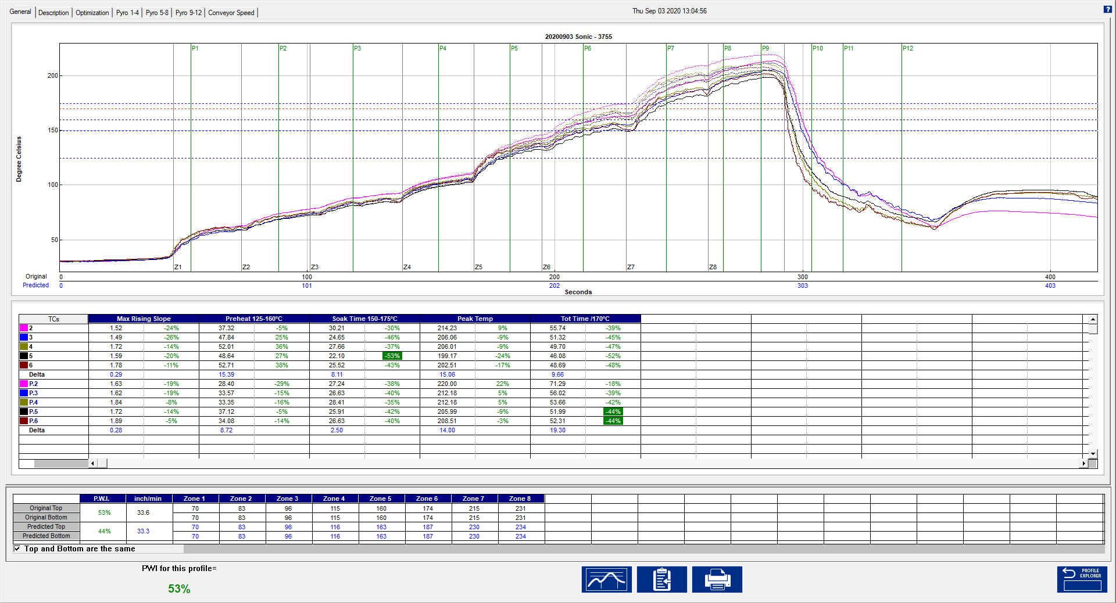

Figure 91: Pyrometer Profiling History – General Tab

The PRI software will display the baseline profile on the profile graph in a solid line format and the Pyrometer Profile appears on the profile graph in a dashed-line format. This display method allows you to easily distinguish between the baseline and Pyrometer profiles.

Below the profile graph, the Pyrometer Profile and baseline profile statistics are displayed. Below the statistics, the Pyrometer Profile and baseline profile recipes are displayed.

**Graph Controller**

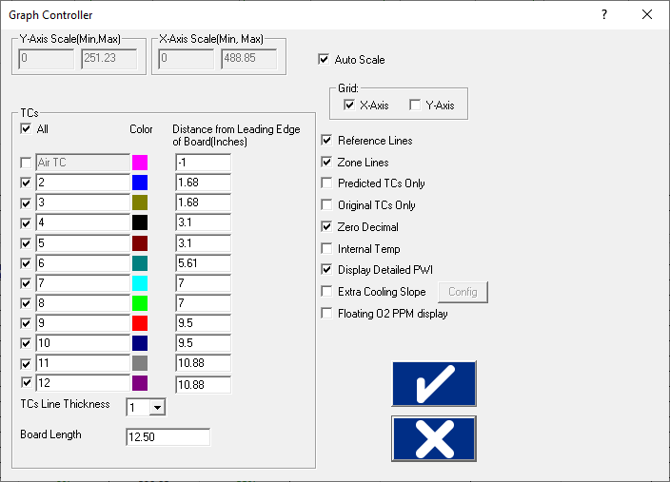The ***Graph Controller*** settings allow you to modify the view of the PRI-profile graph. To open the Graph Controller, left click on the TC column header in the Statistics table.

**Auto scale –** The Auto Scale feature will automatically adjust the X and Y-axis scales to fit all of the data in the profile graph. When the Auto Scale feature is disabled, you must manually input the minimum and maximum scale settings for the X and Y-axis scales of the profile graph.

**TCs –** The TCs section is a list of the thermocouples used for the profile. If you wish to view the profile without a particular thermocouple, you can deselect it, or deselect the “All” check box, and choose only the thermocouples you wish to view. The software recalculates the PWI and updates the profile statistics based on the remaining thermocouples selected. You must select at least one product thermocouple

Figure 92: Graph Controller

**TC Line Thickness –** The pull-down menu lets you select five different thicknesses for the TC lines drawn on the graph.

**Board Length –** Displays the board length defined when the profile was run

**Grid –** Enables/disables the view of the X and Y-Axis scales.

**Reference lines –** Enables the view of Reference Lines displayed on the profile graph. These lines represent any temperatures referenced in the selected Process Window.

**Zone lines –** Enables the view for the oven zone lines on the profile graph.

**Predicted TCs only** - Removes the original profile plot from view, displaying only the prediction profile plot on the graph.

**Original TCs only** - Removes the predicted profile plot from view, displaying only the original profile plot on the graph.

**Zero decimal** – When viewing the Examine tool, this setting enables or disables the decimal display. When unchecked, the software will display one decimal point.

**Internal temp** – Enables the view of the profiler’s internal temperature profile plot on the graph.

**Display Detailed PWI** – With this unchecked, you will only see the “overall” PWI for the profile. It will not display the individual TC PWI values.

**Extra Cooling Slope** – Enabling this feature displays multiple Cooling Slope measurements which are customizable by the user.

**Floating O2 PPM display** – When the *O2 Live* option is purchased, you can enable/disable a window on the graph that shows the O2 measurement recorded during that profile. See the O2 Live (Optional) section for details*.*

**Automatic Calculation of Delta T + Delta (Or Range) for all Statistics**

The software will automatically calculate, and display in the statistical chart, the Delta for both the original and predicted profile data for all TCs for all Statistics. This is the range of the highest to the lowest value for any given specification. This information is strictly being displayed and is not factored in to the PWI value and is not used in the Navigator or Auto-focus calculations.

**Examine Tool**

|  |  |
| --- | --- |
| You can also view the Delta T (∆T), or Delta Temperature, at specific points across the profile by right mouse clicking on the graph. This will bring up a pointer and a chart will appear in the upper left corner of the graph. | b  Figure 93: Examine Tool Display |

Wherever the pointer moves across the profile, the following data appears:

* The first column is the actual temperature for each TC, Original.
* The second column is the temperature of the predicted profile data – based on setpoint or belt speed changes.
* The Delta T for both actual and predicted TC data.
* The time during the profile at which the pointer is placed

## Historical Mode - Description Tab

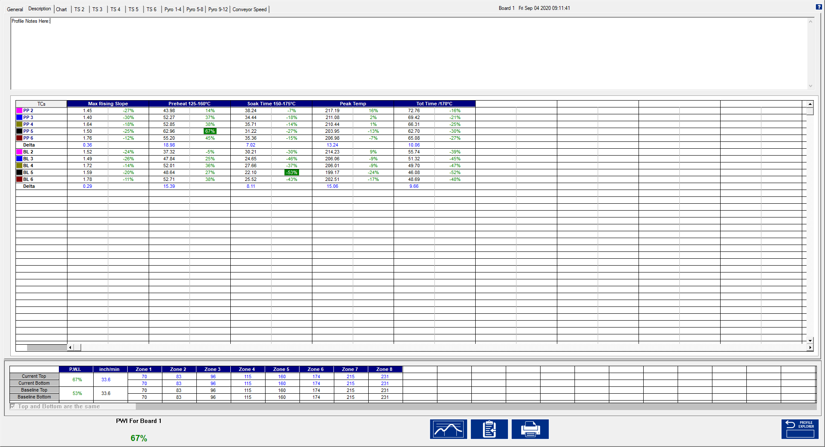

Figure 94: Pyrometer Profiling History – Description Tab

In Historical mode the Description tab displays the Baseline profile description notes. Below the description area, the Pyrometer Profile and baseline statistics, and recipes are displayed. In the bottom-left corner, the PWI (and the barcode number, if enabled) for the selected board appears.

## Historical Mode - Chart Tab

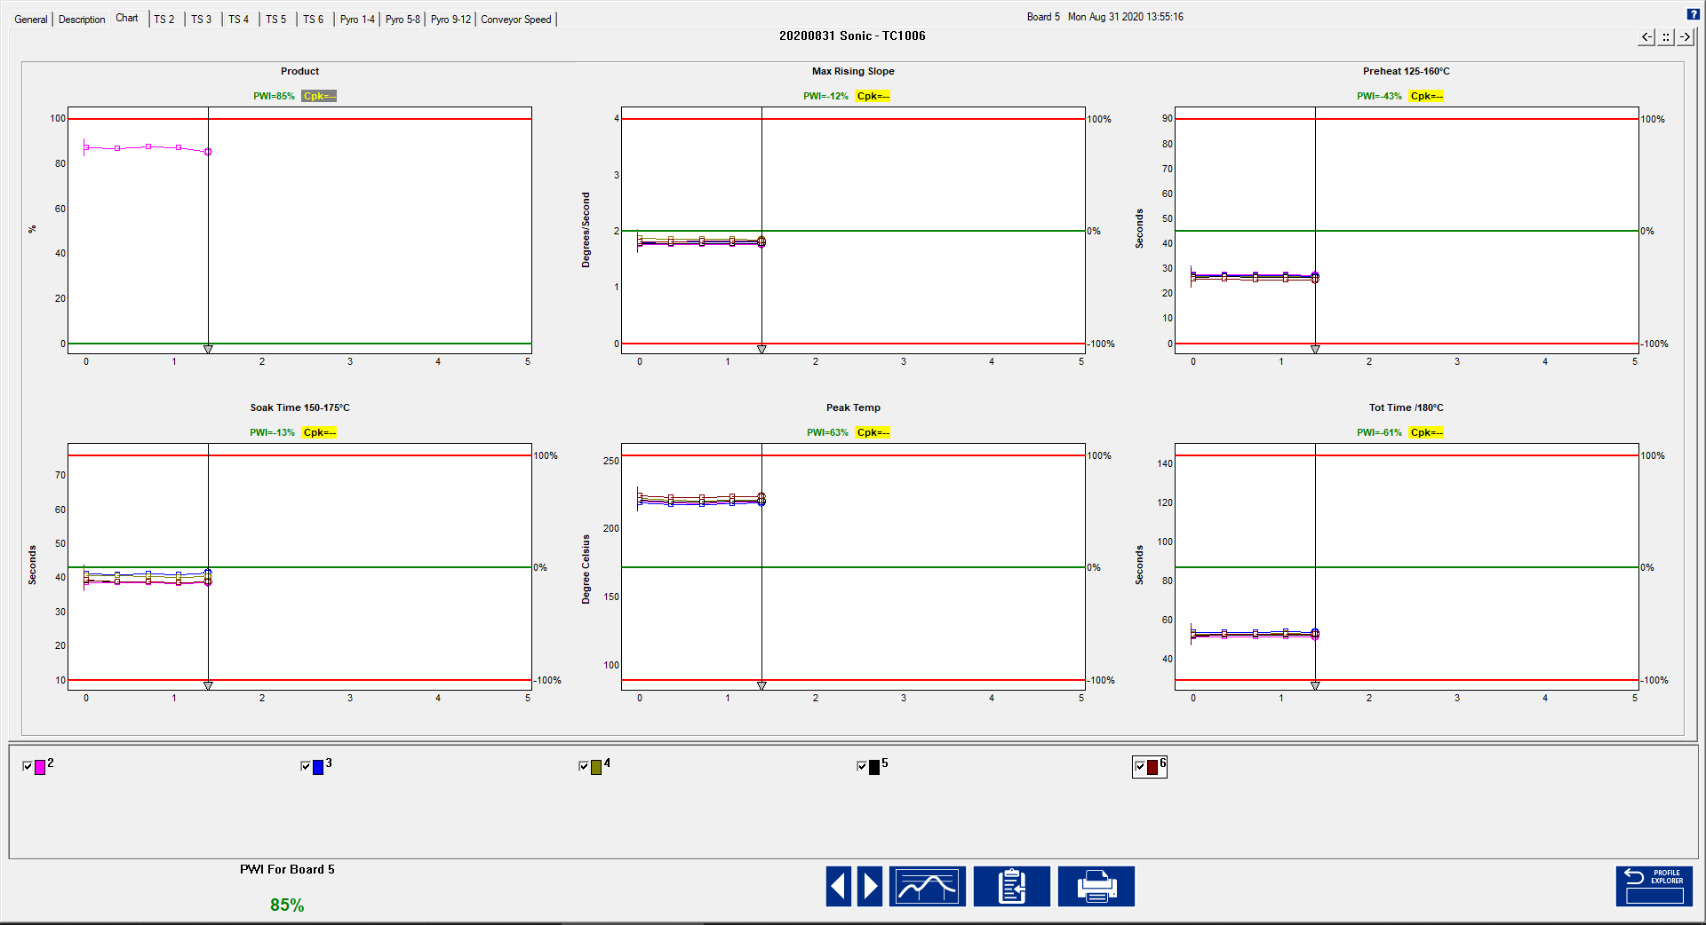

Figure 95: Pyrometer Profiling History – Chart Tab, all charts

The Chart tab will display a control chart for the overall profile PWI and for each individual process specification with alarm limits as defined in the Process Window setup. The chart data will coincide with the Pyrometer Profile data for the selected board, date and time.

##### View Control Charts

Depending on the screen resolution, setting of the computer not all charts may fit within the screen area. Use the buttons in the upper-right corner of the Chart tab to select the number of charts to display and toggle between then.

The control charts hold all of the historical Pyrometer Profile data for your product as selected in the Profile Explorer. Each data point on each chart represents a board that has passed through your oven.

**Board selector line -** Each chart has a Board Selector Line at specific board #. The board # appears at the top of the screen, along with the date and time that board # was entered into the PRI system. You can move the Board Selector line position by clicking and dragging the small triangle at the bottom of the Board Selector line.

The Maximum PWI and Cpk for the selected board, date and time are highlighted above the corresponding chart(s).

Each chart contains data for every product thermocouple used during the profile. Below the charts you can de-select the TCs that you wish to remove from the control chart display. De-selecting a TC will remove the data for that TC from each control chart. Click the check box again to display the data for that TC. In the bottom-left corner, the PWI (and the barcode number, if enabled) for the selected board appears.

##### View Chart Data

To view individual chart data, click inside the chart area of your choice. This will display that chart in a full screen format. Move the mouse pointer over the chart data, and a display box will appear. This display box data includes barcode number, PWI, Cpk, date, and time for each board. The date and time for the last board to exit the oven appears at the bottom of the full screen chart.

### History Mode Chart Options Menu



Figure 96: History mode-Chart Options Menu

* **Meter window –** Right click anywhere in the full screen chart area. The Chart Options menu will appear, select Meter Window. This will display a small data box in the upper-left corner of the profile graph. This data box will display the historical – statistic data for any selected board. To select a board move your mouse pointer along the chart data, at each data point the historical – statistic data for that board appears. Right-click in the chart area again and de-select Meter Window to disable this feature.
* **Point protector –** When this feature is enabled, the software will display individual data points for each board. A small square shaped data point represents a production board. A small circle shaped data point represents a profile board. To activate this feature right click anywhere in the full screen chart area. A menu will appear, select Point Protector. This will display the individual data points on each control chart. De-selecting this feature will remove the data points from the control chart, showing only a plot of the same data. By default, the Point Protector is enabled for charts containing 20 boards or less. Click in the full screen chart area again to return to the regular Chart tab view.
* **Event History-** This feature is enabled as a default setting in the software. When viewing the charts tab while in History mode an Event History dialog box appears. The Event History dialog box will contain a list of all alarms and alarm related events that happened during the (selected) Pyrometer Profile.

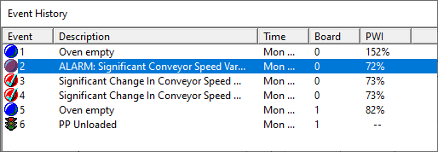

Figure 97: Event History dialog box

**Disabling Event History Display** - Right click anywhere in the full screen chart area. The Chart Options menu will appear, select the Event History option.

**Charts Tab Buttons**

The Charts tab will have two extra buttons found only on this screen:

|  |  |
| --- | --- |
|  | **Scroll backwards in time** – Clicking on the green left arrowhead will result in displaying the *previous* set of pyrometer profiled boards. |
|  | **Scroll forward in time** – Clicking on the green right arrowhead will result in displaying the *next* set of Pyrometer Profiled boards. |

**Note***:* Each chart can display a maximum of 100 data points (boards) at any given time. Every 100 data points are considered a set of data. A set of data can contain up to 100 data points, or if the production run was stopped before 100 boards were processed, a data set may contain less than 100 data points.

## Historical Mode - Troubleshooting Tab

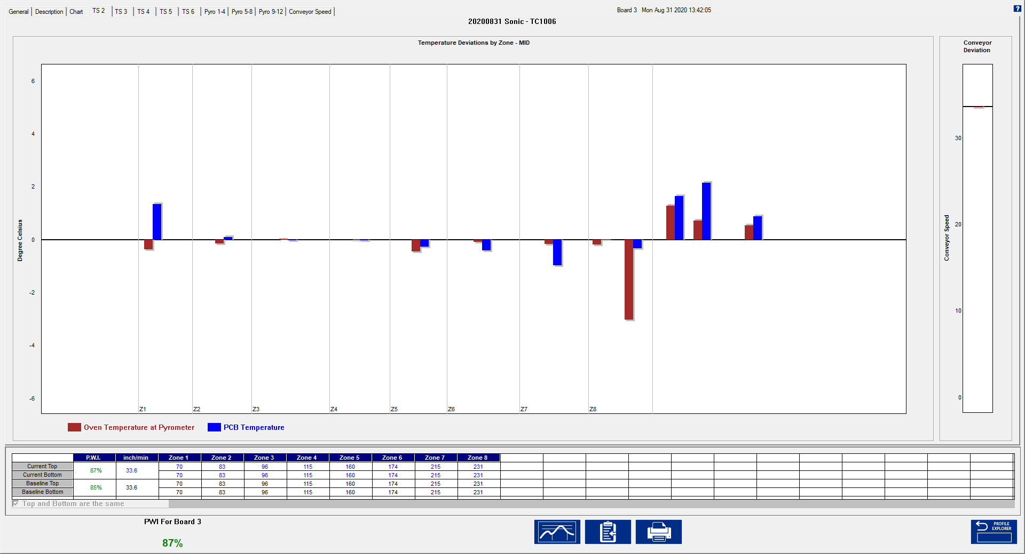

Figure 98: Pyrometer Profiling History – Troubleshooting Tab

The Troubleshooting tab shows historical pyrometer and conveyor speed deviation. The Board #, date and time appears at the top of the screen. To change the board #, go to the Charts tab and move the Board Selector Line to a different board (#) number. The PWI for the selected board appears in the bottom-left corner.

Depending on your oven and needs, the number of pyrometers required will change. On the screen, each zone is displayed on the TS tabs within the vertical gray lines.

##### Historical Mode Buttons

While in Pyrometer Profiling - Historical mode, the software displays four buttons at the bottom of the screen.

|  |  |
| --- | --- |
|  | **View/Edit Process Window –** This lets you view and edit the process window specifications and limits. |
|  | **Copy to Clipboard –** This button copies the profile or Pyrometer Profile data to the clipboard for use with third-party software such as a spreadsheet application, or SPC software. |
|  | **Print –** This button will print the current profile as displayed on the General Tab.  **Note**: If you wish to print a tab besides the General tab, pressing F9 on your keyboard will print the contents of any screen in the software. |
|  | **Profile Explorer –** This button will return you to the Profile Explorer. Click this button when finished viewing historical Pyrometer Profile data. |

# Barcode Functions



PRI software has two main barcode functions, *Process Traceability*, and *Process Control*. For either barcode function, the barcode scanners connect directly to the DAU-Alarm/Barcode port or to the pigtail connector of the alarm relay-cable if an alarm relay is also being used. The Alarm Relay is required for use of the Process Control barcode function. Alternatively, a Serial or USB scanner can also be connected directly to the PC running the PRI software. See *Appendix C – Barcode* for more information.

### Process Traceability (PT)

The Process Traceability function enables process traceability with profile data for every product linked to its barcode number. The software will match the barcode number and complete process data to every single production board recorded by the system. The Process Traceability Barcode function can be used with or without the Process Control function.

### Process Control (PC)

The Process Controlfunction enables process control by reading the product barcode label before the product enters the oven and confirms that a specific area of the barcode correlates to a specified product. If the barcode string value matches the current process string value, production continues as normal. If the incoming barcode string value differs from your defined string value, an alarm is activated and the process can be stopped until the operator acknowledges the alarm and takes the proper action. In order to utilize the Process Control feature, your barcode strings need to contain at least one character (referred to as a “String”) that is common to all boards in a production run. For example, when running “Product A”, all barcode labels for “Product A” would be “ABCxxxx”, where “ABC” would represent the common characters (String) on each barcode label, and “xxxx” would represent the rest of the barcode characters, which would typically be unique to each individual board. The common character string can fall anywhere within the barcode. The barcode functions can be used together or separately. There are multiple ways to install the barcode hardware. The correct method will be determined by the KIC hardware and your barcode labeling techniques.

### Barcode Product Sensor

The Barcode Product Sensor (BPS) is an optional product sensor used exclusively with the barcode option for improved functionality.

Using the BPS, the PRI system is able to determine if any given product has had its barcode label successfully scanned. If a product triggers the sensor and there is no barcode string read into the software, the system will give a NO READ alarm. (Alarm 5C)

### Scanners

The PRI barcode option is offered as a software only option. You must provide the serial port or USB barcode scanner, support/ utility software, all communication cabling, and mounting hardware.

Here are some important points to consider when planning to use PRI with the barcode option:

1. The barcode reader must have either a 9-pin D-Sub serial connector (RS-232) for communication or be a USB model that can be programmable for Serial Port interface.
2. Barcode readers with Raster scan (multi-scan) are recommended
3. Barcode reader must be capable of the following communication settings:

**Baud Rate: 9600 bits/sec, Data Bits: 8, Parity: None, Stop Bits: 1**

1. The scanner(s) must be programmed to have both a “Line Feed” and “Carriage Return” after each string is scanned.
2. The scanner must be programmed for a single output for each board scanned.
3. You will need the barcode reader utility software in order to configure the barcode reader.
4. Non-standard cabling may be required for multiple barcode applications.

## Barcode Types

Since the software does not actually read the barcode labels, you can use any barcode type that your barcode scanner is capable of reading. Verify your barcode scanner can read the barcode type prior to KIC installation. Refer to the scanner manufacturer for programming of the settings.

## Configuration Overview

1. Program the barcode scanner settings using the software utility that is provided by the scanner manufacturer.
2. Select desired functions/settings in the Barcode tab of the Configuration Program, and then enable the barcode option(s) in Global Preferences. The PRI Hardware Status screen will help you verify your barcode reader is connected properly.
3. Test the hardware connection.

### Configure and Test the System

Start by ensuring that the Barcode software key is properly connected to your PC. Verify the software key is correctly installed by viewing the Hardware Status screen. Confirmation appears in the Software Key field.

If you do not see confirmation displayed, check the following:

* Check to make sure software key is properly installed and correctly seated.
* Check to make sure the key you have is programmed for Barcodes.
* Check to make sure the USB port is functional.

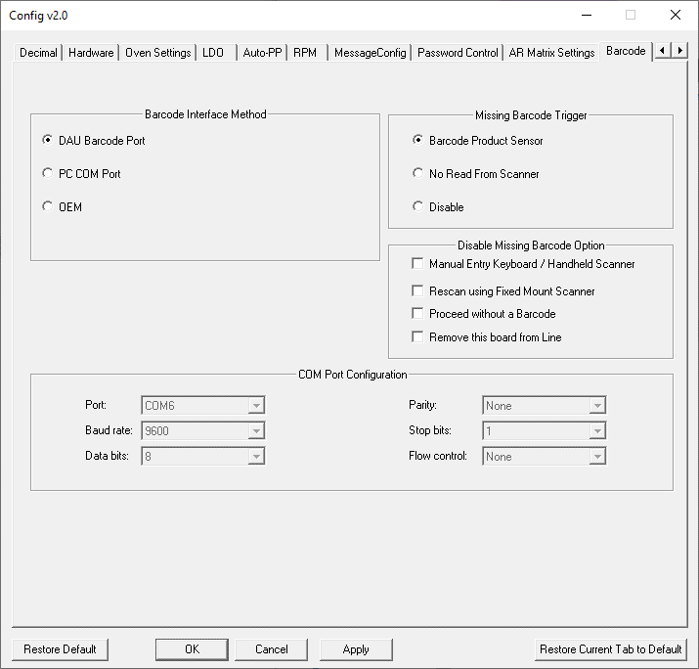

1. Shut down the PRI software and in the C:\PRI directory run the ConfigurationProgram.exe
2. Select the Barcode tab and select the applicable configuration.
3. Click Apply then OK to save the changes and close the application.
4. Restart the PRI software.

NOTE: See the Barcode Tab section in Appendix C for more details on each setting.

Figure 99: Barcode Tab Config Program

1. 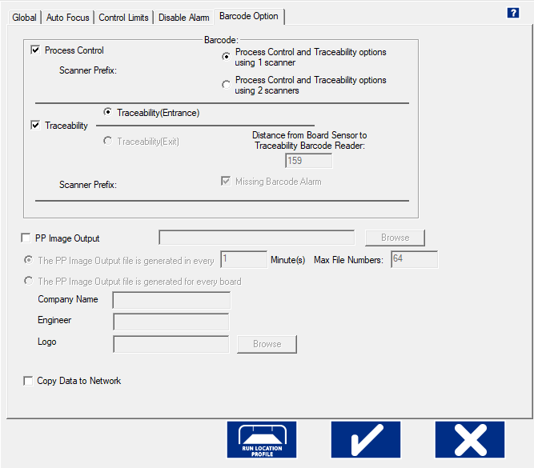Open the PRI software. From the main menu, select the **Global Preferences** button, and then select the ***Barcode*** tab. Select the Barcode option(s) that apply.
2. There are several possible barcode hardware configurations. The correct barcode configuration will depend on the KIC hardware and barcode labeling technique. For barcode type configuration details, see the section titled Barcode Types.
3. Select your barcode function(s) and enter any measurements that apply. The Missing Barcode Alarm feature is only for the Process Traceability function.

Click the check button to save and return to the main screen.

Figure 100: Barcode Tab – Global

### View Barcode Data on the Hardware Status Screen

**Hardware Status** – Once a barcode function is enabled, a barcode field is added to the Hardware Status screen as seen below.



Barcode field

Figure 101: Barcode – Hardware Status

Scan a barcode and the barcode string will appear in the Barcode section, . In order to view the barcode value, the conveyor must be moving. The barcode information will not display until the encoder begins moving.

### Test with The Barcode Log Configuration File

**Barcode Log** - You can also verify that the barcode feature is configured properly or for troubleshooting purposes by viewing the Barcode-Log file. If the barcode scanner hardware is connected and functioning properly, the system generates a log file. Every barcode value read by the system is logged and viewable.

To view the barcode-log file go to C:\PRI\Log\barcodeLog.txt. This file will list the date, time, and barcode value for each barcode read into the software.

## Pyrometer Profiling and Barcodes

**Note**: The barcode option requires a software key in order to function. The software key must remain connected at all times during use.

### Enable Barcoding Per Product

You can turn on or off the Process Control and Traceability functions on a per product basis. When the Barcode feature is active, in Profile Explorer you will find checkboxes for the two different functions to the right of each product folder. These checkboxes allow you turn on/off the feature independently for each product:

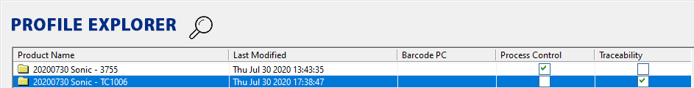

Figure 102: Barcode enable – Profile Explorer

### Process Control

When Pyrometer Profiling is started, the system produces the Barcode Process Control dialog box. This dialog box gives you the opportunity to:

* Enter or change the Process Control String.
* Disable Process Control for this Pyrometer Profile run.

As long as the Process Control function is enabled, this dialog box will appear every time Pyrometer Profiling is started.

For Process Control you are required to enter the barcode String that is specific to the product that is running. The software reads the incoming String and compares the barcode string to that of the Process Control String, for every product. If the string values differ, an alarm is activated, and the process is stopped via the alarm relay device.

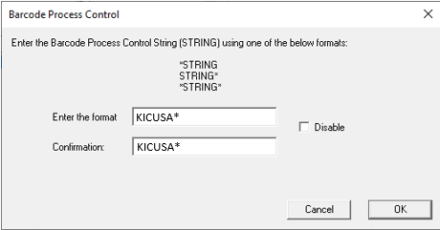

Figure 103: Barcode Process Control dialog

#### Barcode Product Sensor (BPS)

PRI systems using the optional BPS and Process Control barcode function will have the ability to activate an alarm if a products barcode label is not read.

When the BPS detects a product whose barcode label has not been read, or the BPS is tripped accidentally, an alarm is activated, and the process is stopped via the alarm relay.

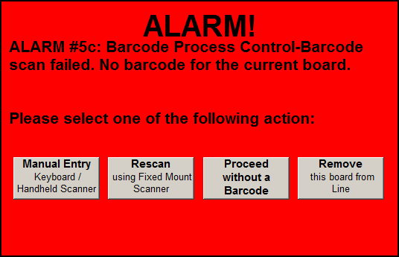

Figure 104: Alarm 5C

Control buttons on the screen let you:

* Manually reenter the barcode, using the keyboard or a handheld scanner
* Rescan the barcode with a mounted scanner
* Continue production without the barcode
* Remove the board from the line

### Traceability

The Traceability function enables process traceability with profile data for every product linked to its barcode number. When installed on a load conveyor, the scanner reads barcode labels before the products enter the oven. If the barcode label is not read, the process is stopped before the product enters the oven. This method requires use of the Alarm Relay, and load conveyor.

PRI systems using a BPS and Process traceability barcode function will have the ability to activate an alarm if a products barcode label is not read. When the BPS detects a product whose barcode label has not been read, or the BPS is tripped accidentally, an alarm is activated and the process is stopped via the Alarm Relay.

Control buttons on the screen let you:

* Manually reenter the barcode, using the keyboard or a handheld scanner
* Rescan the barcode with a mounted scanner
* Continue production without the barcode
* Remove the board from the line.

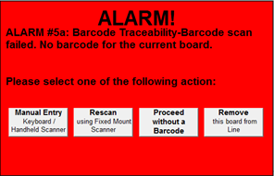

Figure 105: Alarm 5a

### Display Barcode Queue

A button for the barcode queue is available on the Graph, Description, Charts, and Troubleshooting screens during a live PP. This allows a user to remove a product and its associated barcode string from the line before the product enters the oven. The software will display this button even if all barcode options are disabled. When hovering the mouse over the button, a tool tip “Display Barcode Queue” will display.

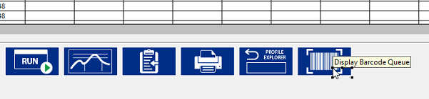

Figure 106: Barcode Queue

#### Barcode Queue

When opened, the **Barcode Queue** shows a list of all the barcodes currently in the queue in order. The next barcode to be assigned to a board appears at the top of the list. A barcode is automatically removed from the list after the board has completely passed the entrance board sensor.

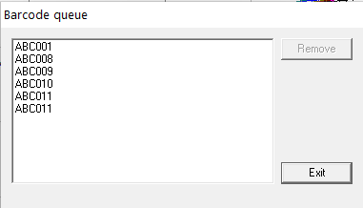

Figure 107: Display Barcode Queue

The **Remove** button is disabled by default. When you select a barcode, the **Remove** button becomes active.

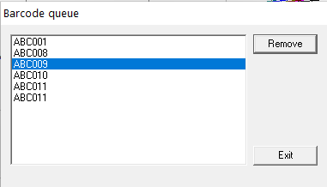

Figure 108: Remove Barcode

1. When removing a barcode string, click **Yes** on the window that asks you to “*Confirm you want to delete this barcode string from the queue*?”   
   Clicking **No** returns the user to the Barcode queue window.

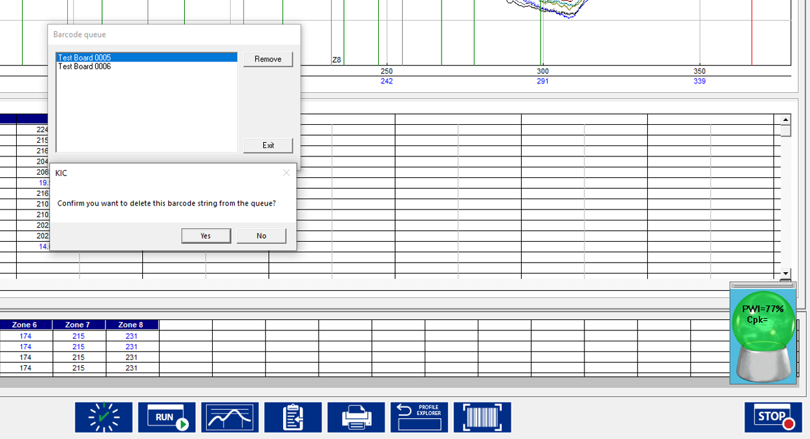

Figure 109: Confirm remove

The software then removes that string from the queue and the next string in line will be assigned to the next board.

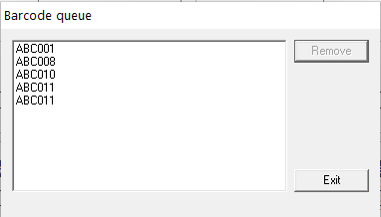

Figure 110: Updated queue

In the example below, barcode VT0002 had been removed from a queue, and you can see it is reflected in the board data.



Figure 111: Removed barcode

## View Barcode Traceability Information Historical Data

In the Profile Explorer screen, there is a Barcode button located at the bottom of the page. Select this button to search for specific bar-coded products and view their profile information for the date/time they were processed. A dialog box appears with a field to enter the barcode string with a Search button next to it. You can enter the value using the keyboard, or by selecting the scanner check box and then using the barcode scanner to scan the actual barcode eliminating the need to enter the value manually.

Below this is a field that will list the time, date and PWI for that barcode, if it exists for the chosen product. Either double-click the listing or highlight it and then click the View Selected Profile button. This will bring you to the Historical Pyrometer Profile graph for that board.

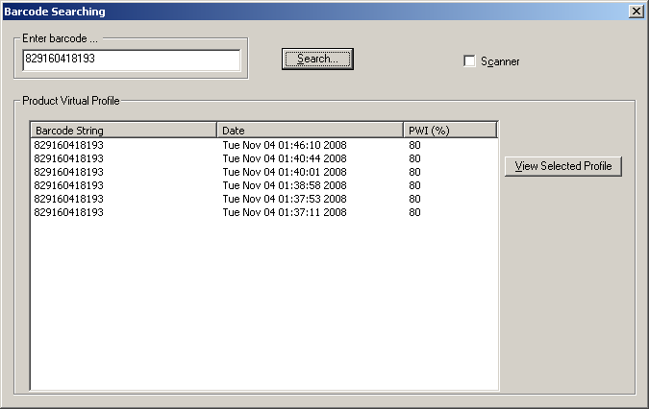

Figure 112: Barcode Search

The software will display the barcode value in the bottom-Left corner of the Pyrometer Profile screen:

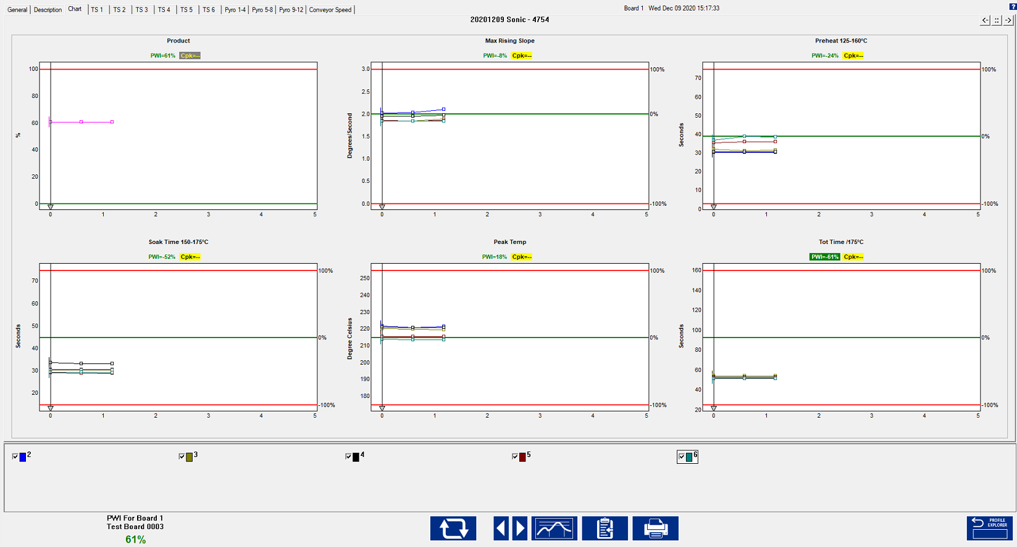

Barcode value display for most recent read by the system or selected board if viewing historical Pyrometer *Profile* data.

Figure 113: Pyrometer Profiling – Chart Tab

## Live Data Output And Barcodes

The **Live Data Output** (LDO) function will output the thermal process data to a file. The thermal process data will include barcode information for every board when both Barcode Traceability and the Live Data Output feature is enabled.

Below is an example of the KIC_PRI_LiveDataOutput.txt file that is generated by the system when LDO is active.

**Note**: the tables below were created by importing the LDO data file into Microsoft Excel.



**Barcode data for each board**

Figure 114: Example Live Data Output text file

# Live Data Output

The Live Data Output (LDO) feature outputs Pyrometer Profile (PP) data in real time for use by third-party applications such as Line Balancing/Production Monitoring Host or SPC software. This data includes barcode information (where applicable) and all relevant profile data, statistics, and limits. There are several different LDO formats that can be chosen from. Examples of these formats will be shown later in this section.

**Output of the LDO File Data** –When the PP is running, the statistical data from each newly completed Pyrometer Profile is written to the LDO file when the board exits the oven.

**Viewing LDO Data** – LDO is designed to output data only and is not meant as a historical database. It is intended to be used with third party software that collects the LDO data while the Pyrometer Profile is running-live. If you are not running third party software to collect the LDO data, and wish you to view historical data, this can be accomplished from within the actual KIC software in use.

**LDO Destination** – The location where the LDO output file is written to can be specified by the user in the ConfigurationProgram.exe utility.

**Note**: For the Live Data output to function, the appropriately programmed USB dongle key must remain connected to the PC at all times during use. You can verify whether or not you have the LDO feature by viewing the Software Key panel in the Hardware Status screen.

**An LDO Output File Example**

Below is an example of the type of data included in the LDO output file:

Figure 115: Live Data Output text file

Process Info:

Product Name:

Profile Board_Soldered TCs

Process Window Name:

____63_37____

Oven Name:

My Oven

Oven Recipe Name:

Conveyor Speed Units:

inches/minute

Temperature Scale:

Celsius

Number Data Points to Calculate CpK:

10

Number of TCs:

6

Number of Statistics:

4

Statistics Limits:

LOW

TARGET

HIGH

Max Rising Slope

0

2.3

3

Soak Time 100-170C

60

120

Reflow Time /183C

45

90

Peak Temp

205

225

Baseline Profile Info:

Profile Start Time:

Thu May 09 12:00:23 2015

Baseline PWI:

81%

Conveyor Speed (Setpoint):

36

Conveyor Speed (Measured):

36.09

Zone Number:

1

2

3

4

5

6

7

Top Setpoints

124

149

157

155

180

225

234

Bottom Setpoints

124

149

157

155

180

225

234

Barcode

Date and Time

Product

PWI

Conveyor

Max Rising Slope

PWI

CpK

Speed

TC2-data

TC2-PWI

TC2-CpK

TC3-data

TC3-PWI

TC3-CpK

c9876d

Thu May 09 12:08:11 2015

75.9

-1000000

35.8

2

-13.5

-1000000

2.1

-7.3

-1000000

ABC123+=-

Thu May 09 12:09:39 2015

75.7

-1000000

35.8

2

-13.3

-1000000

2.1

-7.1

-1000000

12345

Thu May 09 12:13:12 2015

74.6

-1000000

35.8

2

-13.8

-1000000

2.1

-7.2

-1000000

1234565

Thu May 09 12:15:05 2015

75.8

-1000000

35.8

2

-13.9

-1000000

2.1

-7.2

-1000000

Thu May 09 12:18:27 2015

73.8

7.17

35.8

2

-12.9

85.43

2.2

-6.3

84.6

## LDO Formats

There are several standard LDO formats to choose from:

* TSV or CSV format for WordPad
* TSV or CSV format for Excel
* 1 Board 1 File (TXT format)
* 1 Board 1 File (XML format)
* 1 Board 1 File (CSV format)

The following are specialized output formats and not typically selected by most users:

* KP Data Only (CSV)
* XML Format A
* XML Format A2
* CUSTOME LDO

## Details of Output Files

### TSV and CSV for WordPad

* The output file type is a .TXT
* TSV format is Tab delimited
* CSV format is Comma delimited.
* The output file is first generated when the PP is started
* File is appended as each board exits and PP is calculated
* The default output file name is KIC_PRI_LiveDataOutput.txt
* The user can choose to define their own specific output file name
  + If default or user defined naming is selected, output file is overwritten on product changeover occurs
  + File name format can also be set to: PRODUCT_YYMMDD_HH-MM-SS.txt
    - When this naming is selected, a new file is generated when product changeover occurs

### TSV for Excel

* The output file type is a .TXT
* Format is Tab delimited
* The output file is first generated when the PP is started
* File is appended as each board exits and PP is calculated
* The default output file name is KIC_PRI_LiveDataOutput.txt
* The user can choose to define their own specific output file name
  + When default or user defined naming is selected, output file is overwritten when product changeover occurs
  + File name format can also be set to: PRODUCT_YYMMDD_HH-MM-SS.txt
    - When this naming is selected, a new file is generated when product changeover occurs

### One Board One File (TXT format)

* The output file type is a .TXT
* Separate individual file is generated as board exits oven and PP is calculated
* File name is ProductName_OvenName_YYMMDD_HH-MM-SS_BarcodeString (Barcode string included when applicable)
* User cannot change file name – with exception of not including barcode in file name

### One Board One File (XML format)

* The output file type is a .XML file
* Separate individual file is generated as board exits oven and PP is calculated
* File name is ProductName_OvenName_YYMMDD_HH-MM-SS_BarcodeString (Barcode string included when applicable)
* User cannot change file name – with exception of not including barcode in file name

### One Board One File (CSV format)

* The output file type is a .CSV file
* Separate individual file is generated as board exits oven and PP is calculated
* File name is ProductName_OvenName_YYMMDD_HH-MM-SS_BarcodeString (Barcode string included when applicable)
* User cannot change file name – with exception of not including barcode in file name

**Note:** Examples of each of the available output file types can be found in the C:\PRI\Sample LDO files folder.

## Configure LDO

1. With the KIC software shut down, browse to the C:\PRI folder and run the ConfigurationProgram.exe application, and select the LDO tab:

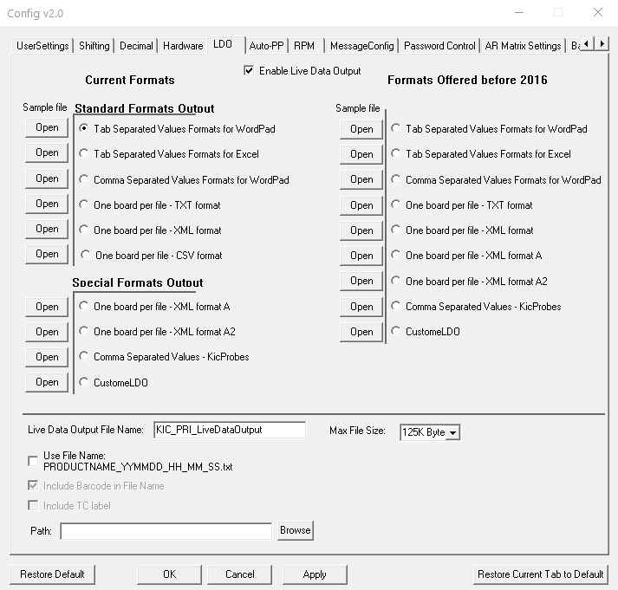

Figure 116: LDO configuration

1. Check the ***Enable Live Data Output*** checkbox
2. Select the desired Format
3. The type of Format chosen will affect what naming structure for file will be used (See Details of Output Files above).
4. Select the destination path for the output file by clicking on the Browse button. This needs to be a location on the local drive.
5. “Max File Size” lets you specify how large the LDO output file can get before a new one is started.

If a PP is running for an extended amount of time, once the maximum file size is reached, a new file will be generated and the new file name will be appended with a _# as shown in the example below:

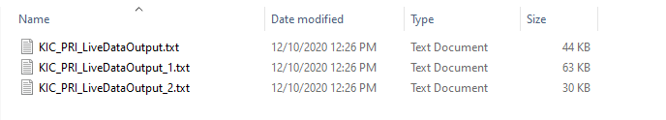

Figure 117: Live Data Output files

## Delete Accumulated LDO Files

In time, accumulating LDO files can take up too much hard disk space and need to be deleted. The software provides an *Auto Delete* function that lets you specify time intervals for automated file purging. You can specify a maximum number of days–up to 1827 (five years)–that the system retains the files before automatic purging. You can also select a time in the 24-hour cycle for the system to automatically check for files that exceed the maximum day limit.

1. In the PRI folder, double-click on the **AutoDelete** icon. 

The Auto Delete LDO files screen appears:

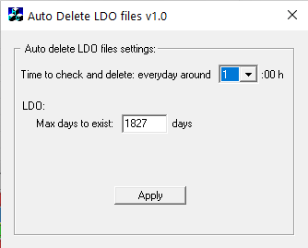

Figure 118

1. Click in the ***Max days to exist*** field, and type in a new value.



|  |  |
| --- | --- |
| 1. Use the drop-down list to select an hour during the day to check for old files.   C:\Users\dklueck\Desktop\Auto Delete LDO time to check2.png   1. Click the **Apply** button. | C:\Users\dklueck\Desktop\Auto Delete hour list exposed.png |

# Dual Lane Systems and Functionality

The PRI system can monitor production through dual lane reflow ovens. This section will define the unique capabilities of the dual lane configuration.

A *Dual Lane-Dual System* configuration uses two instances of the software application to track different recipes through the oven.

The *Dual Lane-Single System* tracks two lanes of the same recipe with one instance of the software.

A radio button display during the installation routine lets you choose between the standard configuration or one of the dual lane setups.

## Dual Lane Dual Systems

A dual system installation features two distinct instances of the PRI software and a complete duplication of the thermal management hardware. Dual systems include *two*:

* Pairs of pyrometers
* Encoders
* DAU
* Board sensors

|  |  |
| --- | --- |
| Each PRI instance receives data from its own associated DAU. Each stores its logged data and executable subroutines in separate folders identified as either *front rail* or *back rail*. (The front rail designates the lane closest to the lifting cover of the oven—the back rail designated the lane closest to the hinge of the oven cover.) | C:\Users\dklueck\Desktop\DSC09143b.jpg  Figure 119 |

The two instances of the software permit using different recipes in each lane. In the desktop toolbar, each PRI instance is represented by its own icon – F for Front Rail and B for Back Rail.



Figure 120

## Configure Dual Lane Systems

During the software installation, you will have the option to select what type of system will be in use:

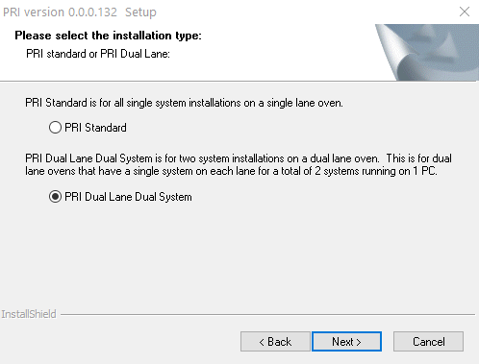

Figure 121: Dual Lane install

You would select “*Dual Lane Dual System*” if there is a complete system installed on each lane of the oven.

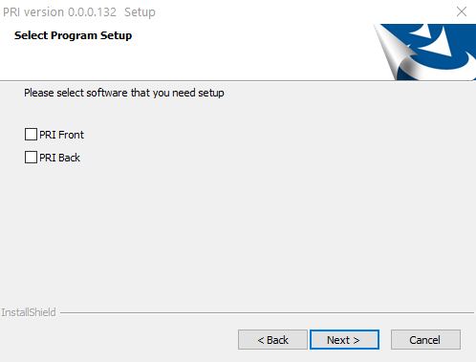

Figure 122: Dual lane - directory

When “*Dual Lane Dual System*” is selected, as noted previously, there will be two separate software directories used – one for the “Front” and one for the “Back”. You will be able to choose whether you want to install the software for either one, or both directories.

### Dual Lane Configuration

Additional settings for a Dual Lane system configuration can be found in the *ConfigurationProgram.exe* located in the C:\PRI directory.

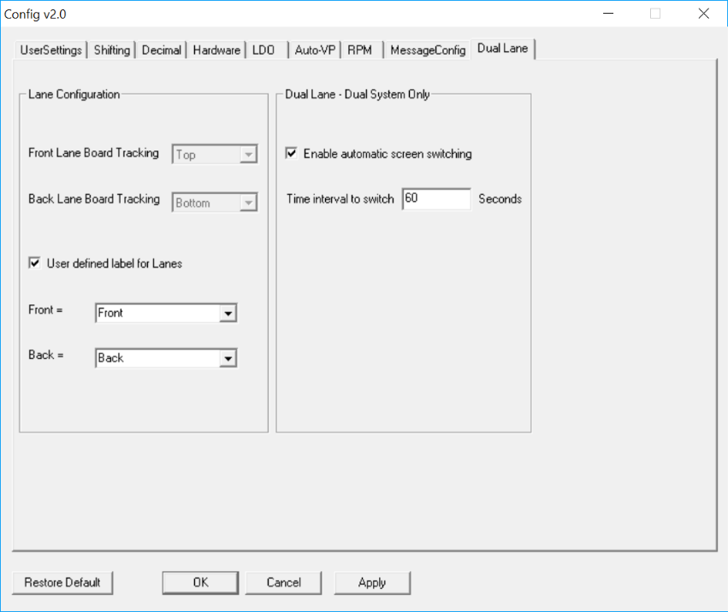**Lane Configuration** – For a Dual Lane-Single System, this section allows you to specify the position of the Board Tracking display in the software for each lane.

**User defined label for Lanes** – By default, the software will label the lanes “Front” and “Back”. When the checkbox is checked, the drop-down menu allows you to select alternate designations for the lane names.

**Note:** The Front Lane is always the lane closest to the front side of the machine.

**Dual Lane – Dual System Only** – When a Dual System is in use, there are two instances of the PRI software running – one for each lane. By default, a user must select the lane they want to see on the screen at any given time.

Figure 123: Dual Lane Config

When selecting this checkbox, the user can define an interval for the software “automatically” to switch over to the other lanes display after no input from the mouse cursor.

**Note:** For Dual Lane Dual System installations, the settings in this configuration utility must be entered into both install directories – C:\PRI Front Rail and C:\PRI Back Rail.

On Dual Lane Dual Systems, when you select *User defined label for Lanes*, the selection chosen will display as a watermark on the Index, General, Description, Charts, and Troubleshooting screens. See example below:

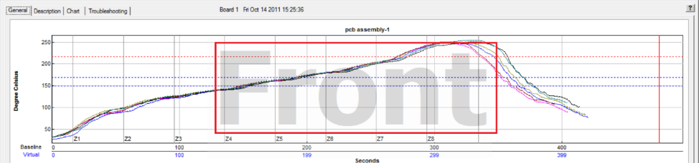

Figure 124

#### Configuring to profile

The profiler can only communicate with one lane at a time, so you must select which lane you want the profiler to connect to. Disconnect then reconnect the profiler (or Smart Dock/Base Station where applicable). A pop-up menu will display in the lower right of the screen allowing you to select which lane to connect to. Repeat these steps to change to the other lane.

Figure 125: Profiler connect

# Use Sweet Spot Target (Optional)

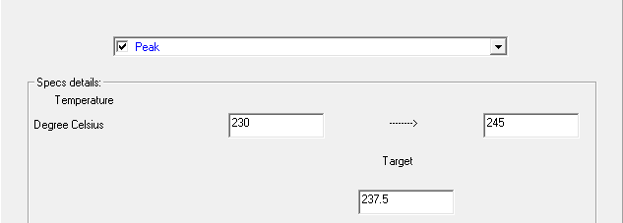

Figure 126: Sweet Spot option

Normally, when selecting a specification, only an upper and lower limit is defined, and the “target” value is automatically the center of the upper/lower limits. If you have purchased the *Sweet Spot Target* option, enabling this feature allows you to manually define your own Target value for each statistic. This function may be desired when there is a defined specification window, but the desired optimal value may not be the exact center of the limits.

# O2 Live (Optional)

**Note**: The software key must always remain connected during use for *O2 Live* capabilities to function.

*O2 Live* is an optional feature that allows you to display an O2 PPM measured value on a profile, or Pyrometer Profile data. *O2 Live* is not an oxygen analyzer, but an option that allows for the output from a user’s existing analyzer to be read in and displayed by the PRI software. An external interface device connects between the output of the oxygen analyzer, and the PC (USB port) running the PRI software*)*. This O2 PPM value is available in the following areas of the software:

* Baseline Profile
* Pyrometer Profile (Live)
* Pyrometer Profile (Historical data)
* SPC
* LDO

## Configuration

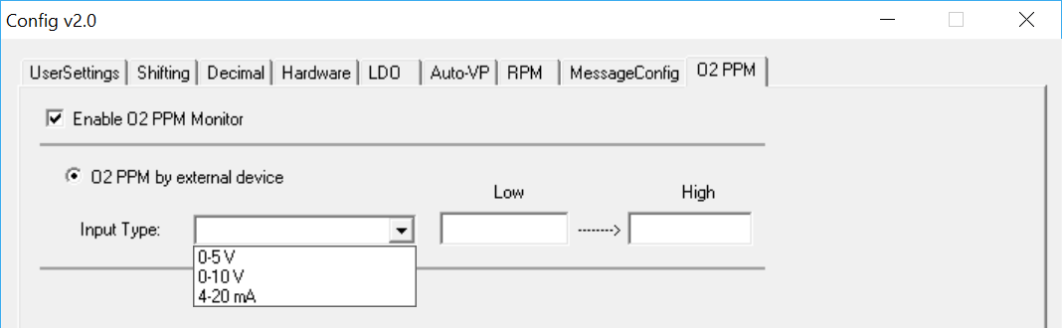

Figure 127: O2 Live Configuration

1. With the KIC software shut down, in the C:\PRI folder, run the *ConfigurationProgram.exe* application and select the O2 PPM tab.
2. Select ***Enable O2 PPM Monitor***
3. From the Input Type drop-down menu, choose the option that corresponds with the type of output used on the customer’s oxygen analyzer.
4. The Low and High values will correspond to the minimum and maximum range of the output, e.g. a Low of 0=0 volts, and a High of 500 equals 5 volts.
5. Click the **Apply** and **OK** buttons at the bottom of the Configuration Program to save changes and close.
6. Restart the PRI software and access the Global Preferences screen.

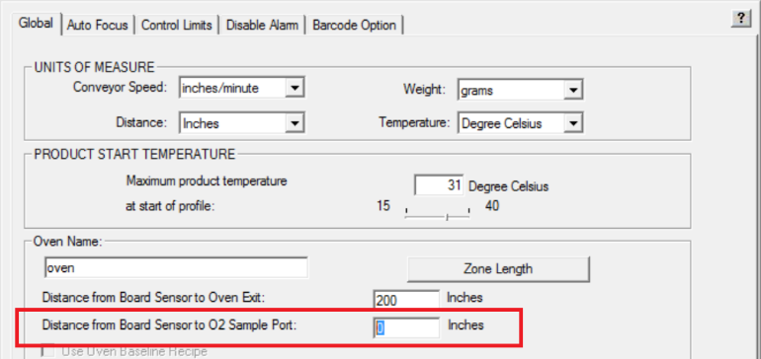

Figure 128: O2 Sample Port Entry

1. Enter the measurement from the KIC Board Sensor to the point inside the oven tunnel where the O2 sampling port is located.

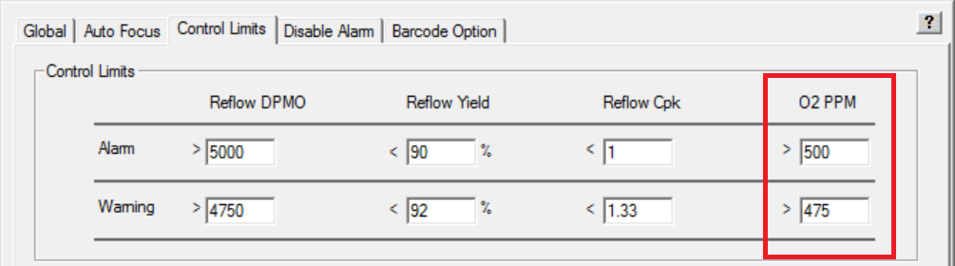

Figure 129: O2 PPM Control Limits

1. Select the Control Limits tab to specify the Warning/Alarm limits for the O2 PPM.
   1. When the measured value is below the Warning limit, the O2 display window will be Green in color
   2. When the measured value exceeds the Warning limit, the O2 display window will be Yellow in color
   3. When the measured value exceeds the Alarm limit, the O2 display window will be Red in color and will trigger the *KIC Alarm Relay* where applicable.

Below are the formulas used for calculating the O2 PPM value depending on type of analyzer output:



Figure 130: O2 PPM formulas

## Operation

When the O2 feature is used, a “floating” window displays on the screen showing the measured value, and is color-coded based on the measured value:



Figure 131: O2 PPM Floating Windows

Below are examples of the O2 PPM display in various areas of the software:

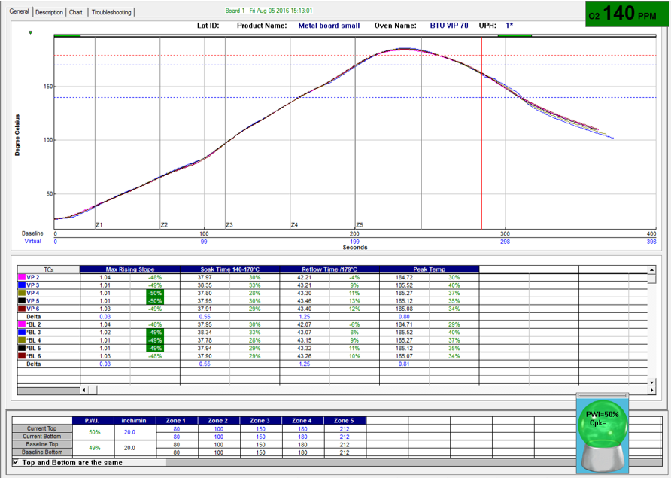

Figure 132: O2 PPM display-PP Graph

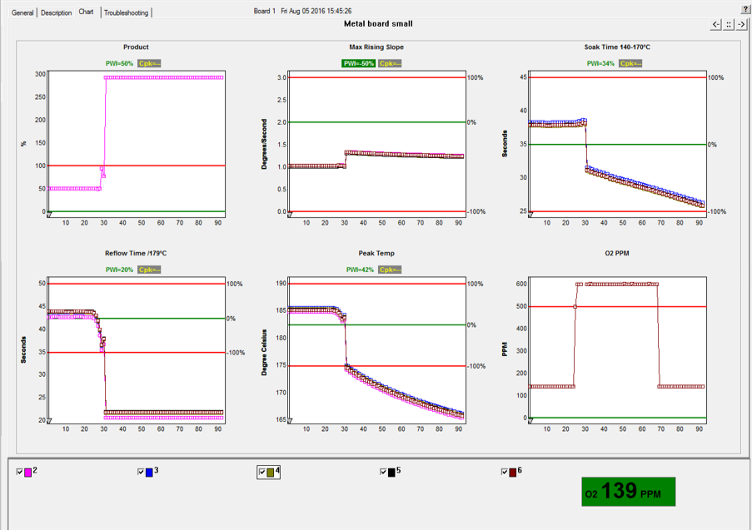

Figure 133: O2 PPM display-Charts Tab

# PP Idle Mode (Optional)

**Note**: The software key must always remain connected during use for *PP Idle Mode* capabilities to function.

PP Idle Mode is an *optional* feature that allows the KIC software to automatically go into a type of “sleep –mode” during Pyrometer Profiling when the energy saving function of some newer ovens is in use. When energy savings features are enabled on the oven, the oven control software will typically modify several of the process parameters – such as conveyor speed, blower fan speed, and even zone setpoint temperatures. When this occurs, the KIC software would normally alarm on the detected changes to the process. Using PP Idle Mode allows the software to ignore those changes during energy saving periods, thus eliminating unnecessary warnings/alarms from being activated.

During PP Idle Mode, the crystal ball will be grey, the statistics chart will be blank, no PP data will be calculated, and no process related alarms or warnings will display or be recorded. When the entrance board sensor is triggered, the system will automatically exit Idle Mode and return to normal PP operation.

## Configuration

The feature is enabled by shutting down the software, running the ConfigurationProgram.exe (in the C:\PRI directory) and selecting “Use PP Idle Mode” in the area shown below, and entering the amount of time the oven should be empty before entering Idle Mode:

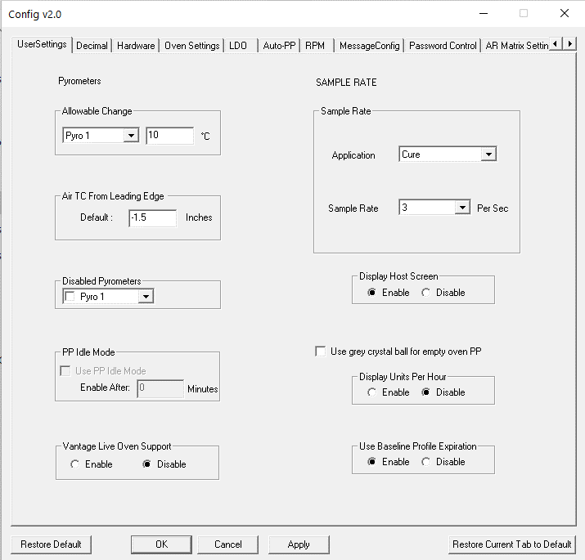

Figure 134: PP Idle Mode Configuration

When PP is running, there will be an additional button on the screen allowing you to manually Enter/Exit PP Idle Mode at any time:

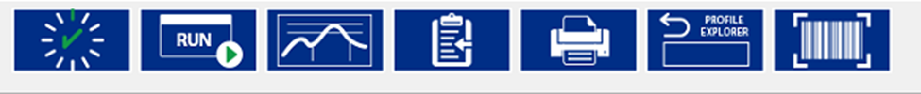

Figure 135: PP Idle Mode

# Units Per Hour

The Units Per Hour (UPH) function can display on the General Tab when PP is running, a count of how many boards (Units) have been processed in the last hour. The number automatically resets back to 0 at the top of the hour.

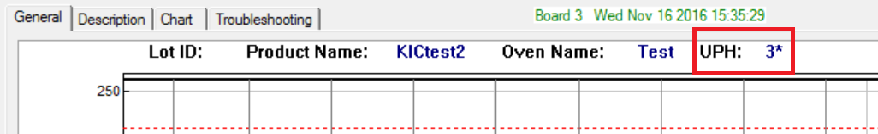

Figure 136: Unit Per Hour

### Configuration

The feature is enabled by shutting down the software, running the ConfigurationProgram.exe (in the C:\PRI directory) and selecting “Enable” as shown below:

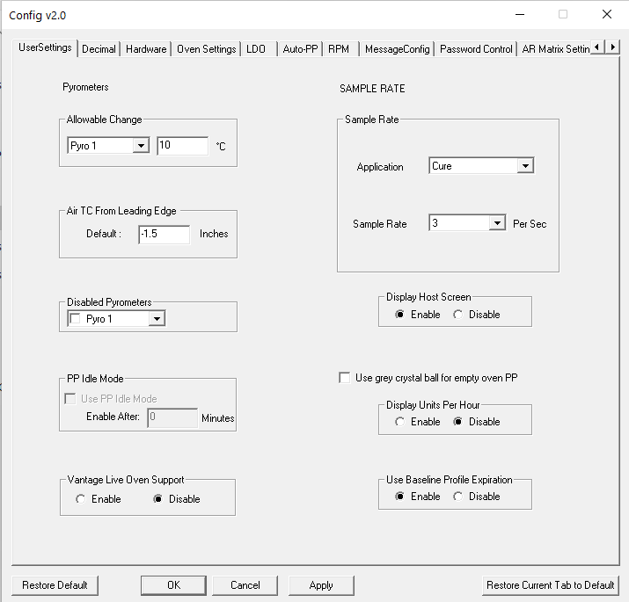

Figure 137: UPH Configuration

# Auto- PP

Auto-PP is an available feature that allows for an automated changeover process. Typically, during a product changeover, an Operator must manually stop the currently running PP, then go into the oven software and select and load the correct oven recipe for the next product to be processed. Then they must go into the KIC software and select the corresponding product and load that PP. This can sometimes lead to the wrong selection being chosen by the user.

Using barcodes, MES control programs, or oven communication, the Auto- PP feature can eliminate the need for Operator intervention in the product changeover process. The proper oven recipe and corresponding PP is automatically loaded based on information sent to the software.

There are multiple configurations of the Auto- PP feature depending on the capabilities and processes in place in the factory. Please contact KIC Tech Support to identify if this functionality can be implemented with your system.

# Profile Printing

The PRI software will print profiles only from within the profile display screens. Click on the printer icon button at the bottom of the profile display to open the Profile printout setup menu. There are two print formats available – Portrait or Landscape.

## Portrait Mode

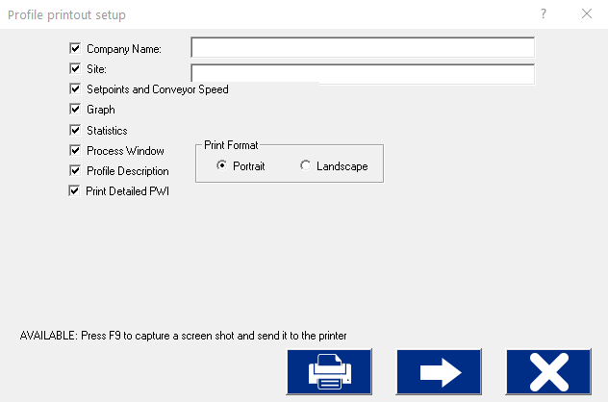

Print

Preview

Print

Cancel

Figure 138: Profile Print Format #1 Options

1. Check the items you wish to include on your profile printout.
2. Press the **Print** button to print the report.
3. Press the **Print Preview Button** to display a preview of the report.

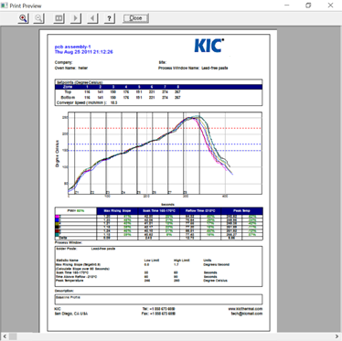

Figure 139: Sample Portrait Print Preview

## Landscape Mode

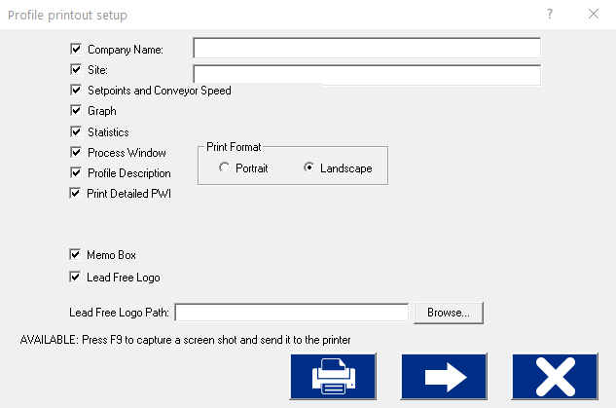

Cancel

Print

Preview

Print

Figure 140: Profile Print Portrait Options

Below are the additional options available with Landscape mode:

* **Memo Box** –Enables/Disables a Memo Box area for Draft, Review and Approval Signatures and Dates.
* **Lead Free Logo** – Enables/Disables the Lead-Free Logo display area.
* **Lead Free Logo Path** – When “Lead Free Logo” is enabled, specify the path to any BMP image file that you want to appear in the Lead Free Logo display area on the report.

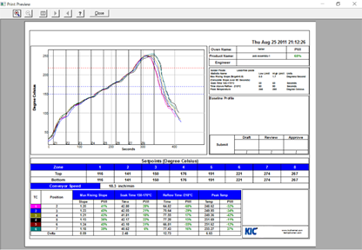

Figure 141: Sample Landscape Print Preview

Optionally, you can print the contents of any screen in the PRI software by pressing **F9** on your keyboard. The **F9** function will not work while viewing the Profile Printout Setup dialog box.

**Note**: Before printing, make sure you have defined a printer for use with Windows.

# Write Data to and View PRI Data Over a Network

## Write Data To A Network Drive

The PRI software can be configured to write the collected data (profiles and historical PP data) to a network drive location. This would allow data from one or even multiple systems to be stored in one centralized location (Server/Shared Hard Drive).

The first step necessary is to map a network drive from the PC running the PRI software to the desired network location. Due to the multiple varieties of OS and network configurations, KIC cannot detail this step. We recommend you contact your IT/Network administrator for setting this up. Below is a typical example of this setup.



Figure 142: Example Network with PRI

Once you have mapped the drive, create a folder on the network drive and copy in the following folders from the C:\PRI directory – Log, Ovens, Process Specs, and Profiles. Once completed, follow the steps below on the PC where the PRI software is installed:

1. Ensure the KIC software is closed, open Windows Explorer, and locate the file:

C:\PRI\Log\KIC2000DataPath.kiccfg

1. The KIC2000DataPath.kiccfg file will open up in Notepad:

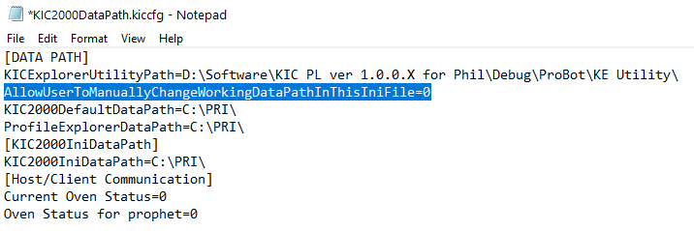

Figure 143

1. Change the line AllowUserToManuallyChangeWorkingDataPathInThisIniFile=0 to the value =1:

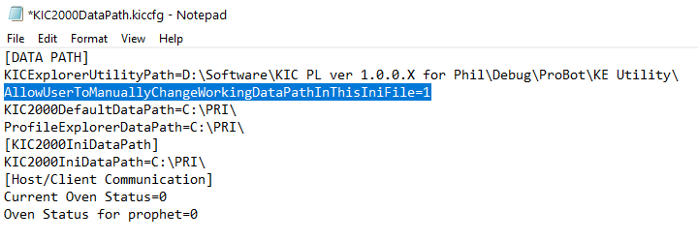

Figure 144

1. Change all of the lines shown below to = the desired network location.

**Note:**This will be the main network folder you created and copied the Log, Ovens, Process Spec, and Profiles folders into.

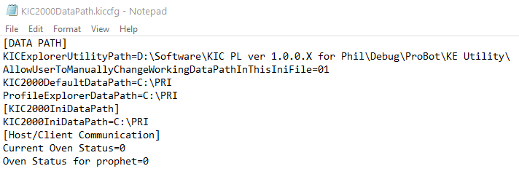

Figure 145

1. Once the DataPath.kiccfg file has been modified with the new locations, choose File/Save from the drop-down menu to save the changes.
2. Close Notepad and start the software.

**CAUTION**: If you changed the default data path and run the software in history mode (select the “I am not going to profile or Pyrometer Profile” button), or if your network is not connected or is not functional, the working directory (location data is written to) will revert to the default location of C:\PRI. To write to the network again, shut down the software and repeat the previous steps 1-6.

1. With the software open, go to the Profile Explorer:



Figure 146

Your new network drive should be displayed in the upper right-hand corner of the screen as the Current Data Path.

**Note**: The Network path will be grayed out and cannot be changed from inside of Profile Explorer.

All data collected in this PRI application will now be written to the network folder chosen.

**Note**: If you have multiple PRI systems, you will need to create a separate folder on the Network drive for each system – e.g. KIC Line 1, KIC Line 2, etc.

## View Historical Data

You can also view all collected data over the network from any computer that has the PRI software installed.

**Use the following steps to view historical data over the network:**

1. The software will open normally. When the main screen appears, click the Profile Explorer button.

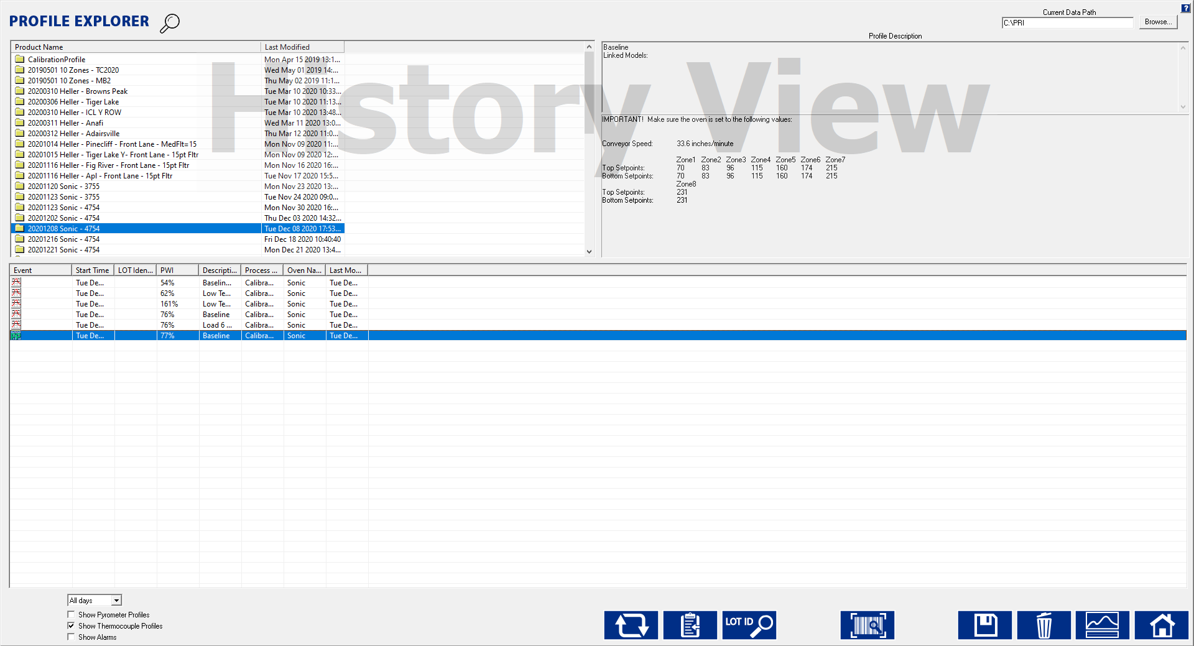

Figure 147: View Historical Data

1. A **Browse** button is enabled in the upper right-hand corner of the screen.

You can now click the Browse button and point to the directory where your profiles are. Keep in mind that you want to direct it to the root directory of the main “Profiles” folder.

For example: If the profiles are in the folder F:\PRI\Profiles\Board A, you would direct it only to the folder F:\PRI\

# Communicate with Oven Controllers

Because PRI can interface directly with the oven controllers on many reflow oven models, several leading manufactures act as Value Added Resellers (VARs) for KIC software. PRI can automatically send setpoints and other recipe data to these oven controller systems, eliminating the need for separate data entry.

The table below lists the oven manufacturers that support communication:

|  |  |  |  |
| --- | --- | --- | --- |
| **Oven Manufacturer** | **Communication Capable** | **Baseline Oven Recipe Capable** | **Min. software version for comm.** |
| **BTU** | Yes | Yes | 2.2 |
| **Vitronics** | Yes | Yes | 7.03 |
| **Heller** | Yes | Yes | 1.0.6.3.2 |
| **Rehm** | Yes, on V6 and VXP models | No | N/A |
| **Seho** | Yes | Yes* | N/A |
| **Senju** | Yes | No | v1.0.0.3 |
| **SMT** | Yes | Yes | v388389 |
| **Sonic** | Yes | Yes | v1005.3.101.22 |
| **Mailbox** | Yes | No | — |

Figure 148: PRI Supported Oven Controller Communications

## Confirm Oven Communications

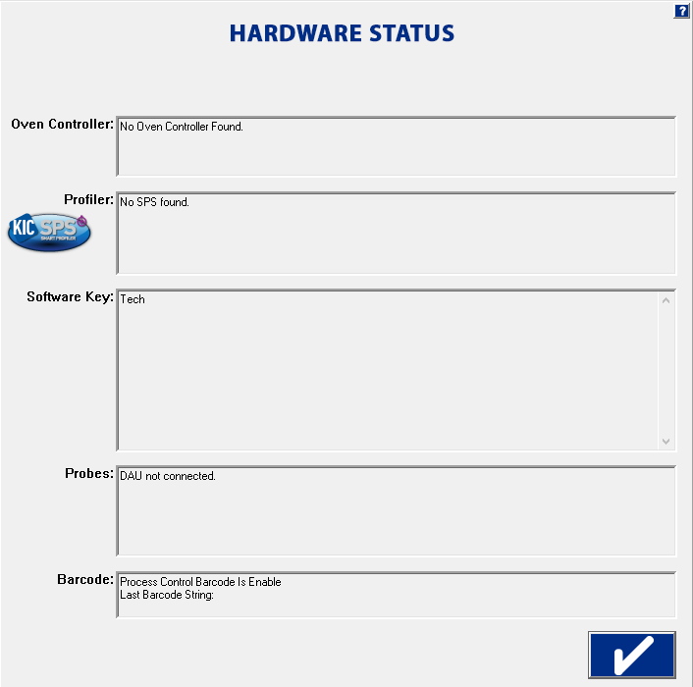

Figure 149: Hardware Status – Oven Controller Communication

Once you’ve installed the system on a communication-capable oven, your first task is to check the Hardware Status screen to see if the software recognizes the oven controller.

If the appropriate system isn’t identified in the *Oven Controller*, field check the following:

* Verify that the software is installed on the same PC and hard drive as the manufacturer’s oven controller software.
* Exit the software and run the *ConfigurationProgram.exe* found in the PRI root folder. The Hardware tab lists a selection of ovens and oven models.
* Contact KIC or the oven manufacturer to make sure the version of oven controller software and firmware is compatible for oven communications.
* Make sure that the latest versions of the correct drivers are properly installed. (Contact KIC or the oven manufacturer for details.)

## Configure Software For Oven Communication

|  |  |
| --- | --- |
| There are *two* items you have to set in the GlobalPreferences screen when configuring the software for use with oven communications.   1. Enter an oven name and zone lengths and zone limit data. 2. Check **Use Oven Base Recipe**. (Optional.) | Graphical user interface  Description automatically generated  Figure 150 |

## Use a Base Oven Recipe with Oven Communication

The operating parameters of a reflow oven are specified by the manufacturer in the oven controller. These parameters may include zone setpoint temperatures, conveyor speed, fan speed, Nitrogen On/Off, conveyor width, etc. Taken together, these parameters form a *Base Oven Recipe*, which PRI uses as a set of default values.

PRI can set/load the zone setpoint temperatures and the conveyor speed parameters, adjusting them from the default values in the Base Oven Recipe.

In order for the engineer to specify the other parameters, a *Base Oven Recipe* must be created. This oven recipe has all the oven parameters except the zone set point temperatures and conveyor speed set correctly. When you load a Pyrometer Profile for a given product, this software will modify the set points and conveyor speed in the Base Oven Recipe, and then load the Base Oven Recipe into the oven controller. In this way, the oven will be setup exactly as it was during the Baseline Profile.

|  |  |
| --- | --- |
| When the *Use Oven Base Recipe* option is selected, nothing will happen until a Pyrometer Profile is loaded from the Profile Explorer. Then the software will present the Browse dialog in order to select the Base Oven recipe. | Baseline Recipe  Figure 151: Browse window for selecting the *Base Oven Recipe* |

## Run A Profile Using Oven Communication

When running profiles with oven communications, be aware of the following differences when compared to regular operations:

1. When running a profile and going through the sequence of screens leading up to the *Select Thermocouple* screen, you will not see a pull-down menu for the oven since there can be only one. You will also not see the screen for the oven settings since this was taken care of in Global Preferences.
2. When you are running the software with oven communication, the software sends data to the oven’s PC control software. This communication seems transparent at first, but once you gain more experience you will see certain signs that the KIC software and the oven controller are communicating. One of the first things you might notice is that the recipe name loaded on the oven controller software will be *KICPROFILE*. Loading the *KICPROFILE* recipe provides the benefit of giving the KIC software a vehicle to update oven settings without having to call a specific recipe file name and location of an oven controller recipe.
3. When running a profile, the software uses a Base Oven Recipe as a starting point for the oven recipe then changes the name to *KICPROFILE* and will/can only change the zone setpoints and conveyor speed settings thereafter. This gives the software the flexibility to change setpoints and conveyor speed on the fly without having you manually rename or save the recipe file.
4. For your first profile, load appropriate temperature and conveyor speed settings in the oven control software. Once you have run your first profile or have loaded an existing profile from the Profile Explorer zone setpoints, you can make conveyor speed adjustments manually while viewing the profile or let it happen automatically if you have the Navigator software option installed.

Once you choose to run a profile *using the predicted setpoints and conveyor speed,* the software automatically sends these new settings to the oven controller software to be loaded. When the new settings are loaded, watch for the following:

|  |  |
| --- | --- |
| * With some oven controllers there may be an audio warning, indicating that the oven is going to change settings. Some of the audio indicators are also accompanied by a timer that will not allow the oven to load the new setpoints until the programmed time has elapsed. These timers can be reduced or turned off at the customer’s discretion. | |
| * The software will display the message “Waiting for the oven controller to acknowledge recipe change”. There is a time delay displayed for an estimated period for the oven to acknowledge the changes and that all conditions are right to set the oven to these new setpoints. | Figure 152: Waiting for Oven Controller to Acknowledge Recipe Change |
| * You may notice with some ovens that it takes longer than others, you’ll have to get a feel for this as you go but if you feel the change is taking too long then switch over to the oven software and try to ascertain if there is some kind of disturbance that would cause the oven controller not to load the new setpoints. | Figure 153: Recipe Copy Successful |

1. If you are starting a profile and the software tells you that the oven’s actual zone temperatures are not within 2 degrees of the of the setpoint value, and you know that you have waited long enough (possibly even answered that they are still changing), but now you know they are not, then you will have to answer *No* and follow the instructions. This information is outlined in the user manual, but what happens next may be a little confusing to a first-time user. Here is a list of what takes place and why:

* You answer ***No*** the temperatures are not getting closer and the system then asks you to change the Setpoint values to that of the Actual. What the system is doing by this is finding out what the oven will control to in certain zones. It then takes the differences and uses them to update the oven.ini file so the next time the system optimizes for a profile it will take the zone delta limitations that it learned and apply it to the next profile. The software will use the new zone delta limits until the values change again by a set of oven setpoints that can’t be maintained by the oven are chosen. Remember that it is very important that you are sure that the oven can’t achieve the original setpoints before you answer ***No***. Once the new delta limits are established this will affect the capability of the Navigator to optimize your profiles.

|  |  |
| --- | --- |
| * Next the system will take you to the Verify Minimum and Maximum Setpoint Temperature screen. This is to verify that we have not allowed the KIC software to choose setpoint values that the oven is not capable of controlling to. | Graphical user interface, application  Description automatically generated  Figure 154: Verify Setpoints |

* Next the software will prompt you that it will calculate new setpoints. When you click on **OK**, the screen will change to a profile graph that has calculated new oven setpoints for the oven to load to produce the optimized profile results. This works the same even if you do not have the Navigator option. If you entered the new setpoints manually the software will automatically find new setpoints like the Navigator would when you get to this point. Be patient you may have to go through this cycle of the oven not controlling to setpoint values a few times before the proper combination of acceptable setpoints and profile optimization can be found. In worst case scenarios you may have to change the 2.0 degrees delta between setpoint and actual because the oven is just simply not capable of getting within 2 degrees C of the setpoint no matter what the temperature. Please contact KIC Tech support if this is the case.

**Note**: If you get into a situation where you are having to adjust too many times and are still not getting setpoints that the oven will control to, but you are or you will be in spec by manually changing predicted setpoints, then go into the Optimization Tab and turn off “Allow Zone Setpoints To Change”. The next time around the KIC software will not change any of the zone values but you can go in and change them manually to exactly what the actual values are and run the profile.

## Start a Pyrometer Profile with Oven Communication

Before running a Pyrometer Profile with oven communications, review the following:

1. You have *Use Base Oven Recipe* checked in Global Preferences, but the software did not ask you to select it when you started the PP. If you have just run your baseline profile and start a PP immediately, without exiting that product, then the PP will start without asking you to choose a Base Oven Recipe. The system assumes since you just ran a successful baseline profile that all of the oven settings are correct, and in turn, the Base Oven Recipe settings are correct.
2. You setup your product and have a baseline profile now but you do not have an oven recipe to match it. What recipe will you load when you want to run production on this product? Remember that even though you originally loaded a specific oven recipe file, the software took over and loaded the KICPROFILE recipe on your oven and did not save any subsequent zone setpoints and trouble changes to that original oven recipe.

You can save any changes made to the original recipe while profiling if you want to create a recipe that can be run on the oven controller without the software running. If you choose not to save the changes, when you load this product under the software it will load the proper recipe parameters for that product.

|  |  |
| --- | --- |
| 1. When starting a Pyrometer Profile from the Profile Explorer, the software prompts you to select your Base Oven Recipe. The *Select the Base Oven Recipe to be loaded* screen appears, letting you to browse your PC and point to the location and file name of the Base Oven Recipe you want to use for this product.   Remember it should be the same one you choose when you originally ran your baseline profiles. If you choose the wrong Base Oven Recipe, you could have boards fall off the conveyor or never even make it in because the Base Oven Recipe you chose does not match the width of the original file you loaded. | Figure 155: Select the Base Oven Recipe to be Loaded |

1. When you have selected and opened the Base Oven Recipe the KIC software will load that recipe on the oven. All of the parameters in this recipe are correct for this product except the zone setpoints and conveyor speed. With some ovens, you may hear and audio warning, you may see the light tower change to an amber state, you may even see the conveyor stop momentarily and then start again indicating that the oven is loading the Base Oven Recipe. Seconds later you may hear or see one or all of these signs again as the software sends just the zone setpoints and conveyor speed settings to the oven controller.

|  |  |
| --- | --- |
| 1. If you have already loaded a PP and selected a Base Oven Recipe then you will not see the *Select the Base Oven Recipe to be loaded* screen, instead you will see the screen shown. Click **Yes** to verify that you are loading the correct Base Oven Recipe. If you choose **No** then the *Select the Base Oven Recipe to Be loaded* screen appears. | Graphical user interface  Description automatically generated  Figure 156 |

**Note**: If you feel that the system is taking too long to load the Base Oven Recipe or the setpoints, switch over to the oven control software and see if you can detect a reason why the oven is not accepting the changes.

## Base Oven Recipe Automatic Verification

For Base Oven Recipe compatible ovens, users can automatically verify the correct Base Oven Recipe before beginning a Pyrometer Profile. This feature is especially useful for users that have multiple production products using multiple Base Oven Recipes. The system lets you select the Base Oven Recipe and if the selected recipe does not match, the Pyrometer Profile cannot begin.

### Enable the Base Oven Recipe Automatic Verification

1. Close the software if open.
2. Find and open the file: C:\software root directory\Log\KIC2000UserSettings.kiccfg
3. In the [PROPHET] section find and edit the line:

AllowNotChangeRecipeAuto=1

1. Save and then exit the file.
2. Open the software.
3. On the Global Preferences screen Global tab, select the **Use Oven Baseline Recipe** check box.

|  |  |
| --- | --- |
| The next time a Pyrometer Profile is started a dialog box appears, prompting you to verify the correct Base Oven Recipe, or select a different one. | Graphical user interface  Description automatically generated  Figure 157 |
| Select the **Yes** button to continue. Select the **No** button to choose a different Base Oven Recipe. | Figure 158 |
| If the selected Base Oven Recipe does not match, a yellow dialog box appears.  To select a different recipe then select the **Continue** button.  When the correct recipe is selected, the software goes directly to the Pyrometer Profile display: | Text  Description automatically generatedFigure 159 |

# Status Messages and Alarms

The software communicates system status through messages that it displays on the monitor. Some simply report an operating condition, some provide a warning that process parameters are changing, and still others, called *alarms,* announce out-of-spec conditions, operational failures, lost communications, and other process critical problems that might require immediate corrective actions.

|  |  |
| --- | --- |
| Alarm messages typically appear in red. An alarm status may accompany a signal from the DAU to the optional alarm relay, which, in turn, may trigger hardware-related events such as sounding audible alarms, lighting signal towers, or stopping infeed conveyors. |  |

Some status messages and alarms are specific to different functions of the software. Some may appear when you are first running profiles to establish a baseline. Others appear only when you begin Pyrometer Profiling.

## Acknowledge Alarms

|  |  |
| --- | --- |
| Once displayed on the monitor, an operator needs to acknowledge the alarm, clicking on it to notify the software that the message has been received and make the displayed panel disappear. |  |
| You can use password protection to limit the ability to acknowledge alarms. To do so, you first need to specify the following value in the KIC2000UserSettings.kiccfg file:  [HOST]  UsingPasswordwithRedAlarm=1  Next, you need to specify a password on the Global Preferences screen *Engineer Password* option. Once password protection is in place, clicking a red alarm message displays a prompt that requires you to enter the password to acknowledge the alarm and remove the message. |  |



Figure 160

**Note**: Password protection only applies to alarms. A simple mouse click acknowledges and clears warning messages.

## Messages During Profiling and Baseline Profiling

During the profiling portion of getting your PRI ready to monitor and record real-time production and prior to starting a Pyrometer Profile, you may experience some conditions that cause the system to alert you to. Below is a table of some of the messages that you might see during this process: See Table 1.

|  |  |
| --- | --- |
| **Message Alarms** | **Message Description** |
| **Message, High PWI** | Recent profile of xxx%, PWI must be 90% |
| **Message Alarm H1** | TPU Communication Failure - wait 5 seconds and try again |
| **Message Alarm H7** | Conveyor has stopped or encoder has been disconnected Pyrometer Profiling cannot be started. |

Table 1: Profiling System Alarms

## System Message and Alarms

### Message, High PWI

|  |  |
| --- | --- |
| If the verification profile PWI is >= 100%, you will receive this message when starting the PP.  If there was a problem with the most recent profile, it can be deleted and the system will try to use the next most recent profile as the baseline profile. Otherwise, you are advised to run another profile. | Figure 161: Message High PWI |

### Alarm Message H1

|  |  |
| --- | --- |
| No communication. (After PRI Launched and did not have time for DAU to communicate with computer.) This message will usually appear if the DAU was connected after the software was launched. This is because a connection to the DAU has not been established yet. Waiting 5 seconds allows a connection to the DAU to be established. | Figure 162: Alarm H1 |

### Alarm H7

|  |  |
| --- | --- |
| This alarm will appear when trying to start a Pyrometer Profile from the Profile Explorer. The oven conveyor must be running and set to the correct speed settings to start Pyrometer profiling. | Figure 163: Alarm H7 |

**Alarms and Messages during Pyrometer Profiling**

The software incorporates the use of warning and alarm dialog screens to let you know if there is a problem and the cause for that problem. Below is a partial list of the warning and alarm dialog screens with explanations. These Alarms are active only when Pyrometer profiling is running.

| **Process Alarms** | **Description** | **Activates Alarm Relay** |
| --- | --- | --- |
| **Alarm # 1** | PWI=x% - Process is out of spec | **Yes** |
| **Alarm # 5** | No Barcode read for this board. –or–  No Barcode read for xxx boards. | **No** |
| **Alarm # 5A** | Process Traceability barcode scan failed | **Yes** |
| **Alarm # 5C** | Process Control barcode scan failed | **Yes** |
| **Alarm # 8** | The length of the current product does not match the length of the product during the baseline profile. | **No** |
| **Alarm # 10** | This alarm only occurs when the KIC software and the oven control software are communicating and indicates that the oven is not set to the baseline profile recipe. | **Yes** |
| **Alarm # 11** | The KIC speed sensor has detected that the conveyor speed has changed significantly since the baseline. | **Yes** |
| **Alarm # 12** | Incorrect Process Control String (Barcode Option). | **Yes** |

Table 2: Pyrometer Profiling – Process Alarms

|  |  |  |
| --- | --- | --- |
| **Hardware Alarms** | **Description** | **Activates Alarm Relay** |
| **Alarm H1** | DAU Communication Failure (happened after Alarm H2) | **Yes** |
| **Alarm H2** | DAU Lost Communication with PC.  Note: This alarm condition can activate the alarm relay that is controlled by the DAU | **Yes or No** |
| **Alarm H7** | Conveyor Stopped or Speed Encoder broken or not connected properly. | **Yes** |
| **Alarm** | Pyrometer X is currently reading Y. This is below the allowable of -100C. Either the pyrometer is not calibrated correctly, or the pyrometer is faulty and must be replaced.  Pyrometer X is currently reading Y. This is above the allowable of 300C. Either the pyrometer is not calibrated correctly, or the pyrometer is faulty and must be replaced. | **Yes** |
| **Alarm** | Pyrometer X internal is currently reading Y. This exceeds the allowable of 300C. Please check oven settings and adjust setpoints if they are exceeding 300C.  If you are still experiencing abnormally high temperature readings, please contact KIC for further support at [tech@kicmail.com](mailto:tech@kicmail.com). | **Yes** |
| **Alarm** | Unable to detect Pyro X. Please check the connections and try again. Contact KIC support at [tech@kicmail.com](mailto:tech@kicmail.com) if you are still experiencing problems. | **Yes** |

Table 3: Pyrometer Profiling – Hardware Alarms

|  |  |  |
| --- | --- | --- |
| **Warnings** | **Description** | **Activates Alarm Relay** |
| **Warning # 2** | This process is likely to go out of spec soon. | **No** |
| **Warning # 3** | The last profile was out of spec. | **No** |
| **Warning # 4** | Oven temps have changed significantly since baseline. | **No** |

Table 4: Pyrometer Profiling – Warnings

### When Alarm #5a Occurs

When the Barcode Product Sensor (BPS) detects a product whose barcode label has not been read, or the BPS is tripped accidentally, the alarm #5A is activated and the process is stopped via the alarm relay.

Alarm #5A displays four alarm buttons: Manual Entry Keyboard/Handheld Scanner, Rescan using Fixed Mount Scanner, Proceed without a Barcode, and Remove this board from Line.

##### Manual Entry Keyboard/Handheld scanner

Click this button when you want to enter the barcode again by using either the keyboard or a handheld scanner connected to a USB Port.

|  |  |
| --- | --- |
| 1. Click the **Manual Entry Keyboard/Handheld Scanner**  button.   The software displays the Barcode input field and hides all other unselected buttons. | Figure 164 |
| 1. Type in the new barcode and press the **Enter** key.   The software will clear the alarm message and deactivate the Alarm relay to allow the board into the oven. | Text  Description automatically generated  Figure 165 |
|  |  |
| The barcode will be added to the board.  Graphical user interface, text, application, Word  Description automatically generated  Figure 166 | |
|  | |

##### Rescan Using Fixed Mount Scanner

Click this button when you want to scan the barcode again by using the fixed mount Barcode scanner.

|  |  |
| --- | --- |
| 1. Click the **Rescan using Fixed Mount Scanner**  button.   The software displays the Barcode input field and hides all other unselected buttons. | Figure 167 |
| 1. Scan the barcode with the fixed mounted Barcode scanner. | Text  Description automatically generated  Figure 168 |

|  |
| --- |
| Once the barcode is scanned, the software will clear the alarm message and deactivate the Alarm relay to allow the board into the oven.  This barcode will added to the board.  Graphical user interface, text, application, Word  Description automatically generated |

Figure 169

##### Proceed Without a Barcode

Click this button when you want to process the board without any barcode.

|  |  |
| --- | --- |
| 1. Click the **Proceed without a Barcode**  button.   The software will clear the alarm message and deactivate the Alarm relay to allow the board into the oven without a barcode. | Figure 170 |
| Figure 171 | |

##### Remove this board from Line

The software will display an alarm message “P*lease remove this board from the line now & click on the “OK” button*.”

|  |  |
| --- | --- |
| 1. Click the **Remove this board from Line**  button. | Figure 172 |
| 1. Remove the board from the link conveyor. |
| 1. Click the **check** button .   The software clears the alarm message and deactivates the Alarm relay to get ready for the next board.  If user clicks the **Cancel** button, the software returns to alarm #5A. | A picture containing text, first-aid kit, vector graphics  Description automatically generated  Figure 173 |

### When Alarm #5c Occurs

When the Barcode Product Sensor (BPS) detects a product whose barcode label has not been read, or the BPS is tripped accidentally, the alarm #5C is activated and the process is stopped via the alarm relay.

Alarm #5C displays four alarm buttons: Manual Entry Keyboard/Handheld Scanner, Rescan using Fixed Mount Scanner, Proceed without a Barcode, and Remove this board from Line.

##### Manual Entry Keyboard/Handheld Scanner

Click this button when you want to enter the barcode again by using either the keyboard or a handheld scanner connected to a USB Port.

|  |  |
| --- | --- |
| 1. Click the **Manual Entry Keyboard/Handheld Scanner**  button.   The software displays the Barcode input field and hides all other unselected buttons. | Calendar  Description automatically generated with low confidence  Figure 174 |
| 1. Type in the new barcode and press the **Enter** key.   The software will clear the alarm message and deactivate the Alarm relay to allow the board into the oven. | Text  Description automatically generated  Figure 175 |
| This barcode will be added to the board if the software also is using the Traceability barcode option.  Graphical user interface, application  Description automatically generated  Figure 176 | |

##### Rescan Using Fixed Mount Scanner

Click this button when you want to scan the barcode again by using the fixed mounted Barcode scanner.

|  |  |
| --- | --- |
| 1. Click the **Rescan using Fixed Mount Scanner**  button.   The software displays the Barcode input field and hides all other unselected buttons. | Calendar  Description automatically generated with low confidence  Figure 177 |
| 1. Scan the barcode with the fixed mounted Barcode scanner. | Text  Description automatically generated  Figure 178 |

|  |
| --- |
| Once the barcode is scanned, the software will clear the alarm message and deactivate the Alarm relay to allow the board into the oven.  This barcode will be added to the board if the software also is using the Traceability barcode option.  Graphical user interface, application  Description automatically generated |

Figure 179

##### Process without a Barcode

Click this button when you want to process the board without any barcode.

|  |  |
| --- | --- |
| 1. Click the **Proceed without a Barcode**  button.   The software will clear the alarm message and deactivate the Alarm relay to allow the board into the oven without a barcode. | Calendar  Description automatically generated with low confidence  Figure 180 |
| Graphical user interface, application  Description automatically generated  Figure 181 | |
|  | |

##### Remove this board from Line

The software will display an alarm message “*Please remove this board from the line now & click on the “OK” button*.”

|  |  |
| --- | --- |
| 1. Click the **Remove this board from Line**  button. | Calendar  Description automatically generated with low confidence  Figure 182 |
| 1. Remove the board from the link conveyor. |
| 1. Click the **check** button .   The software clears the alarm message and deactivates the Alarm relay to get ready for the next board.  If user clicks the **Cancel** button, the software returns to alarm #5C. | A picture containing text, first-aid kit, vector graphics  Description automatically generated  Figure 183 |

##### When Alarm#12 Occurs

When a barcode string is received that differs in format from the current product, the software will display a red alarm message - Alarm#12 – with three buttons: Stop Pyrometer Profiling, Process with current Barcode, Remove the board from Line.

##### Stop Pyrometer Profiling

|  |  |
| --- | --- |
| 1. Click the **Stop Pyrometer** **Profiling**  button. | A picture containing text, screenshot, sign, sale  Description automatically generated  Figure 184 |
| 1. Click the **check** button  to stop Pyrometer profiling. | A picture containing text, first-aid kit, vector graphics  Description automatically generated  Figure 185 |
| **Note:** Users must wait for all boards to be removed from the oven. | Graphical user interface  Description automatically generated  Figure 186 |

##### Process with Current Barcode

Users may deactivate the alarm relay to allow a board into the oven even if the barcode is in incorrect. Use this button to stop the alarm when you want to use the barcode that is on the label.

|  |  |
| --- | --- |
| 1. Click the **Process with Current Barcode** button . | A picture containing text, sign, screenshot  Description automatically generated  Figure 187 |
| This barcode will be added to the board if the option for *Traceability* was selected on the ***Barcode Option*** tab. | Graphical user interface, application  Description automatically generated  Figure 188 |

##### Remove this Board from Line

You use this feature when you want to remove a PCB out of Line before it is passed into the oven but are going to keep the current Pyrometer Profile running.

|  |  |
| --- | --- |
| 1. Click the **Remove this board from Line** button . | Timeline  Description automatically generated  Figure 189 |
| 1. Remove the board from the line and then click the **check** button . | A picture containing text, first-aid kit, vector graphics  Description automatically generated  Figure 190 |

# Light Tower

There are two available light towers – one is connected directly to the optional Alarm Relay and uses a single Red light; the other connects to the USB port of the PC, and uses 3 colored lights – Red, Yellow, and Green.

Both lights are a means of providing an audio or visual cue when the automatic system software has determined that the oven process has reached an out-of-control condition.

## Standard Light Tower

This light tower plugs directly into the *Alarm Relay* box. It uses a single Red light with an audible buzzer, which are both activated anytime an alarm condition occurs. Because it is controlled directly by the *Alarm Relay*, the light and audible buzzer will stay on for as long as the *Alarm Relay* is energized.

## 3 Color USB Light Tower

As this light tower connects to a USB port on the PC running the PRI, it can be used with or without the *Alarm Relay*. With the use of the USB Light Tower, you get additional visual information on the state of your process through a variety of LED indicators – Red, Yellow, and Green. You also have the ability to mute the audible buzzer when an alarm condition occurs. When an alarm occurs, a small button will appear in the upper left corner of the Crystal Ball. Clicking on this button will mute the audible buzzer. Clicking the button a second time will un-mute the buzzer. If left muted, and the process returns to an in-spec condition, the buzzer will be automatically be active again when the next alarm occurs.



### LED Light Status

* When PP is not running – All LEDs and buzzer are turned off
* When PP is running, and the process is in-spec but the oven is empty – GREEN LED flashing
* When PP is running, and the process is in-spec with product in the oven – GREEN LED on solid
* When PP is running, and the process is in a Warning condition – YELLOW LED on solid
* When PP is running, and the process is in an Alarm condition – RED LED on solid
* When PP is running, and the process is in an Alarm condition w/Buzzer muted – RED LED flashing

**Note**: For more information about the Light Tower and Alarm Relay, see the *Automatic System Hardware Installation Manual* (TFS-330210-000).

# Appendix A: The Process Window Index

#### A Method for Quantifying Thermal Profile Performance

## The Problem

While there are currently statistically valid methods for quantifying pick and place and screen printer performance, there is no widely accepted method for comparing performance of thermal profiles, and thus, no quantifiable system of ranking thermal process performance. Once a thermal profile has been run, it is judged as being either in or out of spec, and perhaps subjectively judged as being OK, good, or really good. Efforts to track process performance for SPC or QC generally focus on a single, or a small group, of profile statistics; for example, peak temperature of one or two thermocouples on a golden board. The Process Window Index is a statistical method for ranking thermal profile and thermal process performance.

## Define the Process Window Index

|  |  |
| --- | --- |
| The Process Window Index is a measure of how well a profile fits within user defined process limits.  This is done by ranking process profiles on the basis of how well a given profile “fits” the critical process statistics. A profile that will process product without exceeding any of the critical process statistics is said to be inside the Process Window. The center of the Process window is defined as zero, and the extreme edge of the process window as 99%. | Process-Window-Index  Figure 191: Process Window and PWI |
| A “Process Window Index” of 100% or more indicates that the profile will not process product in spec. A “Process Window Index” of 99% indicates that the profile will process product within spec, but it is running at the very edge of the Process Window. A “Process Window Index” of less than 99% indicates that the profile is in spec and tells users what percentage of the process window they are using: for example, a PWI of 70% indicates a profile that is using 70 percent of the process spec. | PWI-Theory  Figure 192: The Process Window Index (Single Statistic—Peak Temperature of one Thermocouple) |

The PWI tells users exactly how much of their process window a given profile uses, and thus how robust that profile is. The lower the PWI, the better the profile. A PWI of 99% is risky because it indicates that the process could easily drift out of control. Most users seek a PWI of below 80%, and profiles with a Process Window Index between 50% and 60% are commonly achieved (if the oven is sufficiently flexible and efficient).

The Figure Above shows the Process Window Index for the Peak Temperature of a single thermocouple. The Process Window Index for a complete set of profile statistics is calculated as the worst case (highest number) in the set of statistics.

For example: if a profile is run with six thermocouples, and four profile statistics are logged for each thermocouple, then there will be a set of twenty-four statistics for that profile, and the PWI will be the worst case (highest number expressed as a percentage) in that set of profile statistics. Note that shows the user-designated critical statistics for a single thermocouple.

PWI How Determined - Leaded R0511A -- NoTitle NoBorder

Figure 193: The Process Window Index  
(Multiple Statistics for a Single Thermocouple and Final PWI Calculation)

## 

## Calculate the PWI

To calculate the Process Window Index: i=1 to N (number of thermocouples); j=1 to M (number of statistics per thermocouple); **measured_value[i,j]** is the [i,j]th statistic’s value; **average_limits[i,j]** is the average of the [i,j]th statistic’s high and low limits; and **range[i,j]** is the [i,j]th statistic’s high limit minus the low limit.

PWI Calculation Formula R0811A No Border

Figure 194: Formula for calculating the PWI

Thus, the PWI calculation includes all thermocouple statistics for all thermocouples. The profile PWI is the worst case profile statistic (maximum, or highest percentage of the process window used), and all other values are less.

**Note:** When using non-centered Target values, a modified formula is used.

## Benefits of Ranking Thermal Profile Performance

The analysis of thermal profiles with the Process Window Index offers four significant benefits. The first is that profiles can be easily compared, and users can be confident that they are using the best profile their process can achieve. Before the PWI was available for profile analysis, comparing profiles was subjective, and users could never be certain they had the best profile for their product. The PWI provides an excellent opportunity for process improvement and its use is a significant step towards Zero-defect Production.

The second benefit is that the PWI greatly simplifies the profiling process. When used in advanced profiling tools, all profile statistics are reduced to a single number (the PWI) that even the most inexperienced operator can understand. This means significant savings in terms of training costs and a reduction in defects caused by operator error. It further means that in a few minutes, an inexperienced operator can setup an oven with the optimal profile, a job that formerly could take an experienced engineer hours.

The third benefit is that because the PWI reflects the performance of the whole profile, it provides much better indicator of process capability than tracking a single statistic. The PWI thus provides excellent data for SPC and other QC monitoring programs while simplifying data gathering and reducing process monitoring costs.

Finally, the PWI gives users a simple method for comparing thermal process performance. Comparisons may be made between individual lines on the shop floor, between processes at multiple plants, and between processes using dissimilar equipment. The ability to quantify thermal process performance will give electronics assemblers a means for comparing the performance of their soldering equipment. This is of value in selecting equipment, for buy off, and for process troubleshooting.

is the result of a series of tests comparing oven performance using several sizes of PCBs. Each board was profiled in the given oven, and then an automated profile prediction tool was used to find the optimal profile for that board in the given oven. After the oven setpoints were changed and the oven stabilized, a second profile was run to confirm that the predicted PWI had been achieved. The table below shows that there is significant variation in oven performance between various makes and models. In this test, Oven C had more zones than Ovens A and B, and performed better, as would be expected.

|  |  |  |  |  |  |
| --- | --- | --- | --- | --- | --- |
| **Oven** | | **Board Type** | | | |
| **Manufacturer** | **Model** | **Motherboard** | **Cell Phone** | **Display Adapter** | **Mainframe** |
| A | X | PWI = 87% | PWI = 62% | PWI = 79% | PWI = 126% |
| B | Y | PWI = 71% | PWI = 58% | PWI = 61% | PWI = 93% |
| C | Z | PWI = 33% | PWI = 29% | PWI = 34% | PWI = 58% |

Table 5: Comparison of Oven Performance – Best Achievable PWI

## Conclusion

The simplicity of the Process Window Index makes its validity as a statistical tool readily apparent and its adoption as an industry standard clearly offers a significant opportunity for the improvement of the soldering process. The advantages detailed above point to its value in demystifying the soldering process and open the door to precision control of a process that has been ignored for too long. Issues like the coming of Lead-free electronic assembly mean that electronics assemblers can no longer be complacent about their soldering process. Sophisticated tools utilizing the PWI as a standard for accurately measuring the thermal process will mean more efficient production, improved and simplified process control, and higher quality final product.

# Appendix B: Recalculating Zone Delta Limits from Navigator/Auto-Focus Predictions

Occasionally, when using the *Navigator* or *Auto-Focus* options to generate new recipes, it may give suggested setpoints that your specific oven may not be able to achieve. For example, it may suggest setting Zone 1 to 100 and Zone 2 to 150, but after loading the settings, you find that your oven is only able to hold Zone 1 to 109. When this situation occurs, there is procedure in the software you can follow that will force it to “learn” the capabilities of your oven, which means it will be able to provide suggested setpoints that your oven is more likely to be able to maintain. The steps below will show how to perform this recalculation both on a stand-alone PC, and also when the software is communication with the oven control software.

## For Stand-alone Software Installations (Not Communicating with Oven)

|  |  |
| --- | --- |
| 1. When you go to start the predicted profile, click on the traffic light and the software will first ask if the oven is stabilized. Choose **No**. | Figure 195 |
| 1. Next, it will ask you if the oven is still in the process of stabilizing. Choose **No**. | Graphical user interface, text, application, Word  Description automatically generated  Figure 196 |
| 1. The software will then display this message, letting you know that it will now start the “recalculation” process. (**Note:** on a stand-alone oven, you do not need to change the actual oven setpoints at this point). Click **OK**. | Graphical user interface, text, application  Description automatically generated  Figure 197 |
| 1. On this screen, change the zone setpoints to the actual temperature that the oven is able to maintain. After entering new setpoints, click the **arrow forward** button. | Graphical user interface  Description automatically generated  Figure 198 |
|  |  |
|  |  |
|  | |

## For Oven Controller Software Installations

|  |  |
| --- | --- |
| The following section outlines the steps used when your profiling software is installed on the oven PC, and is communicating with the oven control software. | |
| 1. When you go to start the predicted profile, click on the traffic light and the software will prompt you if the oven temperatures are not within 2 degrees of the zone setpoint. If the temperatures are not getting closer, click **No**. | Graphical user interface, text, application, Word  Description automatically generated  Figure 199 |
| 1. ***Important:*** you will now need to switch over to your oven control software and change the setpoints to the temperature that the zones are actually controlling to. Only click **OK** after you have modified the oven recipe. | Graphical user interface, text, application  Description automatically generated  Figure 200 |
| 1. Next, it will bring you to the Zone Setpoint and Zone Min/Max Temperatures screen. This is just to allow you to confirm that the Min/Max values that are entered are correct. Click the **arrow forward** button. | Figure 201 |
| 1. Click **OK** on this screen to start the “recalculation” of the zone delta limits. | Figure 202 |

The software will now automatically change some of the default settings of the software, to settings that are more applicable to your specific oven, in regards to how it calculates the suggested recipe setpoints. When the calculation is completed, it will return you to your original profile plot, and it will display a new “Predicted” recipe suggestion that your oven should be able to maintain.

# Appendix C: Configuration Program

The system has many individual software settings that can be changed to suit the users process and or hardware set up. The configuration program tool facilitates quick and easy system setting changes, saving the user from the complications of manually editing the configuration files.

**Note:**  Only persons with advanced training in the automatic system software should modify these settings. Changes using this tool will directly affect the data collected by the system. Configuration software tool location:

C:\PRI\ConfigurationProgram.exe

## User Settings Tab

**Allowable Change** – Defines how much deviation is allowed in any one of the Pyrometers before a Warning condition is generated.

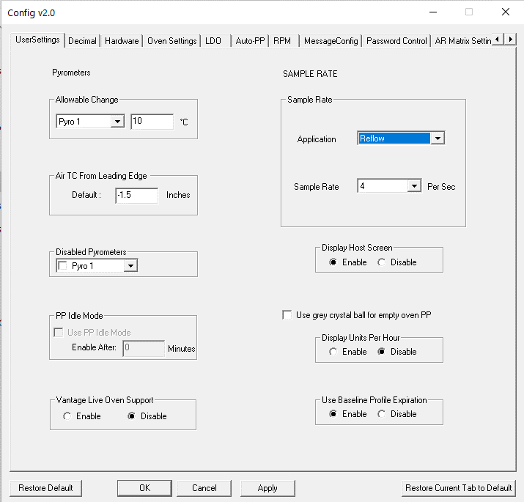

**Exclusion** – Allows user to disable any of the pyrometers from the PP calculations.

**PP** **Idle Mode** – Optional feature that can be used along with energy savings features of some ovens.

**Display Host Screen** – Enables/disables the display of the Host diagnostic screen.

**Display Units Per Hour** – Enables live display on top of PP general tab that tracks how many products have been processed in the past hour (value resets at the top of each hour).

**Vantage Live Oven Support –** Enables interface of data with the Vantage System.

**Use Baseline Profile Expiration** – Automatically require new baseline profiles after specified number of days.

Figure 203: User Settings Tab

**Temperature Triggers and Sample Rates**

The temperature triggers dictate when the profile begins and ends allowing for more consistent data collection. This area of the tool allows you to change the temperature trigger values as well as sample rate for each application type.

There are three temperature triggers:

**Start -**The profile Start temperature trigger is always 2C above the “Maximum Product Temperature at start of profile” setting in the Global tab of the Global Preferences screen. This value can be changed as needed from as low as 15C to as high as 40C.

**Mid Point –** The midpoint temperature trigger must be higher than the start trigger, and the End trigger. Be sure the temperature in your heated process will achieve this setting or the profile will fail.

**End –** The profile will end when all of the thermocouples attached to the profiler have cooled to below the End-Temperature trigger setting.

**Sample rate –** Set the sample rate for each application type.

### Use Baseline Profile Expiration

Enabling this function allows the system to require a new baseline profile is run after a specified number of days have elapsed. When enabled, additional functions will appear on various screens in the software.

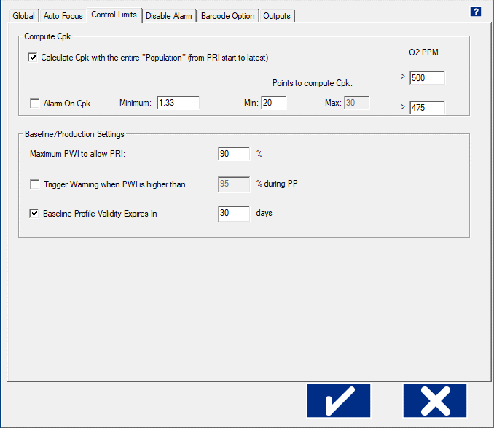

**Global Preferences/Control Limits Tab** – When it is enabled in the Configuration Program, it adds an additional selection at the bottom of this tab. Selecting the checkbox allows you to define the number of days after a baseline profile is run that it will automatically expire. This feature can be used to ensure that the system is always using an up to date profile as the baseline.

**Note:** When expired, the profile will still be viewable. However, it will not be able to be used as the baseline for monitoring production.

Figure 204: Baseline Expiration

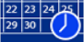

**Profile Explorer – Search Button** - When the expiration feature is enabled, you will see a new button appear in Profile Explorer:

1. Click this button to access a search window which will allow you to easily identify when each of your baseline profiles will expire.
2. Enter the number of days (window of time remaining until profiles will expire), and then click Search.
3. All products with a baseline profile set to expire within the specified timeframe will be displayed. Figure 205: Baseline Search
4. Selecting a particular product and clicking on the *Run New Baseline Profile* will automatically take you to the *RUN A PROFILE* screen and will select that product name.

## Decimal Tab

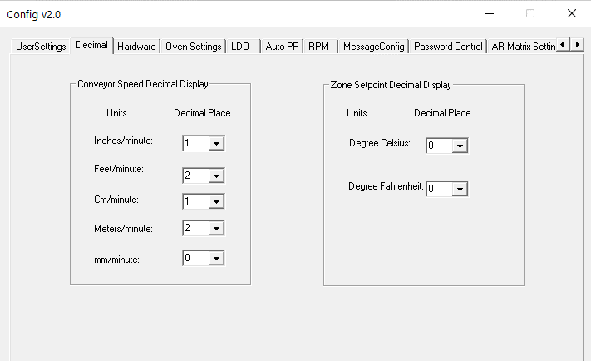This area controls the number of decimal places for the Conveyor Speed and Zone Setpoints displays in the software.

Figure 206: Decimal Tab

## Hardware Tab

This area controls the configuration of the DAU network addresses and allows for enabling or disabling of the oven communication when applicable.

Figure 207: Hardware Tab

## Auto-PP Tab

Auto-PP is a specialized feature for product changeovers that is dependent on a wide variety of variables. There are multiple configurations of the Auto-PP feature depending on the capabilities and processes in place in the factory. Contact your systems supplier to identify if this functionality can be implemented with your system.

## Message Config Tab

When certain messages are displayed in the software, the user can select a checkbox for “Do not show this again”. If checked, that message box becomes “disabled”. This area allows the user to enable or disable those messages.

Figure 208: Message Config Tab

## Password Control – Multi User

The software offers a Multi User Control capability to configure certain functions as password protected and, thus, requiring the use of specific user levels.

**The user types are:**

* Administrator
* Engineer
* Tech
* Operator (default)

### Access to the Password Control Tab

By default, the Multi User Control is disabled. When this password function is enabled, it will require the entering the default Administrator password before the Configuration Utility can be accessed. The Password Control tab can only be used by the Administrator, or the Engineer/Tech user types if specified.

If the Multi User Control is enabled and a user starts the utility, the utility will not launch until they enter the correct password (*Default Administrator password is Admin*).

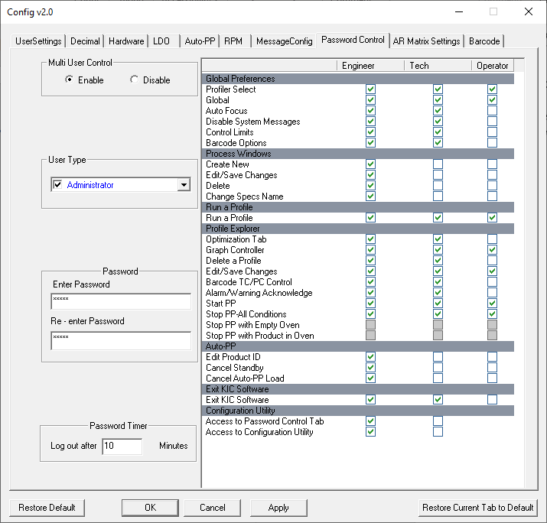

Figure 209: Password Control Tab

### Multi User Control

To apply Multi User Control, Administrators will click the **Enable** radio button and then click **OK**.

The confirmation dialog is answered, and then the utility must be restarted.

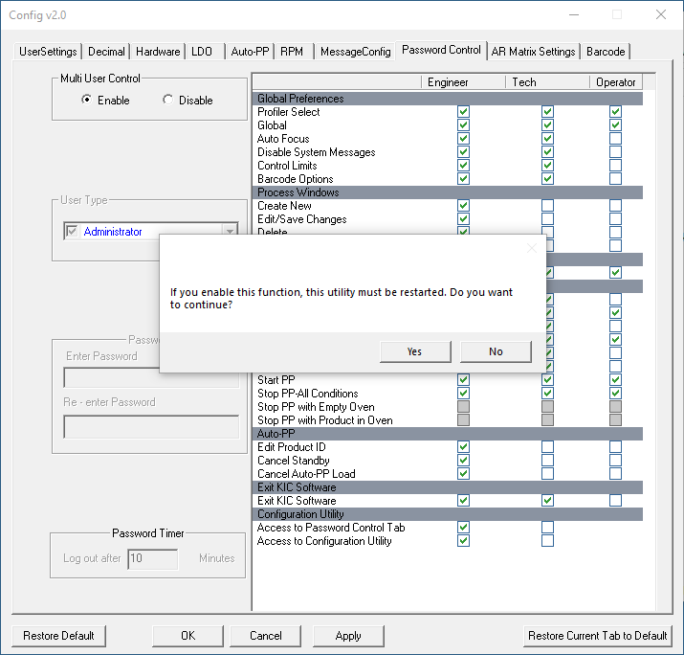

Figure 210: Restart Configuration Program

When the administrator logs back in, a password is required. **The default password is Admin**.

### Password Control Tab

The **Password Control** tab allows administrators to manage passwords and permissions for each user type. The image below represents the Password Control tab when Multi User Control is enabled. This tab displays a **Password Control Chart**, highlighted, which contains a list of every area in the software. At the bottom of the list, you can give access to the rest of the Configuration Utility tabs, and the Password Control tab individually.



Figure 211: List of Control

**Stop PP Selections**

There are three different available options for controlling when a PP can be stopped:

* Stop PP – All Conditions: This is the default setting. An authorized user can stop the PP at any time.
* Stop PP with Oven Empty: User can stop the PP only when there is no product in the oven.
* Stop PP with Product in Oven: When user clicks Stop button, they have a choice to wait for products to exit the oven, or they can force a stop even if there is still product in the oven.

**Note:** To enable use of either of the second two options, the *Stop PP – All Conditions* selection must be unchecked.

##### Examples of Stop PP Selections

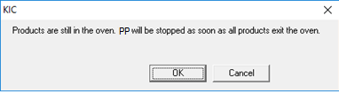

**Stop PP with Oven Empty:**

**OK** – Clicking **OK** will acknowledge this message window and the PP will stop automatically once the last board exits the oven.

**Cancel** – The *Stop* request will be cancelled, and the PP will continue to run.

Figure 212: Stop Message 1

**Stop PP with Product in Oven:**

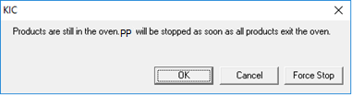**OK** – Clicking **OK** will acknowledge this message window and the PP will stop automatically once the last board exits the oven.

**Cancel** – The *Stop* request will be cancelled, and the PP will continue.

**Force Stop** – The PP will stop immediately and return to the Profile Explorer screen.

Figure 213: Stop Message 2

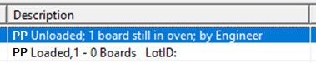If the ‘Force Stop’ selection is used, additional notes will be automatically added into the *Description* column in Profile Explorer. It will note which user level stopped the PP, and how many products were still in the oven when the stop occurred.

Figure 214: Event in Profile Explorer

### User Type Area

The **User Type** pick list allows the Administrator to select and enable the password function by user type.

By default, each user in the menu will be unchecked/disabled. By selecting a user type, you not only enable or disable the password entry field and the Password Timer, but also select the type of user to enable and configure.

The columns in the **Password Control Chart** will be enabled depending on the user type selected:

* Administrator = All columns enabled
* Engineer = All columns enabled
* Tech = Only Tech and Operator columns enabled



Figure 215: User Type

### Password Area

The Password entry fields are disabled until a user type is selected.

When a user type is selected, the **Enter Password** fields will display as ‘XXXXX” if a password had previously been entered. When a user enters a password ‘X’s will show to indicate an entry, but not show the actual password. After entering a password in the two fields, click the Apply button before changing to another User Type.

### Password Timer Area

The **Password Timer** is configurable and represents the amount of time before the user is automatically logged out due to being idle.



Fi

gure 216: Set Password and Timer

### Main Screen with Password Control

With Password Control enabled, the software Main Screen with display a Log In button with a letter on it.

* O= Operator (default)
* A = Administrator
* E = Engineer
* T = Tech

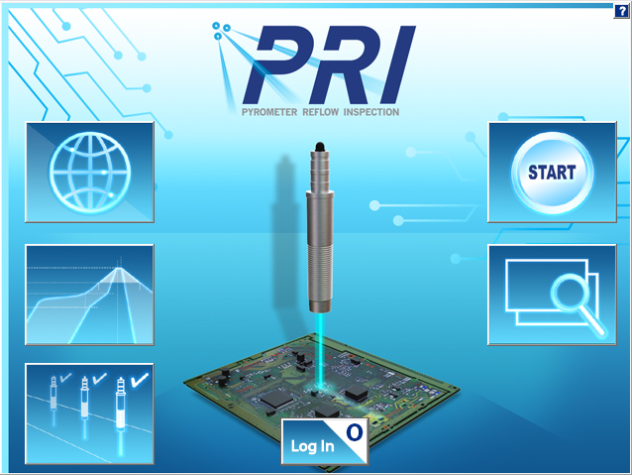

Figure 217: Main Screen - Password

**Note:** The Operator user type is the default, and typically has the least access privileges.

### Main Screen Log In

When the Log in button is clicked, the software displays a drop-down menu, as shown here.

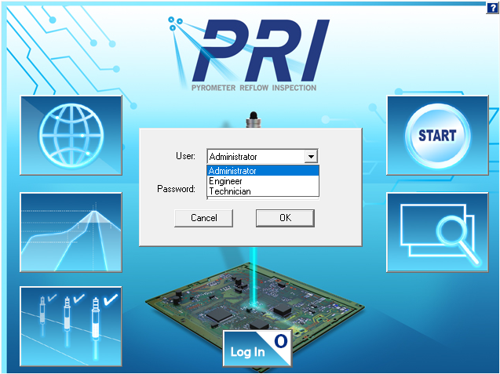

Figure 218: Main Screen - Login

**Note:** You can log in from most screens, such as from the Log in button in the lower left of the Graph screen.

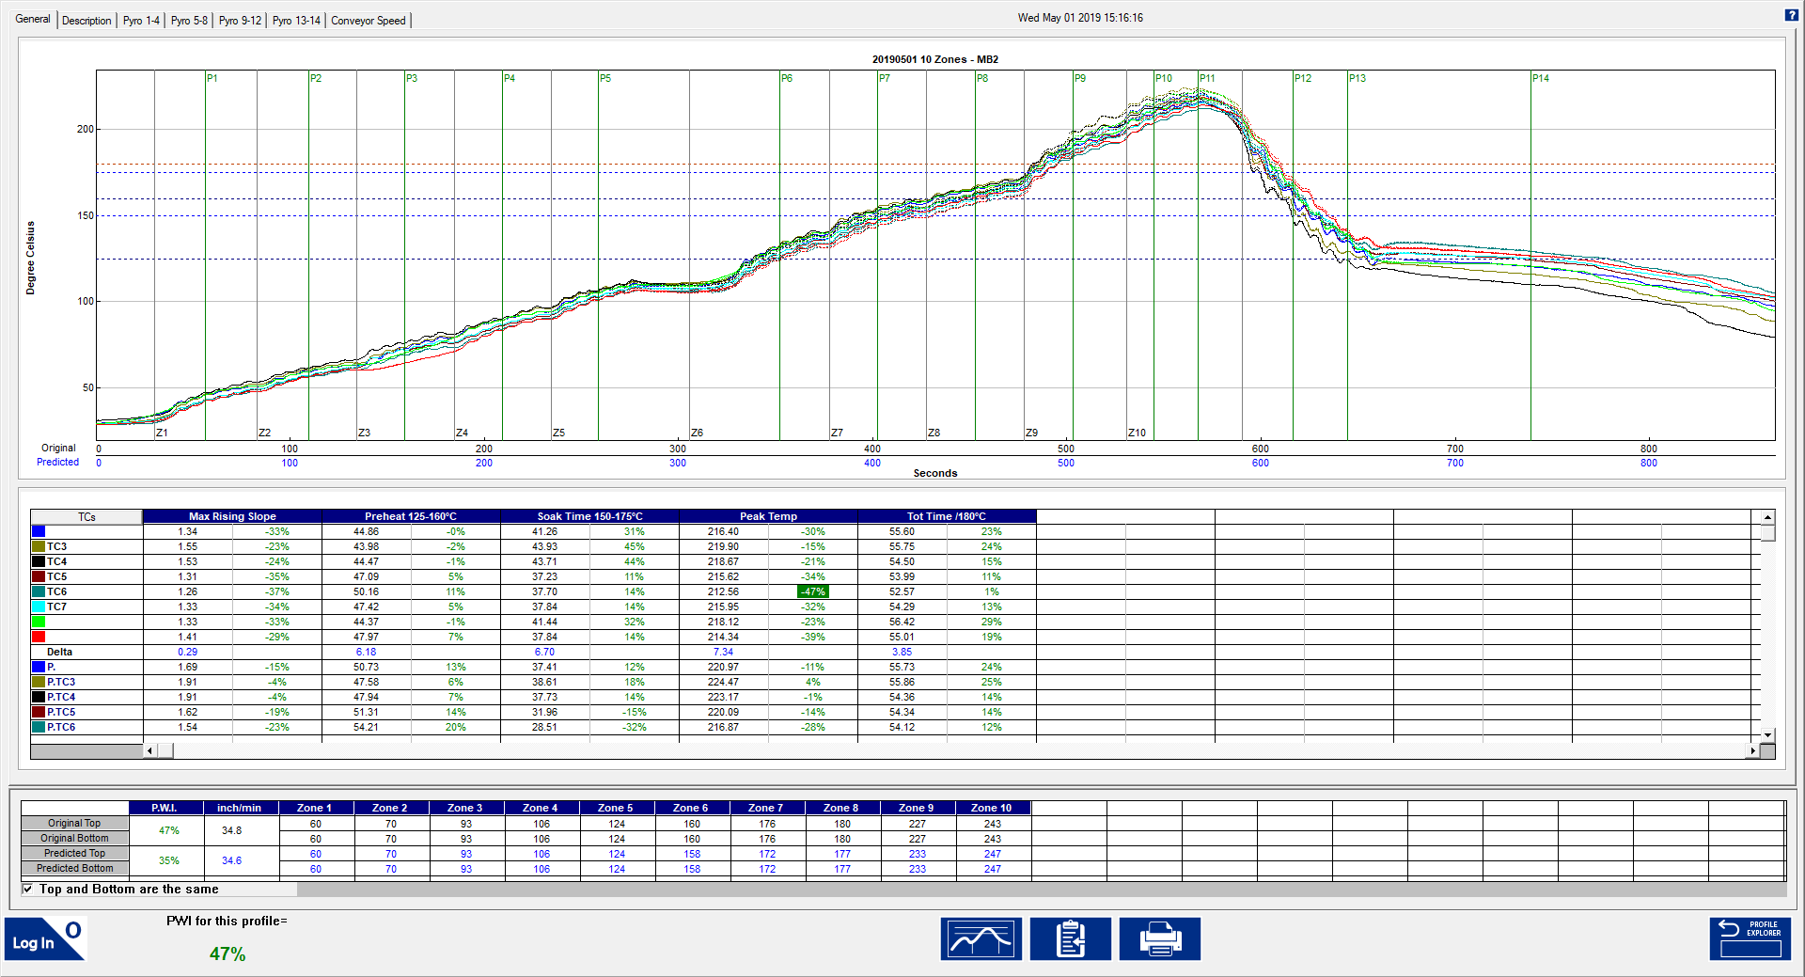

Figure 219: Graph Screen - Login

### Example of Limited Access to Functions

This screenshot shows the limited access that an Operator, for example, may have. Notice that there are no privileges to create, edit, delete, or save changes.

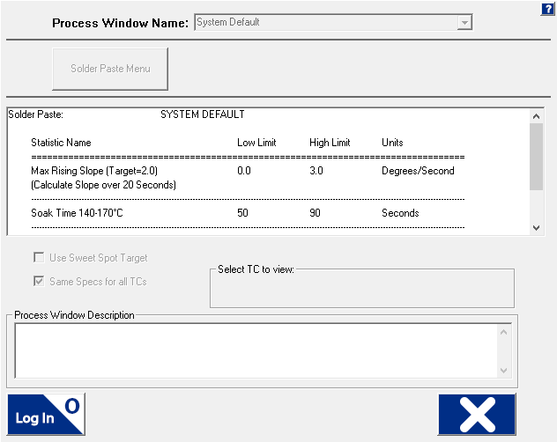

Figure 220: Process Window – Password

### Responding to an Alarm



Figure 221: Alarm Message – Password

## AR Matrix Settings Tab

When the **Alarm Relay**is in use, you can match the alarm output behavior to your specific production needs through the Alarm Relay Matrix. By default, the system only outputs a signal to the relay when it is running Pyrometer Profiling and an alarm (red crystal ball) condition. The alarm condition prompts the DAU to send a signal that energizes the **Alarm Relay**, letting it power an audible or light indicator or stop an infeed conveyor.

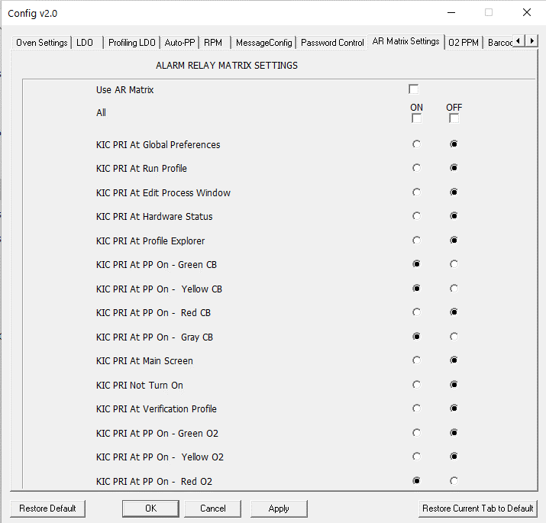

The tab presents a matrix of radio button options that lets you choose when to send the signal from a variety of operational conditions. For example, you might want to keep boards from entering the oven except when the Pyrometer Profile is in a green or yellow crystal ball state. Selections you make on the matrix will “invert” the signal that energizes the alarm relay, stopping the infeed conveyor from allowing boards to enter.

Even if someone tried to bypass the entire system by shutting down the KIC software, it can be configured so that it still would not allow product to enter. The matrix gives you more control over your process, ensuring that tjsystem is in use whenever product is run.

Figure 222: AR Matrix

*.*

|  |
| --- |
|  |

### Use the Alarm Relay Matrix

1. Select the **Use AR Matrix** checkbox to enable the matrix settings.

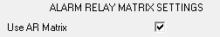

Figure 223

**Note**: The ***All*** option lets you turn all the alarm options on or off.

1. Click the check boxes to enable or disable the alarm features you want.
2. Click **Apply** then **OK** to accept the new settings and close the window.

If you are currently running the PRI software, as the window closes, you return to the screen you had open when you started the utility.

**Note**: Exit the PRI software before attempting to make any changes to the Alarm Relay Matrix.

### A Matrix Example

|  |  |
| --- | --- |
| In the example to the right, ***Use AR Matrix*** is selected, meaning that for any items selected as ***ON****,* the alarm relay will be energized. For any that are selected as ***OFF***, the relay will be de-energized.  In this example configuration, the *Alarm Relay* will be energized at all times, except when a PP is running, and there is a green, yellow, or gray crystal ball. | Figure 224: AR Matrix Example |

## Barcode Tab

The **Barcode** tab is used for configuring some of the barcode interface functions and some barcode operations.

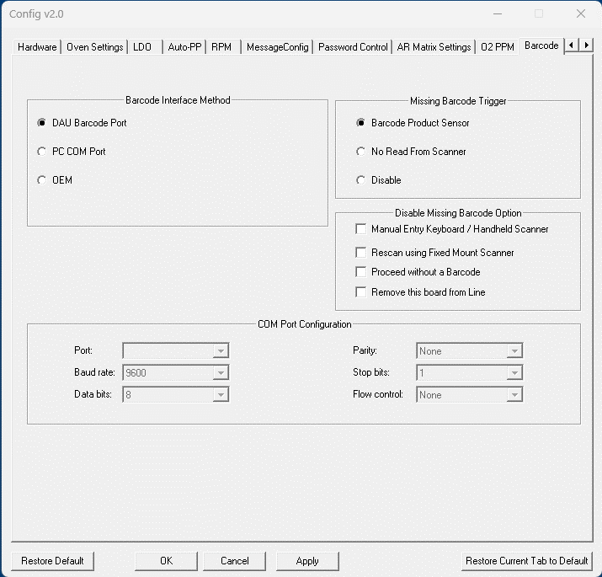

Figure 225: Barcode Tab – Configuration Program

### Barcode Interface Method Area

The **Barcode Interface Method** area specifies where a barcode string will be coming in:

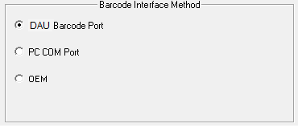

**DAU Barcode Port** – via 9 pin serial connection on DAU

**PC Com Port** – via 9 pin serial port or USB Port on PC.

**Note:** To use a USB barcode scanner, it must be programmable for a USB Serial Port interface.

**OEM** – only available with specific oven manufacturers

Figure 226: Barcode Interface Method

If PC Com Port is selected, the **COM Port Configuration** area also becomes active. This area specifies which Com Port the scanner is connected to, and the Com settings. This area must be configured when using either a DB9 (Com Port) or USB connected scanner:



Figure 227: Com Port Configuration

**Missing Barcode Trigger Area**

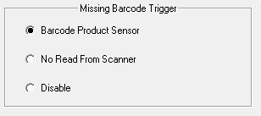

The **Missing Barcode Trigger** area specifies what method is used to trigger the Missing Barcode Alarm function.

**Barcode Product Sensor** – requires the installation of the BPS sensor adjacent to the barcode scanner. If this sensor is triggered, and a barcode is not received, the Missing Barcode Alarm is generated.

Figure 228: Missing Barcode Trigger

**No Read from Scanne**r – some scanners can be programmed with a “No Read” output. If “No Read” is the string received, the Missing Barcode Alarm is generated.

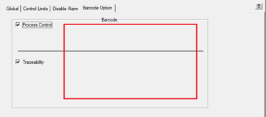**Disable** - the software will never generate a Missing Barcode alarm. Typically used when some other process verification is in use and the alarm from KIC is not required/desired.

**Note:** When either **“***No Read From Scanner***”** or **“***Disable***”** is selected, some of the configurations previously referenced in the *Barcode Section* will automatically be disabled.

Figure 229: Barcode – Global Preferences

### Disable Missing Barcode Option Area

This area allows you to disable some of the available choices that are given when a Barcode alarm is displayed:



The four selections listed represent buttons that a user can click on when a Barcode alarm appears on the screen. By selecting a particular checkbox, the software will no longer display that button on the alarm message dialog window.

Figure 230: Disable Missing Barcode Buttons

For example, when the barcode option is in use, and you never want a product to be allowed to enter the oven without the associated barcode string attached to the data, you can select the ‘Proceed without a Barcode’ checkbox. This will prevent that button from being accessible. Below is an example of a Missing Barcode Alarm condition, when that function is disabled. The open spot is where the ‘Proceed without a Barcode’ choice would have been displayed:



Figure 231: Example - Button Disabled

# Contact KIC

|  |  |
| --- | --- |
| On the Web You can find the latest KIC product news along with a library of useful information at our website:  [www.kicthermal.com](http://www.kicthermal.com) or [www.kic.cn](http://www.kic.cn) | map |

### KIC Technical Support

KIC Tech Support (phone) is available by email:

USA: [tech@kicmail.com](mailto:tech@kicmail.com)

### KIC Product Training

Contact KIC Customer Support by email, [training@kicmail.com](mailto:training@kicmail.com)

### KIC Sales

Contact KIC sales:

USA: [sales@kicmail.com](mailto:sales@kicmail.com)

### Find the KIC Representative in Your Area

Send an email or visit our web page to find a local representative.